STOP and THINK - Feeling Management

How do I feel?

- When did the feeling start?
- What level of feeling? Low 0--1--2--3--4--5--6--7--8--9--10 High
- What happened that triggered this feeling for me?
- Express your feeling to someone:
I feel…………………..….When………………. Because…………………

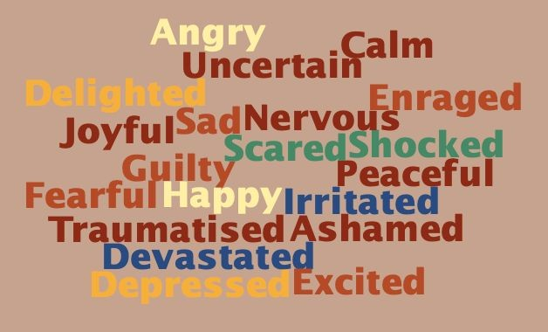

For Key Stage 1 - Managing Anxiety and Anger

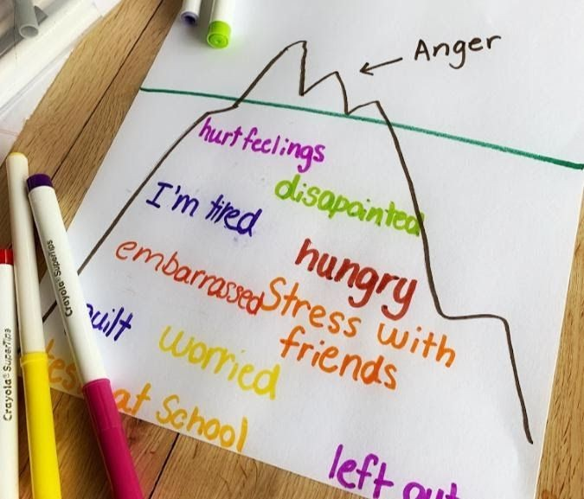

Information for parents, why is your child angry? https://childmind.org/article/angry-kids-dealing-with-explosive-behavior/
https://www.theschoolrun.com/anger-management-for-children
Some self-soothing techniques to help your child try out, see what works best for them:
https://www.understood.org/en/friends-feelings/managing-feelings/fear/8-self
-soothing-techniques-for-your-young-child
Video link how to manage my anger: http://redbridgeserc.org/resources/entry/how-to-mange-anger

Make a sensory calm down bottle: http://redbridgeserc.org/resources/entry/how-to-make-a-sensory-calm-down- bottle
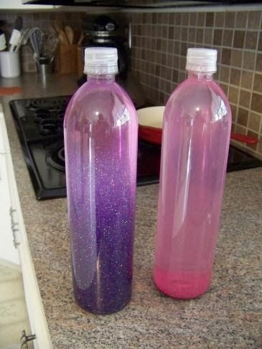

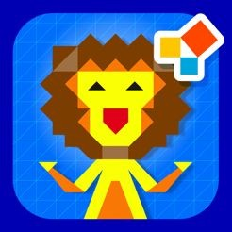
A finger painting app to download on phone or tablet, can help your child relax and focus: http://redbridgeserc.org/resources/entry/zen-studio

An example of an upset body worksheet, asking your child to show you: When you are upset where do you feel it?
http://redbridgeserc.org/resources/entry/upset-body-worksheet
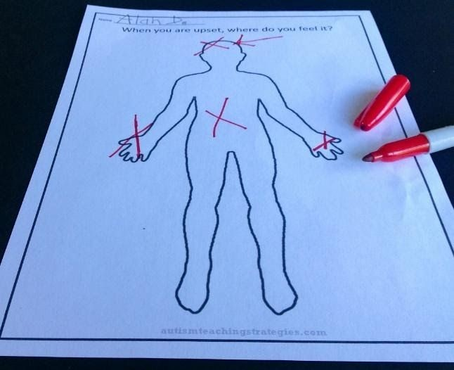

Be prepared for when your child becomes upset/angry. Decide on a safe place together for example:
- Under a table
- Under a blanket
- In a quiet corner

Encourage your child to practise going to their safe space so they know what to do when they do become upset.
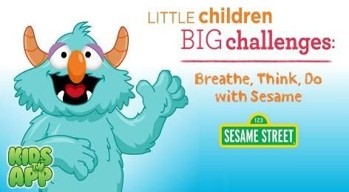
To prevent your child from becoming upset/angry download the App: Breathe, Think Do with Sesame. It is free for any i-phone or android phone and models how children should breathe deeply and think about a solution rather than act out.

To help your child understand their feelings, use the emoji faces and ask your child to point to how they feel at different points during the day.

Some other calming strategies to try:
- Allow your child to pace in the garden and hallway in the home and count their steps as they do this.
- If they are having a meltdown, try not to have a conversation with them but distract them with things you know that interest them.
- Make a list of or talk about activities and topics they enjoy.

Some more helpful resources to support children whilst they are at home: https://www.gov.uk/government/publications/coronavirus-covid-19-online-educa tion-resources/coronavirus-covid-19-list-of-online-education-resources-for-hom e-education#mental-wellbeing-primary







Start your day together with positive thoughts and feelings, this can really benefit everyone in your home especially those who feel anxious easily. Re-create this poster together and pin it up in a communal area or in bedrooms.
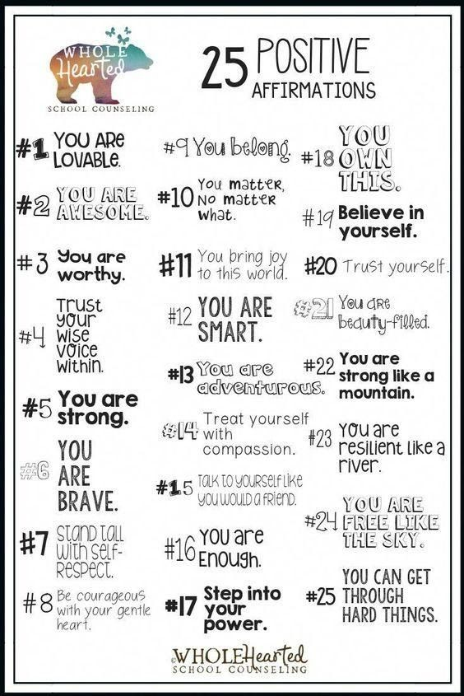

Another activity to do together as a family:

My gratitude jar
Find an empty jar in the house and make a label for it.
Think about different people, things and events you are grateful for.
Write what and who you are grateful for on pieces paper and pop inside your jar. Take these out and read them daily to your parent/carer or others in your home. You can add to the jar whenever you like 😊

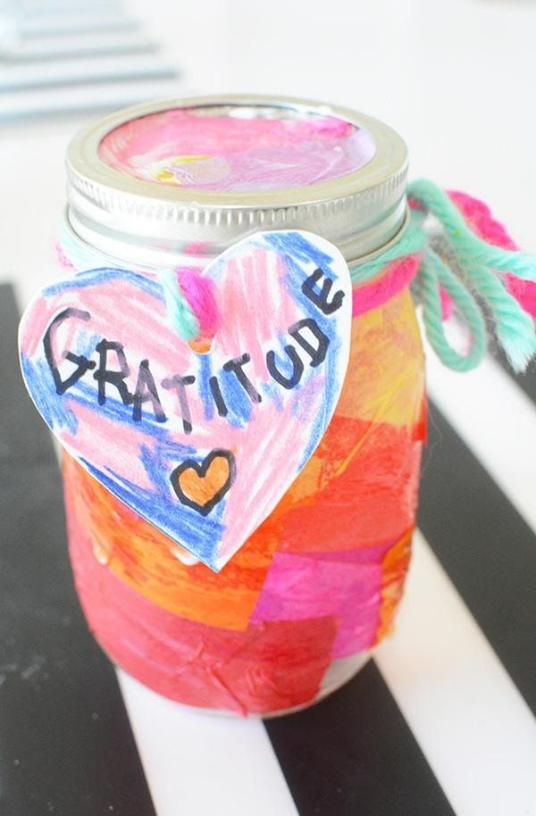
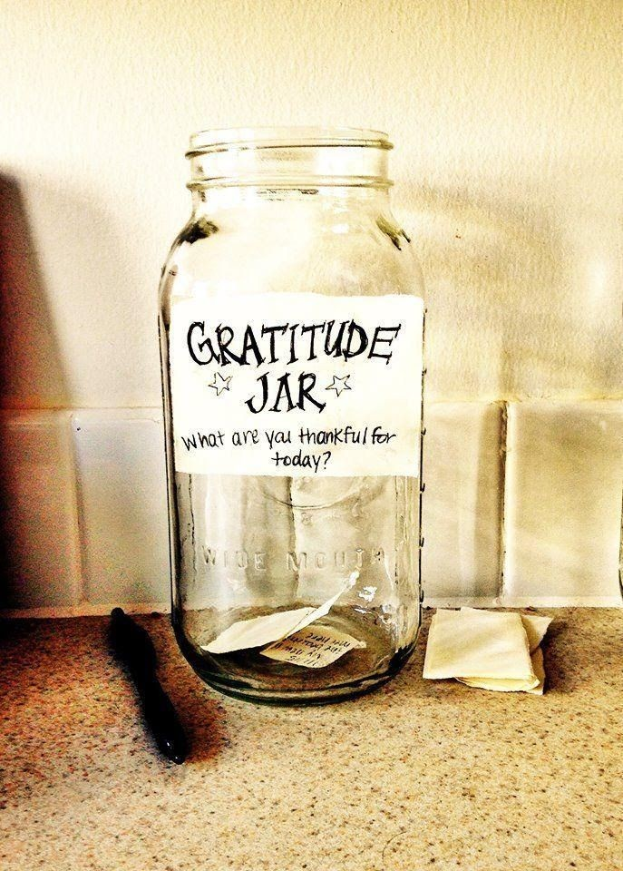

F or Key Stage 2 - Managing Anger I can Manage my Anger!
Learn all about how your brain works and how to manage your anger. Watch the video h ttps://www.youtube.com/watch?v=3bKuoH8CkFc
Then complete the worksheet.

H ow to complete the worksheet (You will find the worksheet on
t he 3rd page).
Calm and Control – Write down as many things that keep you calm and in control for eg. Reading, swimming, eating a healthy snack, etc.
What Bugs Me – Write down all the things that bug you for eg. being teased, people entering my personal space, when an activity is too difficult, when I cannot solve a problem, etc.

Signals of Stress – How do you know when you are getting stressed? For eg. my face gets red, I make a fist, my heart starts to race, I feel hot, etc.

N ext:
T ake a Short Cut

You can take a short cut by noticing your signals of stress and immediately start doing the strategies and techniques to help you calm your anger. This way you avoid ‘flipping your lid’ and you get back on track.
Choose from the following list ways in which you will take a short cut and calm yourself down. If you already have your own calming down technique then you can write that down too.

C alming Down Techniques and Strategies
- Take 3 deep breaths or more if you need it.
- Do some stretches or exercise from www.cosmickids.com
- Drink some cold water, slowly.
- Count backwards from 10, 20 or even 100, slowly and take a deep breath after you reach zero.
- Walk away from whatever is making you angry.
- Talk it out by saying I feel angry because….
- Talk to an adult and ask for help.
- Wait and cool off.
- Go to a different activity. Get your mind on something else by watching something funny, doing some drawing/painting/arts and crafts/making something etc.
- Play with a squishy toy.
- Have a cuddle with your favourite teddy.
- Tell yourself I am managing my anger and the breath.
Refer to the ‘How to help your anger cards’ for more ideas. You can also
●
print these off and stick them on your bedroom wall as a reminder.

N ext:

C omplete the worksheet on the next page.

I can manage my anger!



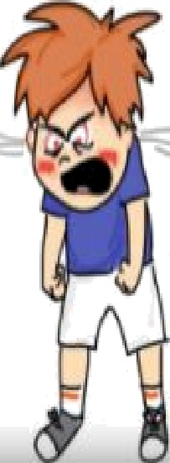
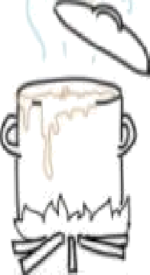


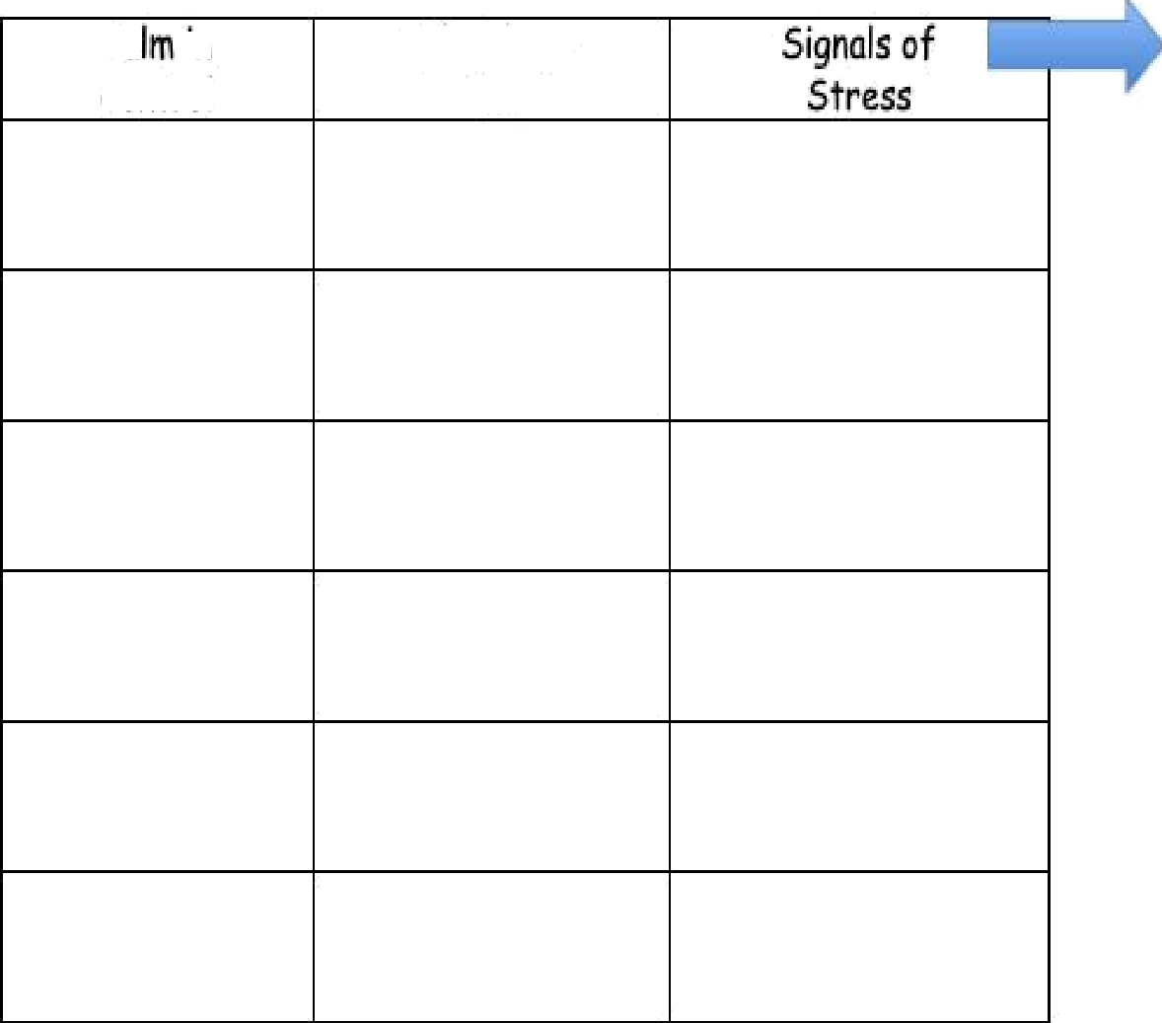
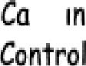
Take a Short but
What bugs
Ae7

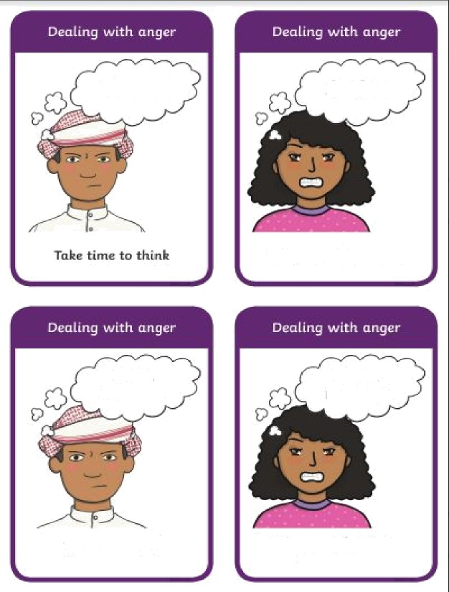
Thinb!
Tell q aursalf to STOP!
I can be calm
1 con
manage
Say to yourself
-1 con be calm"
tell pourset{ gon con moruige this

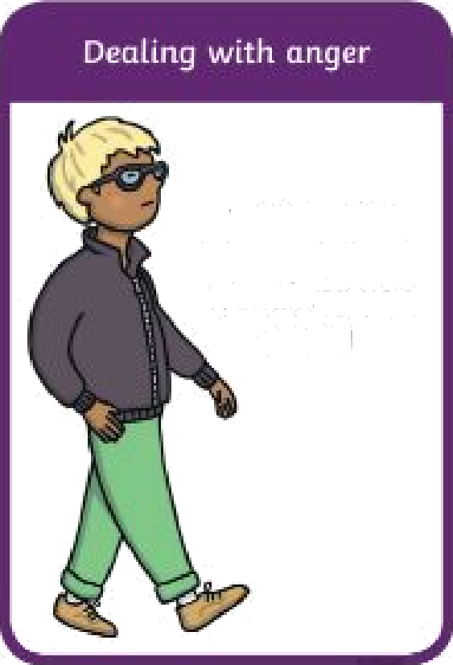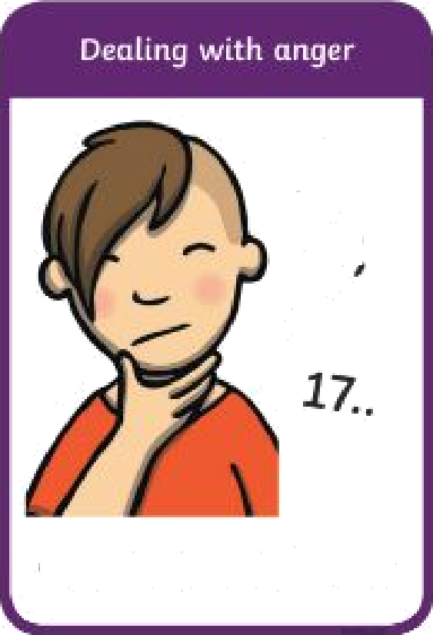

Wolf awug (rom whatever is mak iMg you un grg
29
18,
Count bOE kWarcfs {ro m 20
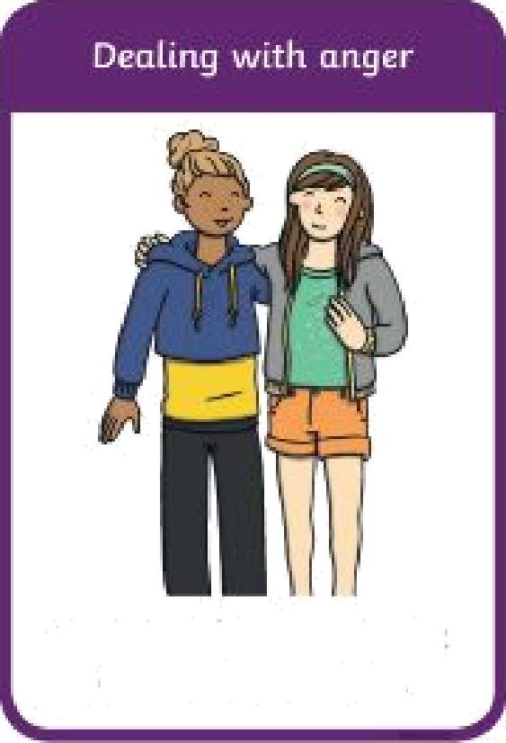
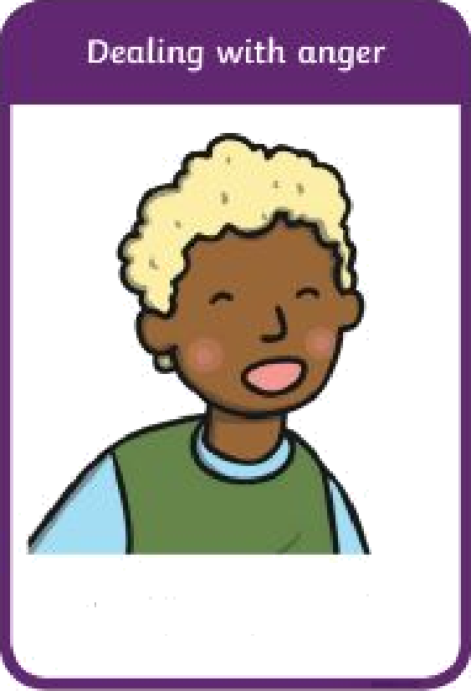

TulL rn a /riend or adult abortt how gall {«cl
Take a deep hrcnth

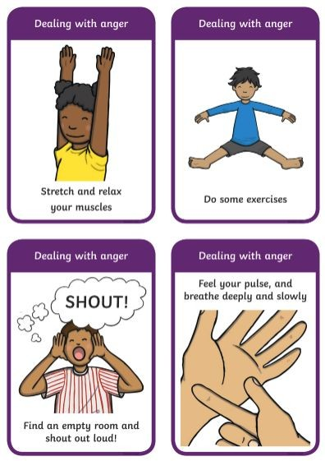

Twinkl Resources

F or key Stage 2 - Managing Anxiety

I can manage my Anxiety





W hat is Anxiety?
Anxiety is an emotion we all feel. It is similar to being nervous or worried or afraid. It is a normal response when you feel threatened.

R ecognising Anxiety – How do I know I am anxious?
It is the sensations in my body that tell me I an anxious. This could be the feeling of dizziness, upset stomach, stomach ache, headache, my heart beats faster, my face might go red or hot and my muscles might go really tight and tense.

W here do I feel Anxious?
I can feel anxious in many places on my body. Using the image on the next page, colour in where you feel anxious. For example, my heart beats faster so I will colour in the area of my heart (or you can draw a heart).

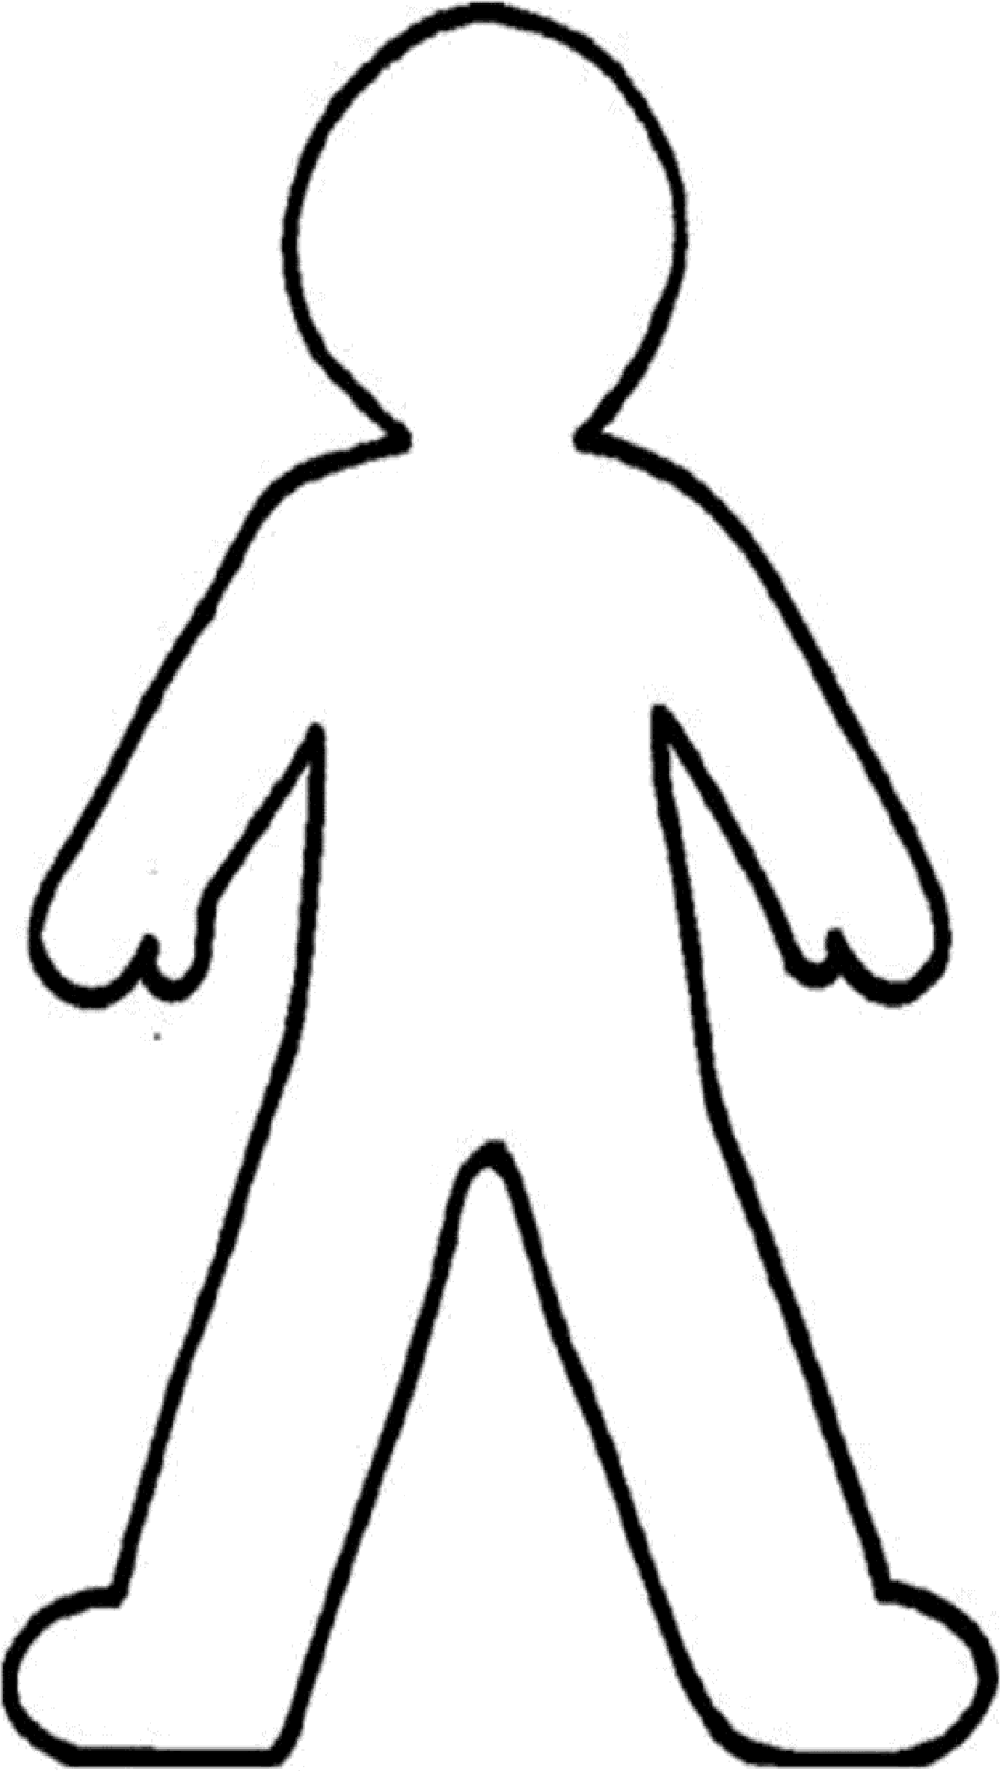

1

H ow to calm my anxiety.
There are different techniques to help calm anxiety. One good technique that can be used anywhere at any time is called the grounding technique.

HOW TO DO IT:
This technique will take you through your five senses to help remind you of the present. This is a calming technique that can help you get through tough or stressful situations.
Take a deep belly breath to begin.
5 - LOOK: Look around for 5 things that you can see, and say them out loud. For example, you could say, I see the computer, I see the cup, I see the picture frame.
4 - FEEL: Pay attention to your body and think of 4 things that you can feel, and say them out loud. For example, you could say, I feel my feet warm in my socks, I feel the hair on the back of my neck, or I feel the pillow I am sitting on.
3 - LISTEN: Listen for 3 sounds. It could be the sound of traffic outside, the sound of typing or the sound of your tummy rumbling. Say the three things out loud.
2 - SMELL: Say two things you can smell. If you’re allowed to, it’s okay to move to another spot and sniff something. If you can’t smell anything at the moment or you can’t move, then name your 2 favorite smells.
1 - TASTE: Say one thing you can taste. It may be the toothpaste from brushing your teeth, or a mint from after lunch. If you can’t taste anything, then say your favorite thing to taste.
Take another deep belly breath to end.

N ext, Have a look at the relaxation techniques below.
R elaxation techniques

Relaxation can help calm your anxiety. There are different techniques that can be done to relax your mind and body.

- You can listen to calming music.
- You can read or listen to your favourite book.
- You can eat a healthy snack.
- You can watch something funny.
- You can listen to meditation on www.cosmickids.com Choose a Peace Out relaxation story from the link below.
https://www.cosmickids.com/category/watch/?video_category=relaxation &changed=video_category
- You can follow this Butterfly meditation https://www.youtube.com/watch?v=_mX4JBBIcBk
- You can do deep breathing. Breathe in for 5 counts and breathe out for 7 counts. This helps the oxygen to go around your body to help calm your anxiety.

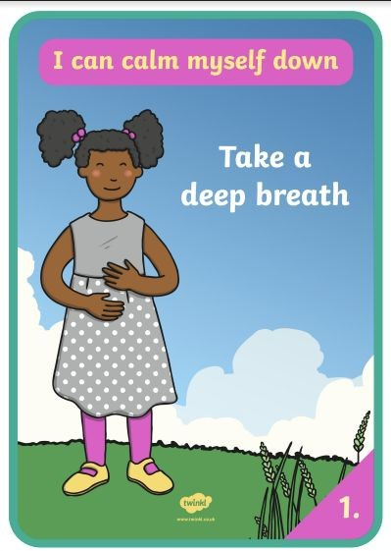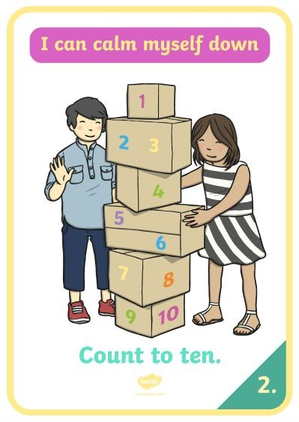

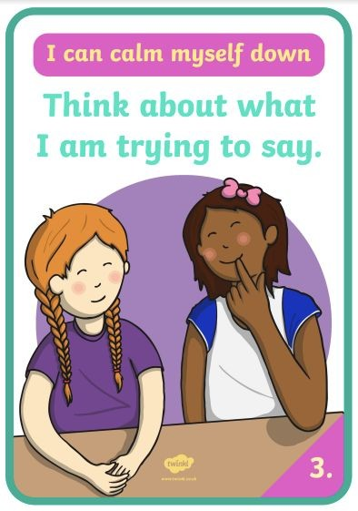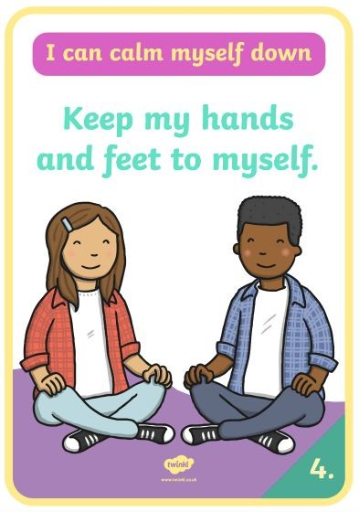

Twinkl Resources

