Dreamcatcher at Moreland, Thursday 26th September 2019

Holly Bland: Social Impact Experiences Manager at Airbnb

Cat Parkinson: PR Manager at Airbnb
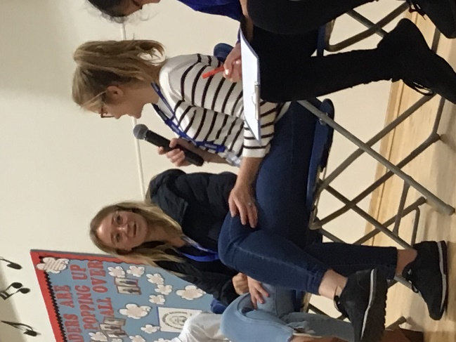
Photo of Holly (left) and Kat (right)
Can you tell us a bit about your work?

Holly and Kat work for Airbnb, a kind of online holiday company that people can book rooms, flats, houses or unusual places to stay for a short break and or a longer holiday all around the world. B and B stands for ‘bed and breakfast’ as most places that you can stay in only offer a bed and breakfast and no other meals are provided. ‘Air’, means that you book it online. There are lots of amazing places to stay!

Holly also tries to help people to find fun things to do near where they stay in their Airbnb and Cat makes sure that the people that want to use Airbnb can find cool places to stay and fun things to do.

What do you like most about what you do?

Holly and Cat like meeting new people and the fun things that they get to do, such as finding unusual places for people to stay. A favourite place that they have found is a giant potato in Boise, Idaho, USA. Yes! You can stay inside the potato as Holly and Kat showed everyone online. Idaho is famous for growing potatoes and this 6 tonne Airbnb home is not made of real potatoes but looks like one outside and inside.

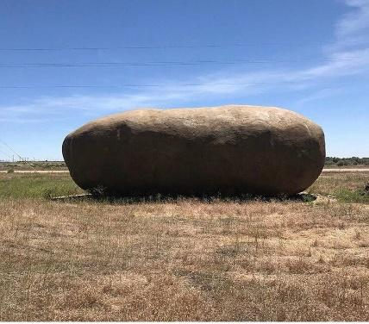 | 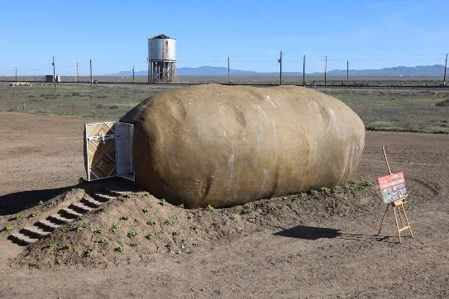 | 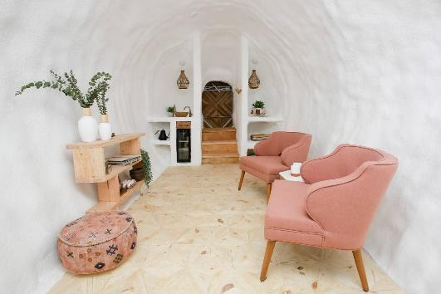

What learning and experience did you need to get your job?

Cat spent time doing internships. This is when a student or trainee works for a company either with very little or no pay, in order to get work experience for this type of work. Cat also worked in museums. Holly worked for charities and different companies getting experience. They went to university too.

Where did you grow up and go to school?

Holly grew up in Yorkshire and went to Headlands school in Bridlington
Cat grew up in Bolton and went to St Peter’s Primary School

What did you dream of doing when you were at school?

Holly dreamed of being an actress in the West End of London and also dreamed of being a Cancer Doctor. Cat dreamed of being a Vet as she loved animals and was inspired by the Harry Potter novels and films.

Do you have any other dreams for your future?

Cat would like to travel the world more, explore new countries and would love to go to Canada. Holly also wants to travel and would like to become a Teacher in the future.

Finally, if you could meet yourself again at our age, what advice would you give yourself?

Holly: “Have loads of fun learning at school and pick something you really like to do. Remember, it’s okay to change your mind too.”

Cat: “Make the most of your holidays because when you are an adult you don’t get as many weeks holidays a year as you do when you are at school”.

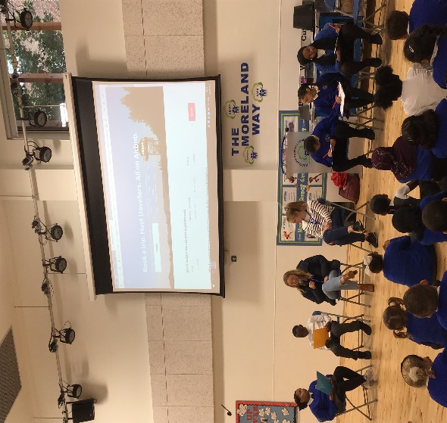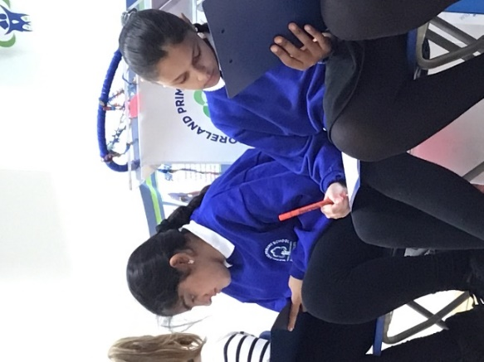
Dreamcatcher Journalists take notes for the Dreamcatcher interviewers

Photographs by Shiloh – Year 2 Pine Class
Dreamcatcher Interviewers: Malachi and Dania Year 6 Cedar Class
Dreamcatcher Journalists – Scarlet, Manaar, Hajer, Israa Year 6 Cedar Class

