Dreamcatcher at Moreland, Thursday 3rd October 2019

Iman and Vivian: Oxford Law Student Ambassadors

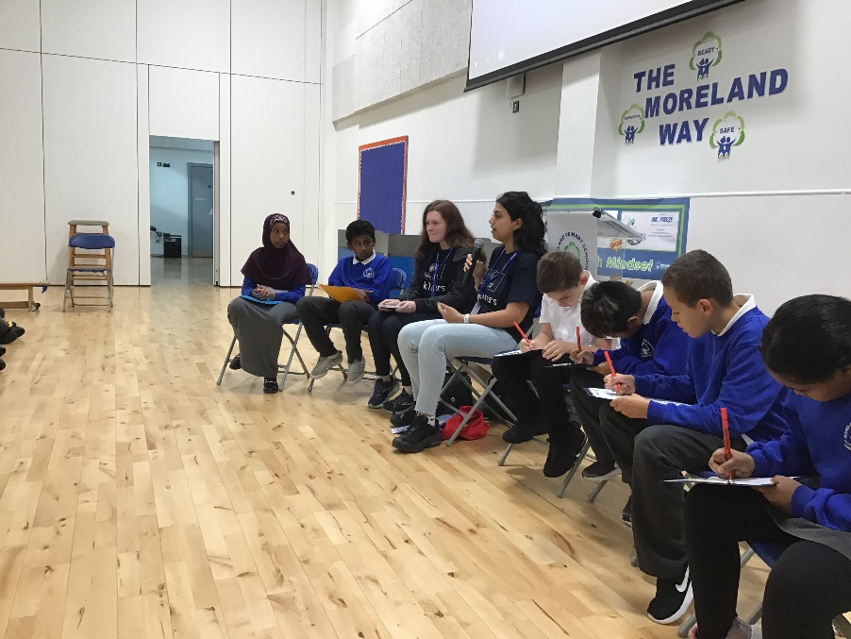
Iman and Vivien

Can you tell us a bit about your work?

Iman: We are full time students and are planning to be lawyers when we graduate from Oxford University.
Vivien: We represent students at Oxford to make sure that their views are heard and valued.

What do you like most about what you do?

Iman: Knowing that in the future we can make a difference to people’s lives.
Vivien: Studying! We enjoy learning and we are taught in small groups which means we get a lot of time with our tutors.

What learning and experience do you need to get to study law?

Iman: It’s a lot of hard work really and you need to be focused and disciplined.
Vivien: We need to keep reading and make sure that we get good grades in order to keep studying law. Reading is really important.

Where did you grow up and go to school?

Iman: I grew up in Singapore in Malaysia.
Vivien: I grew up in Brixton, London.

What did you dream of doing when you were at school?

Iman: I knew that I wanted to do a job that was really important and wanted to make a difference. I always wanted to be a lawyer.
Vivien: I dreamed of being a lawyer and going to Oxford University so this is one dream that I have achieved so far in my life.

Do you have any other dreams for your future?
Imran: I would love to encourage more people from different ethnicities to enter the law profession and to go to Oxford like I have.
Vivien: I just want to encourage people to do what’s right for them and do the best job that I can as a lawyer.

Questions from the audience of children at Moreland for Iman and Vivian:

Q: Who inspired you to become a law student?
A: Teachers and family members.

Q: What were your favourite subjects at school?
A: History, English, Reading and Science.

Q: When you become lawyers, what would your first emotions be?
A: Pride, happiness.

Finally, if you could meet yourself again at our age, what advice would you give yourself?

Iman: “Ask lots of questions and listen well to people that are helping you and advising you.”

Vivien: “Get involved in everything that you can and have fun trying out different activities so that you can become inspired to achieve your dreams in the future”.

Dreamcatcher Journalists take notes for the Dreamcatcher interviewers

Photographs: Year 2
Dreamcatcher Interviewers: Year 6 Cedar Class
Dreamcatcher Journalists –Year 6 Cedar Class

