Dreamcatcher at Moreland, Thursday 17th October 2019

Rhian Jones: Education Coordinator at Humanists UK

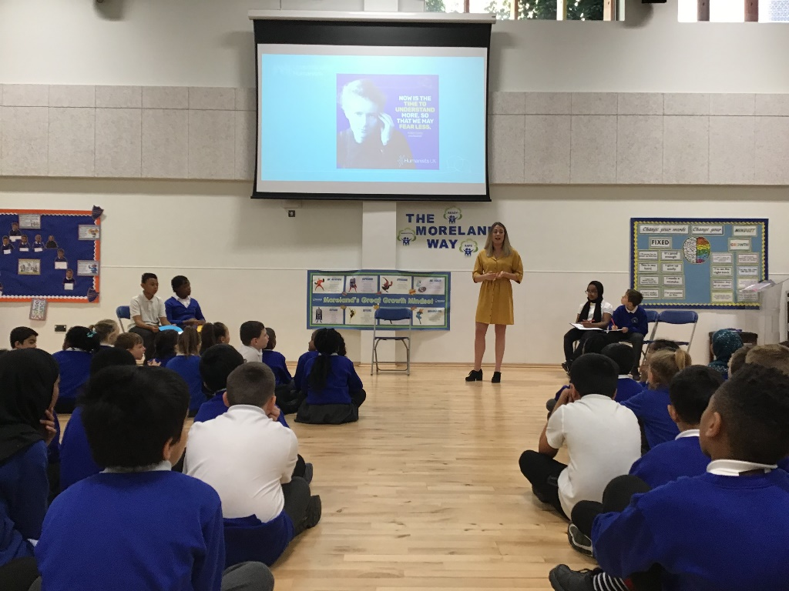
Rhian Jones talking about her role at Humanist UK to Moreland Children today

Can you tell us a bit about your work?

Rhian is involved in ‘Teaching and Learning’ and she helps Teachers to learn about Humanism and how to support their students to be able to think deeply, ask lots of questions, explore ideas and perspectives and discover new things. Rhian herself is a ‘Humanist’.

What do you like most about what you do?

Rhian loves the fun and creative side of her job. She gets to design training to be used online and gets to decide how she teaches adults about humanism.

What learning and experience did you need to get your job?

Rhian studied Science and in particular ‘genetics’. Genetics helps us to understand how the body works and how we inherit features from our parents such as the colour of ours of eyes and sometimes medical conditions. Rhian was inspired to study science because she has a younger sister who has a disability and she wanted to be able to understand her condition.

Where did you grow up and go to school?

Rhian was born in South West Wales and grew up there in a small village surrounded by farmland. She moved the London a few years ago.
South West Wales where Rhian was born 

What did you dream of doing when you were at school?

Rhian had a lot of ideas about what she wanted to do in the future when she was at school. She was interested in dinosaurs and space and wanted to be an astronaut. Rhian also thought about being a doctor too and had always been really interested in Science.

Do you have any other dreams for your future?

Rhian would love to be involved in helping people to understand science in the future.

Questions from the audience of children at Moreland for Rhian:

Q: What was your favourite subject at school?
A: “Science!”
Q: What do you not like about your job?
A: “having to work on the computer such a lot. It is very necessary but I love working with people face to face and don’t enjoy using the computer for long periods of time”.
Q: Who inspired you to go into your job?
A: “I was inspired by Marie Curie, a famous physicist and chemist.

Finally, if you could meet yourself again at our age, what advice would you give yourself?

Rhian says she would advise herself and everyone to “enjoy your time at school and learning for life”.

Dreamcatcher Journalists take notes for the Dreamcatcher interviewers

Photographs by Year 5 Rowan Class
Dreamcatcher Interviewers: Year 6 Cedar Class
Dreamcatcher Journalists –Year 6 Cedar Class

