Dreamcatcher at Moreland, Wednesday 6th November 2019

Kelly Craig: Education and Community Officer for The Dogs Trust North London
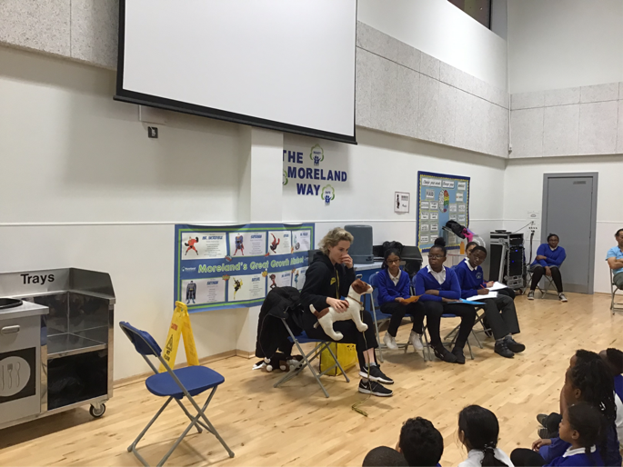

Kelly Craig from The Dogs Trust

Can you tell us a bit about your work?

Kelly helps abandoned dogs and educates the public about the effects of abandonment of and cruelty to dogs. As part of her role, Kelly helps to feed abandoned dogs and look after them. She also matches the dogs up with new owners who will look after and care for them properly and give them a loving home. Kelly teaches children to recognise the feelings of dogs and how to notice if they are happy, sad or grumpy.

What do you like most about what you do?

Working with children and dogs to help everyone understand how to keep dogs safe and happy.

What learning and experience did you need to get your job?

Kelly did a lot of volunteering looking after dogs and got a teaching qualification so that she could teach about how to take care of dogs.

What did you dream of doing when you were at school?

Rhian had a lot of ideas about what she wanted to do in the future when she was at school. She was interested in dinosaurs and space and wanted to be an astronaut. Rhian also thought about being a doctor too and had always been really interested in Science.

Do you have any other dreams for your future?

Kelly would love to continue rescuing dogs and would love to open a shop for dogs that sells everything that they need.

Questions from the audience of children at Moreland for Kelly:

Q: What was your favourite subject at school?
A: Science and reading

Q: How do dogs behave when they first meet you?
A: They can be very frightened or over excited. It’s important to stand still and allow them to come to you, smell you and then they settle down.

Finally, if you could meet yourself again at our age, what advice would you give yourself?

Kelly says she would advise herself and everyone to “Make sure that you try different ideas and find a job that you love. We spend a lot of time working so it should be a job that you really care about and are interested in”.

Dreamcatcher Journalists take notes for the Dreamcatcher interviewers

Photographs by Year 5 Rowan Class
Dreamcatcher Interviewers: Year 6 Cedar Class
Dreamcatcher Journalists –Year 6 Cedar Class

