Dreamcatcher at Moreland, 14th November 2019

Dr Katie Coleman: Local GP (General Practice Family Doctor) on City Road
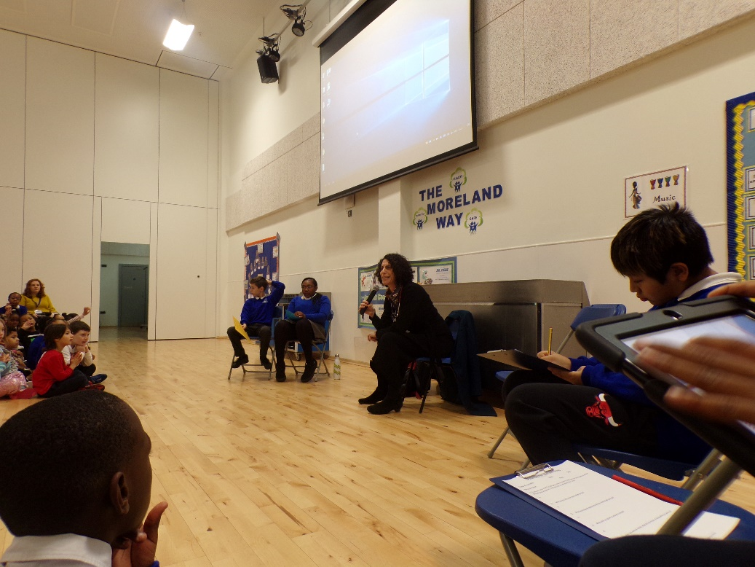

Dr Katie Coleman talking about her role as a GP in a local Dr’s Surgery with Moreland children

Can you tell us a bit about your work?

Katie is a GP, which is a doctor that most people visit when they have a health issue. She listens to patients; may feel their tummies; take their blood pressure; listen to their heart or lungs and take their temperatures. Katie then decides with the patient what their health issue may be and prescribe treatment if it is needed. Katie also helps to plan lots of health services for patients across the area where she works.

What do you like most about what you do?

Katie loves meeting people and says that it’s great to meet so many different people in her job and help to look after them.

What learning and experience did you need to get your job?

Katie had to take exams in science and maths in order to study medicine. She did a lot of voluntary work and spent time in a children’s home and old people’s home. This helped Katie to get into university as they realised she was serious about helping people with their health.

Where did you grow up and go to school?

Katie grew up near Wembley, North London.

What did you dream of doing when you were at school?

Katie really wanted to be a doctor since she was 9 years old. She says she really is one of those people who when they make a decision about something, she goes for it.

Do you have any other dreams for your future?

Katie would love to travel the world and continue to meet people from different cultures.

Questions from the audience of children at Moreland for Katie:

Q: What is it like being a GP?
A: “Very rewarding, you know that you are making a difference to people’s health and wellbeing”

Q: Do you ever get bored being a GP?
A: “No! Never! It’s a busy job, can be stressful but no day is the same and it’s a very interesting role”.

Finally, if you could meet yourself again at our age, what advice would you give yourself?

Katie says “believe in yourself; keep doing what makes you happy; work hard and listen to advice from those that are trying to help you”.

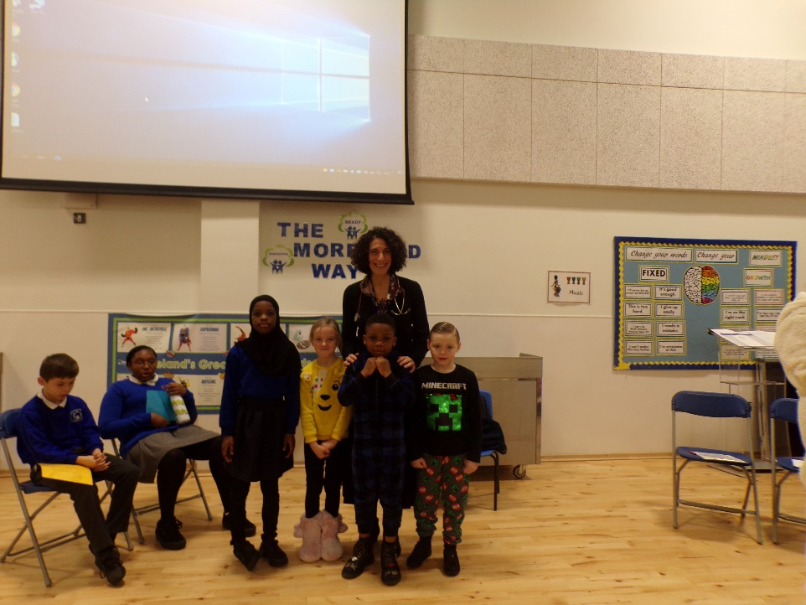

Dreamcatcher Journalists take notes for the Dreamcatcher interviewers

Photographs by Year 5 Rowan Class
Dreamcatcher Interviewers: Year 6 Cedar Class
Dreamcatcher Journalists –Year 6 Cedar Class

