Dreamcatcher at Moreland, Thursday 5th December 2019

Roger Rufey: Consultant Architect for NBBJ and his colleagues Rebecca and Jordan
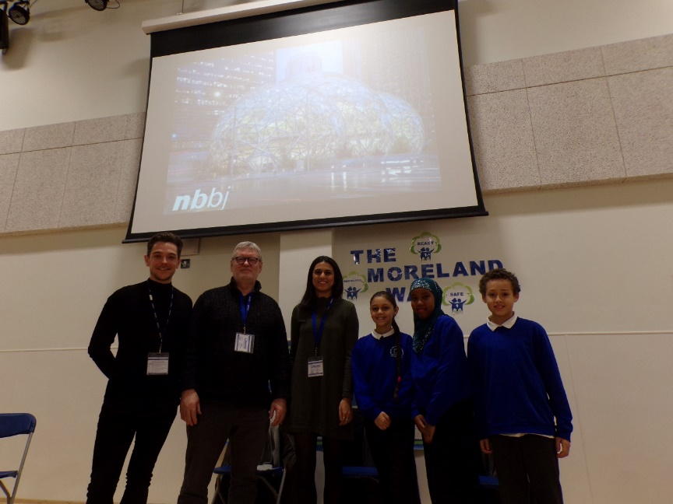
Roger Rufey and his colleagues tell the children at Moreland about their exciting roles designing and creating buidlings.

Can you tell us a bit about your work?

We work as Architects and we draw, design and create models of buildings that our clients (another word for customers) would like to be built. We are based on City Road, not far away from Moreland Primary School. We have eleven offices around the world such as the USA, China, India as well as the United Kingdom.

What do you like most about what you do?

Roger and his team love seeing their drawings, designs and models of buildings come to life as places where people work, live, receive health care and enjoy recreation. Our company designed the ‘Amazon Spheres’ building in Seattle, Washington, USA below at Amazon Headquarters Campus Seatle. It was very exciting to see it finished!


What learning and experience did you need to get your job?

Roger and his team had to study for up to 7 years for a degree (type of qualification) in Architecture. Working in an architect’s office, slowing getting all of the experience that they needed whist studying enabled them to reach their goals.

What did you dream of doing when you were at school?

Roger wanted to be a policeman; Jordan wanted to be an artist or a footballer and Rebecca wanted to be an architect as her grandfather was an architect.

Do you have any other dreams for your future?

Roger and his team want to continue doing the jobs that they love. Rebecca and Jordan want to specialise a bit more in particular areas of architecture.

Questions from the audience of children at Moreland for Roger, Rebecca and Jordan:

Q: Who or what inspired you all to do your jobs?
A: “walking around London looking at all the amazing buildings”

Q: If you didn’t have this job, what job would you have?
A: “use my architect’s knowledge to build film sets”, “manager of Arsenal”, “PE Teacher”.

Finally, if you could meet yourselves again at our age, what advice would you give yourselves?

“Try as many careers and jobs as you can. Be creative and by trying out lots of different ideas you will find what you love”.

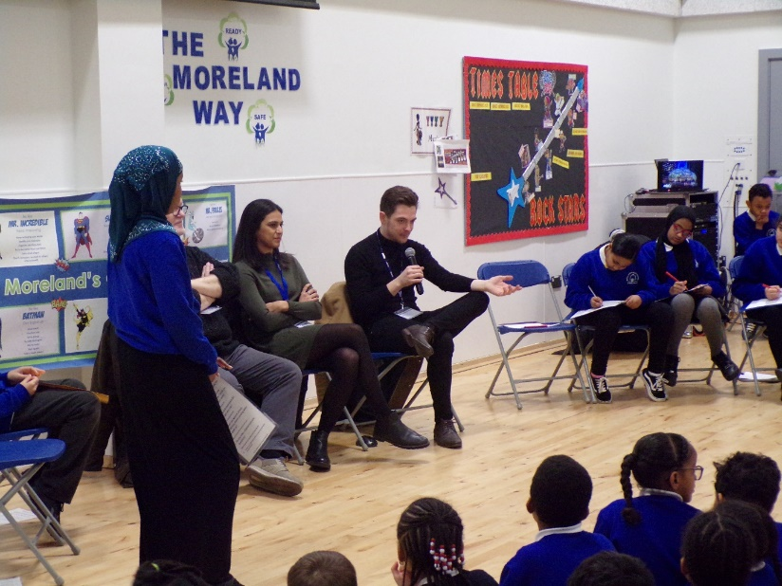

Dreamcatcher Interviewers and Journalists: Year 6 Cedar Class

