Dreamcatcher at Moreland, Thursday 12th December 2019

Katie Lyle: Design Coordinator for Wilmott Dixon

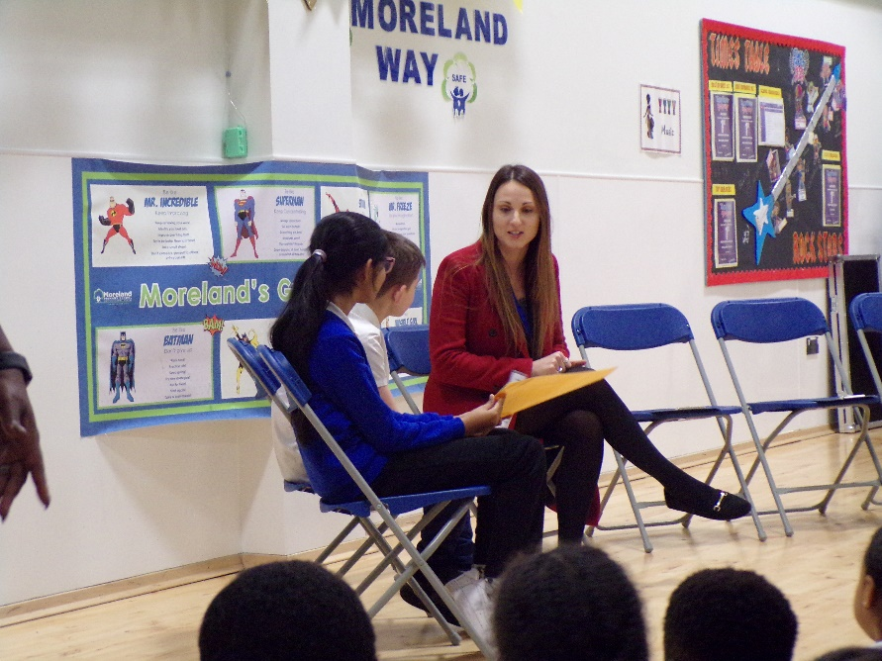

Katie tells the children at Moreland about her role at Wilmott Dixon

Can you tell us a bit about your work?

Katie helps the insides of buildings to be designed and created. She is currently working on a project just over the road from Moreland Primary School at the moment. I make sure that all of the drawings that are made of the designs get to the right people so that the insides of buildings are created and finished on time.

What do you like most about what you do?

Katie likes the variety in her work. She loves being in charge of the drawings and also speaking with the customers to make sure that they get what they have asked for.
What learning and experience did you need to get your job?

Katie did a Diploma (a qualification) in ‘Interior Design’ and then went on to do a Diploma in ‘Construction Management’. These qualifications gave her all of the skills, knowledge and understanding to do her job now.

Where did you grow up and go to school?

Katie grew up and went to school in St Albans, Hertfordshire.

What did you dream of doing when you were at school?

Katie dreamed of becoming a vet and told us that she “loves animals”. Originally that is what she wanted to do but as she grew up her ideas and dreams about her future changed.

Do you have any other dreams for your future?

Katie would love to travel the world and continue to meet people from different cultures and backgrounds.

Questions from the audience of children at Moreland for Katie:

Q: Who inspired you to do your job?
A: “My brother-in-law worked in construction design and he was very good at his job, his work inspired me”.

Q: What is the most satisfying part about your job?
A: “Seeing my building finished with the interior designed just as the customer requested. This is the most satisfying part for me”.

Finally, if you could meet yourself again at our age, what advice would you give yourself?

Katie says “Believe in yourself and never close any doors and opportunities that are open to you, you can be whatever you dream of if you put the hard work in”.

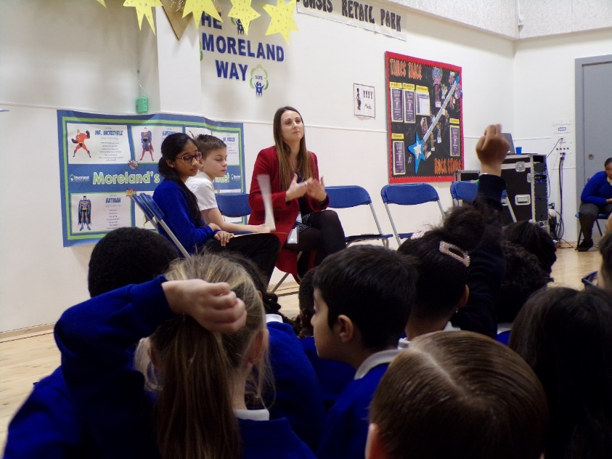

Dreamcatcher Interviews talk with Katie and Moreland Children.

Photographs by Year 5 Rowan Class
Dreamcatcher Interviewers: Year 6 Cedar Class
Dreamcatcher Journalists –Year 6 Cedar Class

