Dreamcatcher at Moreland, 9th January 2020

Rosie Scott: Barrister working at Essex Chambers in EC1
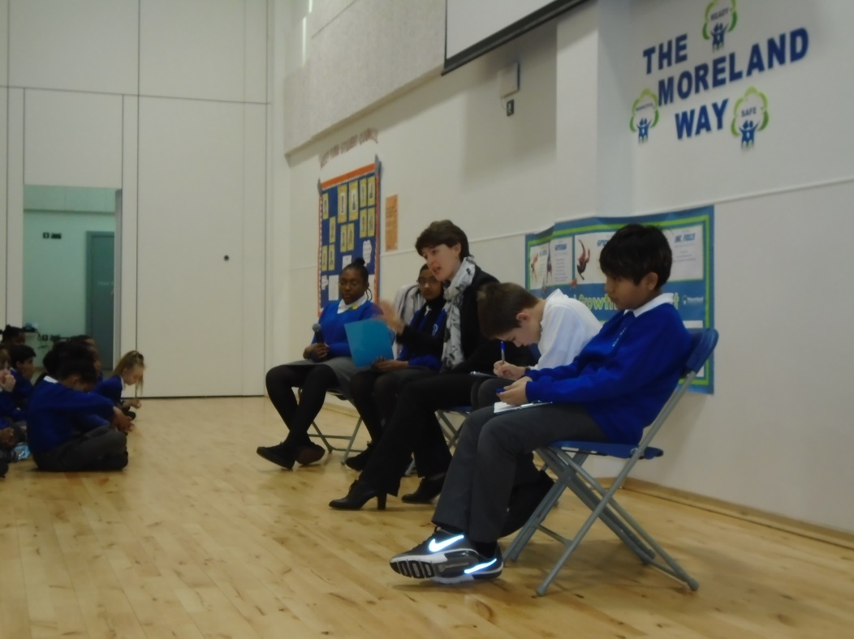

Rosie tells us about her role as a Barrister and the type of cases she works on.

Can you tell us a bit about your work?

Rosie works as a Barrister for Essex Chambers which is based in London, EC1. A Barrister is a type of lawyer that works in courts and Rosie’s work involves helping people about how decisions are made in their lives. Sometimes this involves helping to make good decisions in the best interests of someone who cannot communicate or make decisions themselves. Rosie helps people to get what they need and have a say in what happens next for them.

What do you like most about what you do?

Rosie loves helping people who find themselves in trouble, or are having a lot of difficulties with the law. Working with people is very rewarding and Rosie likes this the most.

What learning and experience did you need to get your job?

Rosie took her GCSEs and A Levels in Secondary School and this helped her to get to go to university. She then trained for many years with a law company and took all the right tests to become a Barrister.

Where did you grow up and go to school?

Rosie grew up and went to school in Oxfordshire.

What did you dream of doing when you were at school?

Rosie thought about being a firefighter; a ballerina, an astronaut and the Prime Minister! Then one day someone said that she was very good and arguing (politely of course like debating) and that maybe she should consider becoming a Barrister so that she could argue people’s cases and rights in the court.

Do you have any other dreams for your future?

Rosie would love to travel the world.

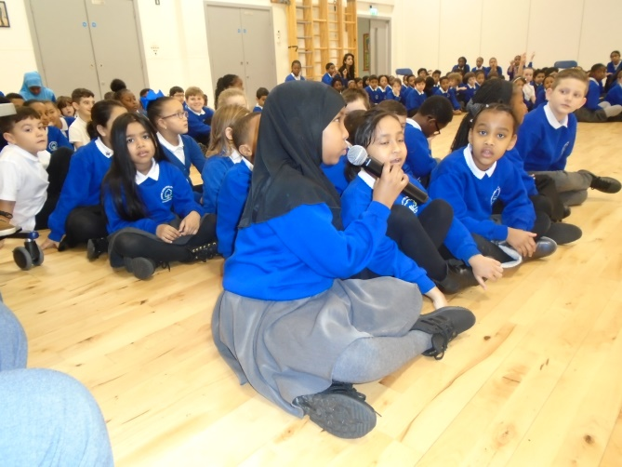

Questions from the audience of children at Moreland for Katie:

Q: Who inspired you to become a Barrister?
A: Rosie says her teachers inspired her and later, she was inspired by Baronness Hale, known as Lady Hale. Lady Hale was a British judge and the first female to serve as the president of the Supreme Court of the United Kingdom. Lady Hale played a big part in the Children’s Act 1989, making sure that children’s rights are protected.

Q: What would you do if you gave up being a Barrister?
A: Rosie would like to be a Teacher and would perhaps still like to be Prime Minister.

Finally, if you could meet yourself again at our age, what advice would you give yourself?

Rosies says “Enjoy what you do now. School is an amazing time in our lives that we will never get back, make the most of your learning for you and your future”.
Dreamcatcher Journalists take notes for the Dreamcatcher interviewers

Photographs by Year 6 Cedar Class
Dreamcatcher Interviewers: Year 6 Cedar Class
Dreamcatcher Journalists –Year 6 Cedar Class

