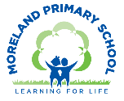
Year 4 Long Term Curriculum Map 24-25
Autumn Term |  | Spring Term |  | Summer Term:
Autumn 1  Windrush | Autumn 2  People of London | Spring 1  Ancient Egypt | Spring 2  Ancient Egypt | Summer 1  Ancient Greece | Summer 2  Take One Picture
Core Text: Coming to England  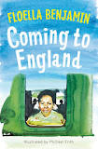 | Core Text: The Journey/ The Boy at the Back of the Class (WCR)  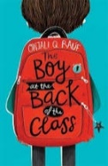  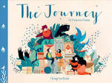 | Core Text: Tutankhamun’s Tomb I was there/ Secrets of The Sun King  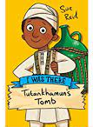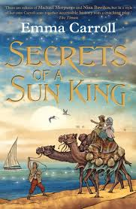 |  | Core Text:  Greek Myths  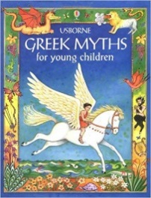 | Core Text: To be decided based on painting
Writing Outcome:  Historical Recount – write a recount of coming to Britain on Windrush  To write a poem | Writing Outcome:  Personal Narrative – diary of a refugee  To write a letter | Writing Outcome:  Newspaper article – Discovery of Tutankhamun’s tomb  Diary entry – Howard Carter | Writing Outcome:  Mystery Story set in Egypt  Write up a science investigation | Writing Outcome:  Write a Greek Myth  Write a short travel guide to Greece | Writing Outcome:  To write a poem
Other Suggested Texts:  The Island  Windrush Child  When Life Gives you Mangoes | Other Suggested Texts:  Welcome to Nowhere  Boy Everywhere  The day the war came  Gerveilie’s Journey  The Colour of Home  The Arrival  When Stars are Scattered  The Night Diary  When Hitler Stole Pink Rabbit | Other Suggested Texts:  Newspaper articles  Extracts from Howard Carter’s Diary | Other Suggested Texts:  Red Pyramid | Other Suggested Texts:  Percy Jackson and the Lightning Seed  Who Let the Gods Out  Oh My Gods | Other Suggested Texts:
Poetry:  Caribbean Dozen  Childhood Tracks –James Berry  Windrush Poem | Poetry:  We Refugees – Benjamin Zephaniah  I wish I’d Looked After my Teeth - Pam Ayres  The Toothless Wonder – Phil Bolsta | Poetry:  The Magic Box – Kit Wright | Poetry:  Ozymandias – Percy Bysshe Shelley | Poetry:  N/A | Poetry:
White Rose Maths:  Place Value  Addition and Subtraction  Area  Multiplication and Division |  | White Rose Maths:  Multiplication and Division  Length and Perimeter  Fractions  Decimals |  | White Rose Maths:  Decimals  Money  Time  Shape  Statistics  Position
Science:  Electricity  Working Scientifically:  Identifying suitable types of enquiry | Science:  Animals including Humans  Working Scientifically: Gather data in a variety of ways | Science:  States of matter | Science:  Science Fair project | Science:  Sound  Working Scientifically: Making systematic and careful-observations and measurements | Science:  Living things and their habitats
Topic Enquiry: Windrush  History:  - Investigating black migration to the UK preWW2  - Finding out about the Windrush generation, why people came to the UK, what their lives were like when they arrived in the UK  - Recognising the positive impact of the Windrush legacy to the UK.  Geography: The Caribbean  - Find out about the human and physical geography of the Caribbean Islands.  - Compare the geography of Trinidad to the UK. | Topic Enquiry: People of London - Migration  History:  - Find out about the history of migration to the UK and London.  Geography:  - Understanding population  - Understanding migration  - Finding out about the different people and communities of London and where people come from with a focus on the Bengali community.  - Understand the push and pull factors for migration.  - Map the journey of a refugee community. | Topic Enquiry: Ancient Egypt  History:  - Have an overview of Ancient Civilisations and understand where Ancient Egypt fits in the chronology.  - Find out about Life in Ancient Egypt.  - Understand the beliefs of the Ancient Egyptians.  - Find out about the discovery of Tutankhamun’s tomb and how this gives us information about Ancient Egypt. | Topic Enquiry: Ancient Egypt  Geography: The River Nile  - Find out about the importance of the River Nile and the physical geography of Egypt.  - Understand the Water Cycle. | Topic Enquiry: Ancient Greece (over 2 terms)  History:  Find out about:  - The chronology of Ancient Greece  - The political structure of society in Ancient Greece including city states, the role of slaves, women’s roles and the birth of democracy  - The evidence that informs us about Ancient Greek civilisation  - What happened at the Battle of Marathon and its significance.  - The beliefs of the Ancient Greeks  - Culture in Ancient Greece  - The legacy of Ancient Greece on our own lives today  Geography: Europe – focus on the Mediterranean  Find out about:  - The key geographical features of Europe  - The location and climate of the Mediterranean countries and compare with the UK  - The geography of Greece and how this impacted on its history.  - Why Greece is a popular tourist destination | Topic Enquiry:  Geography:  Local fieldwork project
Computing:  E Safety: Media Balance and Wellbeing  Your Rings of Responsibility  Computing Systems and Networks – The Internet | Computing:  E Safety: Cyber Bullying  The Power of Words  Google Slides | Computing:  E Safety: News and Media Literacy  Is Seeing Believing  Creating Media – Audio Editing -Audacity  3 Discovery Project – News broadcast | Computing:  E Safety: Privacy and Security  Password Power-Up  Data Logging - NCCE | Computing:  E Safety: Digital Footprint and Identity  This Is Me  Multiple Scenes and Dialogue | Computing:  E safety: Relationships and Communication  Our Digital Citizenship Pledge  Repetition Scratch Shapes
Art :  Painting :  Lorna Simpson style  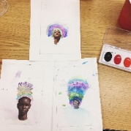  Focus Artist:  Lorna Simpson | Art :  Digital Media:  Portraits  Humans of London – Photography and Digital Collage  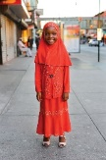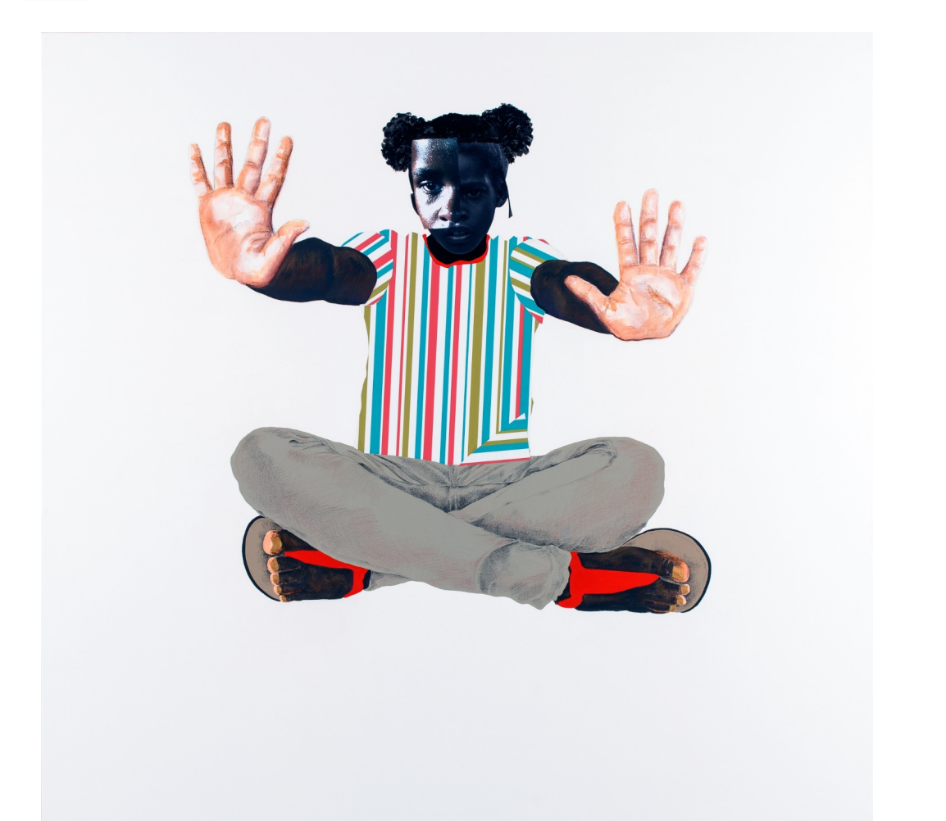  Focus Artists:  Romare Bearden, Deborah Roberts | Art :  Printing, collage, design:  Exploring Pattern  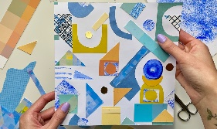  Access Art Unit  Focus Artists:  Rachel Parker, Shaheen Ahmed, Andy Gilmore, Louise Despont | Art :  Drawing and Sculpture :  Canopic Jars  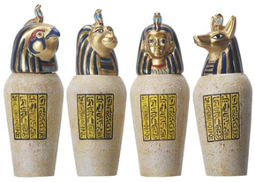  Focus Artist:  Niki de Saint Phalle | Art :  Textiles:  Talking Textiles  (Art/DT project)  Create a textiles piece based on a Greek Myth.  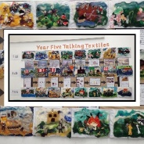  Focus Art:  Art representing Ancient Greece, Jackie Cardie (felt artist)  Forest School Project  Using natural materials to make images  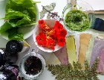 | Art :  Take One Picture
DT:  Electrical Systems:  Make a Light  Kapow Unit | DT:  Digital World:  Mindful Moments  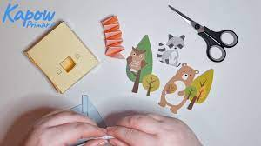  Kapow Unit | DT:  Mechanical Systems:  Make a Shaduf  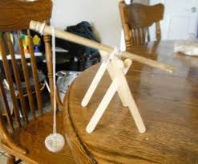  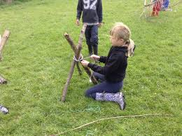  Stand Alone Unit |  | DT:  Textiles:  Talking Textiles  (Art/DT project)  Create a textiles piece based on a Greek Myth. | DT:  Food:  Adapting a Recipe  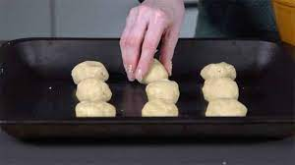  Kapow Unit
Music:  Developing Singing technique – Community Carol Singing  Kapow Unit: Samba and carnival sounds and instruments (Theme: South America)  Instrumental Lessons – Keyboards |  | Music:  Developing Singing technique - Spring concert  Kapow Unit: Changes in pitch, tempo and dynamics (Theme: Rivers)  Instrumental Lessons – Keyboards |  | Music:  Composition project linked to Take One Picture  Kapow Unit: Rock and roll  Instrumental Lessons – Keyboards
Western Classical – Early, Baroque, Renaissance, Classical Era | Western Classical Romantic and up to 1940’s | Western Classical 20th Century Music | 20th and 21st Century Music including Film and Musical Theatre | Popular Music | World Music and Folk Music
Spanish:  Spanish around the world 1 | Spanish:  Greetings 1 | Spanish:  Numbers 1 | Spanish:  The Body Parts | Spanish:  The weather 1 | Spanish:  Horrible Green Monster 1
PSHE:  Identity, society  and equality:  Democracy | PSHE:  Drug, alcohol and  tobacco education:  Making choices | PSHE:  Physical health  and wellbeing:  What is important to  me? | PSHE:  Keeping safe and  managing risk:  Playing safe | PSHE:  Relationships and  health education:  Growing up and  changing | PSHE:  Relationships and  health education:  Growing up and  changing
RE:  What does it mean to be a Christian in Britain today? | RE:  How do people from religious and non-religious  communities celebrate key festivals? | RE:  Why is Jesus inspiring to some people? | RE:  Why is the Bible important for Christians today? | RE:  What can we learn from religions about deciding what is right and wrong?
PE:  Games- Netball  Games-Football | PE:  Games – Tag Rugby  Gymnastics | PE:  Games – Football  Swimming | PE:  Dance  Games - Cricket | PE:  Athletics  Outdoor Adventurous Activity- Orienteering | PE:  Games-Tennis  Forest School  Outdoor Adventurous Activity- Orienteering
Global Citizenship:  Equality and Rights  Power and Governance (4 weeks)  Why do we need rules in society (laws)?  How do people in the UK decide who gets to make the rules?  Project Outcome: School Elections Manifestos  Social Justice and Equity (6 weeks)  How can we create equality?  Should we care about things that are not happening to us?  Why are some people hungry? (Local level-Foodbanks)  What is inequality – food and hunger?  Project Outcome: Social Enterprise – Organise a food bank  Human Rights (5 weeks)  Which of the UN Convention on the Rights of the Child Articles do you think are the most important and Why?  Who is responsible for making sure children’s rights are protected?  Should someone be punished for doing wrong?  What is a suitable punishment?  Project Outcome: UNCRC – Whole School Assembly presentation |  | Global Citizenship:  Respect for Others  Identity and Diversity (8 weeks)  How are we different?  What are the different types of prejudice?  Why do we hold prejudices?  How can we combat prejudice?  Project Outcome: Create a class film celebrating differences and similarities  Peace and Conflict (4 weeks)  How can we manage conflicts effectively?  What affects have conflicts had on our society?  What do we know about conflicts around the world past and present? |  | Global Citizenship:  Ecological Awareness  Sustainable Development (8 weeks)  Starting Point: Whole School Earth Day Celebration  What is climate change? How can we make people aware of the problems?  What is an ecological footprint? Does every person/ country have the same ecological footprint? How can it be reduced?  Globalisation and Interdependence (6 weeks)  What is co-operation?  What are the advantages of co-operation? What are the barriers?  How does a co-operative work?  Project Outcome: Set up a co-operative business – The Fiver Challenge
Global Citizenship Links:  International Day of Democracy  International Day of Peace  Black History Month – celebrating diversity  Dyslexia awareness week | Global Citizenship Links:  Universal Children’s Day  Anti- Bullying Week  Human Rights Day  Remembrance Day  Children in Need  Road Safety Week  World Philosophy Day | Global Citizenship Links:  International Women’s Day  International Mother Language Day  Children’s Mental Health Week | Global Citizenship Links:  Autism Awareness Day  Comic Relief  Fair Trade Fortnight  Mothering Sunday | Global Citizenship Links:  International Mother Earth Day  World Bee Day  Walk to school week  National Children’s Gardening Week | Global Citizenship Links:  BNF Healthy Eating Week  World Environment Day  World Oceans Day  World Refugee Day  Oxfam water week  Recycle Awareness Week  National School Grounds Week
P4C:  Frog and the Stranger – Max Velthuijs: what is a ‘stranger’? what shapes our trust in people? | P4C:  The Silence Seeker – Ben Morley: Joe confuses ‘silence’ with ‘asylum’. Is he a good neighbour? What would you take if you had to leave home? | P4C:  sort factual v philosophical questions on an old object: what is it for? When/why was it made? What makes something ‘valuable’? | P4C:  Seeing the Light (First Stories for Thinking): a king tests his sons to find who is ‘wise’ enough to rule. Is it a fair test? Is the winner ‘wise’? | P4C:  Tadpole’s Promise – Willis/Ross: a tadpole and a caterpillar fall in love and promise never to change… quite a twist to this tale, links to PSHE | P4C:  The Two Painters in Stories for Thinking: what makes a painting ‘good’? Does ‘beauty’ matter?
Emotional Literacy:  Self Awareness  Emotional Literacy Autumn 1 Booklet  Associated Skills  - Identifying emotions  - Accurate self-perception  - Recognising strengths  - Self-confidence  - Self-efficacy  Contents  Introduction: The RULER Anchor Tools – What are emotions, mood meter, class charter, best self.  Lesson 1: How am I feeling? - Motivated  Lesson 2: How am I feeling? – Fear and Anxiety  Lesson 3: How am I feeling? - Worried  Lesson 4: How am I feeling? - Satisfied  Lesson 5: Recognising and celebrating our achievements and reflecting on our strengths and areas to improve  Lesson 6: Self-efficacy and self confidence | Emotional Literacy:  Self Management  Emotional Literacy Autumn 2 Booklet  Associated Skills  - Impulse control  - Stress management  - Self-discipline  - Self-motivation  - Goal setting  - Organisational skills  - Growth Mindset  Contents  Lesson 1: How do you want to feel?  Lesson 2: Moving out of the blue– sadness  Lesson 3: Tool Kit to regulate emotions – sadness  Lesson 4: Dealing with loss and separation  Lesson 5: Growth Mindset – Facing challenges  Lesson 6: Aspiration and Setting Goals | Emotional Literacy:  Social Awareness  Emotional Literacy Spring 1 Booklet  Associated Skills  - Understanding emotions  - Empathy/sympathy  - Appreciating diversity  - Respect for others  Contents  Lesson 1: How do you want to feel? - Revisiting the class charter  Lesson 2: Social Awareness - perspective  Lesson 3: Solving a problem with the blueprint  Lesson 4: Kindness  Lesson 5: Belonging and Community | Emotional Literacy:  Relationship Skills  Emotional Literacy Spring 2 Booklet  Associated Skills  - Communication  - Social engagement  - Relationship building  - Teamwork  Contents  Lesson 1: Key qualities in a friend  Lesson 2: Understanding Anger  Lesson 3: Win win situations in conflicts  Lesson 4: Group work assessing how well it works  Lesson 5: Resisting social pressures | Emotional Literacy:  Responsible Decision Making  Emotional Literacy Summer 1 Booklet  Associated Skills  - Identifying problems  - Analysing solutions  - Solving problems  - Evaluating  - Reflecting  - Ethical responsibility  Contents  Lesson 1: Identifying Problems  Lesson 2: Identifying Solutions - values  Lesson 3: Analysing solutions – pros and cons  Lesson 4: Making a Choice and Taking Action  Lesson 5: Evaluating and Reflecting | Emotional Literacy:  Anti Bullying/ Transition  SEAL – Say No to Bullying  - I can tell you what bullying is.  - I know what it means to be a witness to bullying. I know that witnesses can make the situation better or worse by what they do.  - I know how it might feel to be a witness to and a target of bullying.  - I can tell you why witnesses sometimes join in with bullying or don’t tell.  - I can tell you some ways of helping to make someone who is bullied feel better.  - I know that sometimes bullying is hard to spot and I know what to do if I think it is going on but I am not sure.  I can problem solve a bullying situation with others.
Personal Safety:  - Introduction to the PANTS rule  - Being safe in the classroom/ school environment  - What to do when the fire alarm sounds | Personal Safety:  - Firework safety  - Fire Safety  - Road Safety Be Safe Be Seen  - Drug, alcohol and tobacco education (see PSHE/RES) | Personal Safety:  - Dog Safety  - Stranger Danger  - Review PANTS rule | Personal Safety:  - Staying Safe and Managing Risk at home and out (See PSHE/RSE)  - First Aid (See PSHE/RSE) | Personal Safety:  Road Safety- Green Cross Code  - Who keeps us safe  - Review PANTS rule | Personal Safety:  - Water safety  - Staying Safe in the Sun  - Cycle and Scooter Safety
Enrichment Opportunities:  National Portrait Gallery – Significant People in Black British History  Black Cultural Archives – Windrush Stories | Enrichment Opportunities:  Migration Museum  or  Hackney Museum – Suitcase Stories  Science Museum – It takes Guts  Brick Lane Heritage Walk | Enrichment Opportunities:  TGC- The Ground Beneath our Feet  Petrie Museum | Enrichment Opportunities:  The British Museum- Excavating Egypt  John Wesley Chapel – Easter workshop  3 Discovery Workshop | Enrichment Opportunities:  The Wallace Collection - Classical Myths, Gods, Heroes and Monsters  The British Museum – Question for the People  Adventure Playground | Enrichment Opportunities:  LSO KS2 Concert  National Gallery  Camley Street Natural Park - Habitats
School, Family and Community Events:  International Evening  Class Tea Party  Class led workshop – mental health and wellbeing  Art Exhibition | School, Family and Community Events:  Interfaith Week  Children in Need  Community Carol Concert  Christmas Fair | School, Family and Community Events:  Museum week  Class led workshop – safer internet day  Moreland’s Got Talent | School, Family and Community Events:  Comic Relief  Spring Concert  Science Fair  World Book Day | School, Family and Community Events:  World Earth Day  Learning Outside the Classroom Day  Sports Day  Eid Disco | School, Family and Community Events:  National Field Work week  Summer Picnic

