

SEND Information Report

Moreland Primary School

CONTENTS

Moreland Primary School SEND Information Report 3
Frequently Asked Questions 4
Treehouse Provision 16
Appendix 1 – External Agencies 17

Moreland Primary School SEND Information Report

Moreland Primary School, like all schools in Islington, is committed to meeting the needs of all pupils including those with Special Educational Needs and Disabilities (SEND). Our expectation is that children and young people with SEND will receive an education that enables them to make progress so that they:

- Make good individual progress
- Become confident individuals living fulfilling lives
- Make a successful transition into adulthood, whether into employment, further or higher education or training

About this Information Report
This report answers some of the most frequently asked questions about the school and special educational needs. The format and information in this report has been developed through:
- Consultation with local parents and carers by Islington Council in April 2014
- Ongoing feedback from parents and carers and school staff at Moreland Primary School

We will review and update this information report regularly to reflect changes and feedback. The date for the next annual review of this report is July 2025.
If you need any more information, please see our SEND Policy or contact Dani Fisher on 0207 253 8144.

Frequently Asked Questions

- What kinds of Special Educational Needs and Disabilities (SEND) does the school cater for?

Moreland Primary School is a mainstream primary school and welcomes children and young people across the four main areas:

- Cognition and Learning– for students with specific learning difficulties such as dyslexia, or moderate learning difficulties that affect students in a range of cognitive areas.
- Communication and Interaction – for students who have speech, language and communication needs, a specific language Impairment or a range of communication difficulties.
- Social, Emotional and Mental Health – for students who struggle to engage in the social aspects of school, or who find it hard to cope with challenging emotions. This will range from students needing short-term assistance during a turbulent time in their life, to students with a recognised condition such as ADD or ADHD.
- Physical and / or Sensory - Students whose need is primarily sensory and/or physical have their support overseen by the SENDCO or within the area that most closely matches their need. For example, a student with a hearing impairment may have their support provided for by the Communication and Interaction support team

Children with medical needs - where pupils have medical needs and special educational needs, we will plan and deliver education provision in a co-ordinated way with their healthcare plan. We will also follow the statutory guidance on supporting pupils at school with medical conditions.

- What are the school's policies for the identification and assessment of pupils with special educational needs and disabilities (SEND)?

All Moreland teachers teach children with SEND. All of our staff recognise the importance of identifying SEND early and making effective provision quickly. The identification and assessment of SEND is built into the school’s approach to monitoring the progress of all pupils.

Teachers are supported by the Senior Leadership and Management Teams to regularly assess pupils’ progress. When considering if a child needs SEND support the school takes into account:
- The pupil’s previous progress and attainment
- The teacher’s assessment and experience of the pupil
- The pupil’s development in comparison to their peers and national data
- The views and experience of parents
- The pupil’s own views
- Advice from external support services, where appropriate

Further information is set out in our SEND Policy.

The school uses a range of different assessment tools and systems to help identify and assess pupils with SEND. The tools and assessments gradually draw upon more frequent reviews and more specialist expertise to understanding SEND and match interventions to the SEND of pupils. They are summarised in the diagram below:
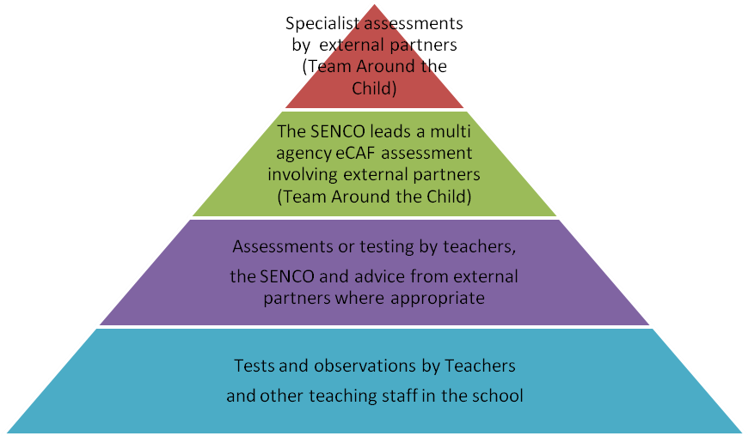
- What are the school’s policies for making provision for pupils with special educational needs and disabilities (SEND), whether or not pupils have Education Health and Care Plans?

Most children with SEND can have their needs met by universal, high quality teaching. This may include teachers adapting what they do and having different approaches to meet different learning styles, personalised learning arrangements for different pupils and a range of interventions normally provided by the school.

If a pupil is identified (through the assessment process above) as having special educational needs or disabilities, their teacher and SENCO will consider what support they need and whether it can be provided by adapting the school’s core offer or whether something different or additional is required.

When a child’s additional needs have been identified, the school’s SEND team will work with families, and sometimes external agencies, to create a plan of support. This will be different for each individual child, but can include the below:

- Provision Mapping: A tracking document of the interventions that are ‘additional to’ or ‘different from’ the universal offer for all children.
- SEND Support Plan: An individualised plan that outlines the strengths and needs a child has and the targets they have in order to make progress created on Edukey.
- Education, Health and Care Plan (EHCP): Where the school has done everything it can to identify, assess and meet the SEND of the child and they are still not making the expected progress, the school or parents may consider requesting an Education, Health and Care assessment. The process for requesting an EHCP assessment in Islington can be found on the Council’s Local Offer website. www.islington.gov.uk/localoffer

Education Health and Care Plans are issued by the Local Authority and are used by the school to plan SEN provision for children with severe and complex needs.

The EHCP includes:
- A detailed profile of the child, their strengths and aspirations for the future
- Any education, health and care needs they have
- The goals or outcomes for the pupil agreed by the family and professionals for the next phase of their education
- Any education, health and social care provision in place to meet their needs

- How does the school evaluate the effectiveness of its provision for SEND?

The quality of teaching is the most important factor in ensuring all pupils make progress. We regularly review the quality of teaching in the school and ensure that teachers are able to identify how individual children learn best and what support they need.

We test the effectiveness of our SEND provision by checking pupil progress and to see if the agreed goals and outcomes for a pupil are being met. Where professionals from health or children’s social care are involved with the child, we will ask for their help to inform and review progress, to make sure that all those supporting the family are working together effectively.

The SENCOs and the head teacher report regularly to Governors on the quality of
SEND provision and the progress towards outcomes being made by pupils with SEND. Governors also consider the attainment data for pupils with SEND and compare it with the progress of other pupils and the progress of pupils in similar schools. This helps to ensure that the approaches used to meet SEND are based on the best possible evidence and are having the required impact on progress.

- What are the school’s arrangements for assessing and reviewing the progress of pupils with SEND?

Every pupil in the school has their progress reviewed regularly and this information will be shared with both parents and pupils. We provide an annual report to parents on their child’s progress, normally at the end of the school year.

Where a pupil is receiving SEND support, we do our best to provide feedback to parents more regularly. We sometimes use home school books to give daily feedback on how a child has been at school that day. We also contact parents by phone or email where we have specific feedback or need to discuss specific achievements, concerns or observations. We also have a parents meeting three times each year including an annual review which all children with EHCPs are entitled to once a year.
Annual reviews are usually led by the SENDCO alongside a member of staff who has a good knowledge and understanding of the pupil’s needs and attainment. Reviews normally last between 45 minutes and 1 hour, although this can vary depending on the progress, if the child’s needs have changed or the review involves a range of different professionals. We always aim to allow sufficient time to plan effectively.
Annual reviews involve the pupil, the family and other professionals where this is appropriate. They are used to:
- Discuss what is working well and not working well
- Find out if the SEND provision has been delivered as planned
- Review the pupil’s progress towards their goals and longer term outcomes
- Discuss and agree clear outcomes for the future
- Discuss and agree the support needed
- Share advice and information on the things that parents can do at home to reinforce or contribute to their child’s progress
- Identify the actions needed to meet the agreed outcomes, the responsibilities of the parent, the pupil, the school, the local authority and other partners.
- A record of the outcomes, action and support agreed through the discussion is then shared with all the appropriate school staff and the pupil’s parents. The annual review form that we use for SEND support and EHCP can be found on our website.

- What is the school’s approach to teaching pupils with SEND?

All pupils, including those with SEND, have access to a broad and balanced curriculum. Teachers plan lessons carefully and think about the wide range of different needs in their class and use the information from assessments and progress reviews to set targets which are deliberately ambitious to encourage pupils to aim high. Teachers plan their lessons with the SEND of pupils in mind, which means that most pupils with SEND will be able to study the full national curriculum along with their peers.

The type of SEND support provided is based on reliable evidence of what works. We are careful to avoid the over reliance of individual support for pupils as evidence shows that in many cases this prevents them becoming independent learners.

The SENCO, supported by the Senior Leadership Team, ensures that staff have sufficient skills and knowledge to deliver the interventions that pupils need.

- How does the school adapt the curriculum and learning environment for pupils with SEND?

We are committed to meeting the needs of all pupils including those with SEND. We have a duty not to directly or indirectly discriminate against, harass or victimise disabled children and young people. We make all reasonable adaptations to the curriculum and the learning environment to make sure that pupils with SEND are not at a substantial disadvantage compared with their peers.

We work closely with families and partners to work out what disabled children and young people might need before they start with us, and what adjustments we might need to be make. We discuss with families what we can do to adapt the curriculum and/or the building as necessary, and in order to get additional resources and support. Teachers will be supported by the SENCO to assess, plan and scaffold the curriculum or make adaptations to meet the needs of pupils with SEND. This may also involve working with outside partners.

When considering which adaptations might need to be made, the SENDCO will work with the Head Teacher and school governors to ensure that the school meets its responsibilities under the Equality Act (2010) with regard to reasonable adjustments and access arrangements. A link to the Equality Act 2010 can be found here: http://www.legislation.gov.uk/ukpga/2010/15/contents

- What additional support for learning is available to pupils with SEND?

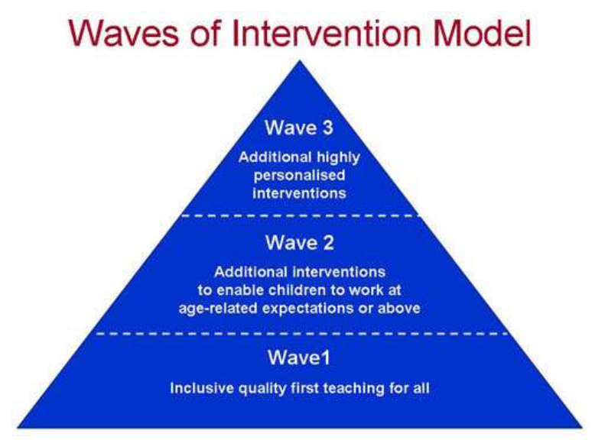
The school organises the additional support for learning into 3 different levels (also called waves).

We provide additional support for pupils with SEND to be able to access exams, when needed.

We are able to support the administration of medication if it is recommended by health professionals. See our Managing Medical Conditions in Schools Policy.

- What extra-curricular activities are available for pupils with SEND?

The school has a wide range of extra-curricular activities available including:

- A breakfast club each morning between 8am – 9am
- Lunchtime clubs/activities
- After school clubs including sports, arts and music activities

We try to make sure that all pupils with SEND can engage in these activities alongside pupils who do not have SEND. Where it is agreed that taking part in these activities will contribute significantly to meeting the agreed outcomes for a pupil with SEND, the school will normally be able to pay for any training, resources or equipment that may be needed. Where a child is struggling with a full day at school, the Head of School and SENDCO will use discretion around whether or not attending out of hours activities are in the child’s best interests.

The school also provides opportunities for pupils to go on school trips and we organise an annual residential trip for years 5 and 6. We will involve parents of pupils with SEND in the planning of school trips and the residential in order to assess the benefits, risks and identify how the needs of individual pupils can be best met.

- What support is available for improving the emotional and social development of pupils with SEND?

The culture and structures within the school aim to encourage the emotional and social development for all pupils, including those with SEND.

We work hard to create a culture within the school that values all pupils, allows them to feel a sense of belonging and makes it possible to talk about problems in a non-stigmatising way. We have clear policies on behaviour and bullying that set out the responsibilities of everyone in the school. We have clear systems and processes so that staff can identify and respond to mental health difficulties.

For children with more complex problems, additional in-school interventions may include:

- Advice and support to the pupil’s teacher - to help them manage the pupil’s behaviour within the classroom, taking into account the needs of the whole class
- Small group sessions - to promote positive behaviour, social development and self-esteem
- learning mentor – the learning mentor can support groups of children and individual children to work through specific issues
- Individual action plans - to support pupils during transition periods, break times
- additional support for the pupil – to help them cope better within the classroom
- Therapeutic work with the pupil, delivered by specialists (within or beyond the school), which might take the form of cognitive behavioural therapy, behaviour modification or counselling approaches, family support and/or therapy by health professionals – to help the child and their family better understand and manage behaviour.

For further information, please see our behaviour management policy.

- Who is the SENDCO and how do I contact them?

Our Special Education Needs and Disabilities Co-ordinators (SENDCOs) are both qualified teacher working at the school who have responsibility for SEND. They work closely with the Head Teacher and governing body as well as all teachers. If you have concerns about your child, you should speak to your child’s teacher before you speak to the SENDCO.

The SENDCOs are responsible for:
- Overseeing the day-to-day operation of the school's SEND policy
- Coordinating provision for children with special educational needs and disabilities
- Liaising with and advising fellow teachers
- Overcoming barriers to learning and sustaining effective teaching
- Managing teaching assistants
- Overseeing the records of all children with SEN and Disability
- Liaising with parents of children with SEND
- Planning successful movement (transition) to a new class group or school
- Providing specialist advice and facilitating training to ensure that all staff are skilled and confident about meeting a range of needs
- Liaising with external agencies including the LA’s support and educational psychology services, health and social services, and voluntary bodies

The SENCOs are both on site 5 days a week. You can request a meeting with the SENCO by phone 0207 253 8144 or via senadmin@moreland.islington.sch.uk

Dani Fisher – Assistant Head Inclusion and Special Educational Needs Coordinator

Hannah Watson (– Special Educational Needs Coordinator

- What expertise and training do the school staff have in relation to SEND and how will specialist expertise be secured?

At Moreland Primary we believe that your child’s learning needs will first be met through the high-quality teaching delivered by his/her class teacher.

Regular professional development ensures that staff are fully aware of how to cater for a range of Special Educational Needs.

The SENDCO is in regular communication with teaching staff to make sure that everyone is aware of what Special Educational Needs there are within the school, and how to effectively support those needs in the classroom.

The school is able to access training programmes from different organisations, including training via Islington and Outreach Teams for The Bridge, Samuel Rhodes and Richard Cloudesley. Individual training can also be arranged, when necessary.

The SENDCO holds the National Award for SENDCOs (Postgraduate Certificate), and uses the skills
gained on this qualification to support teachers in their practice.

- What equipment and facilities are available to support pupils with SEND?

Moreland is a large school set over three floors. The Children’s Centre, Early Years and Year 1 classes are at pavement level with 4 playgrounds that are mostly all at the same level or with sloped access. The corridors are wide enough for wheelchair or walker use and there is a lift for use by pupils who use a wheelchair only. There are two long flights of stairs to access each floor in the main school building and two flights of stairs in the children’s centre to the first floor. The school has more than one wheelchair accessible toilet.
Equipment available in our school to all children at any time needed:

- Music/microphone system available to enhance hearing in main hall
- Communication books (for home and school)
- Sensory equipment and specialist sensory room
- Devices for additional recording e.g. Cameras, video recorders, voice recorders
- SEND software - Communication in Print to produce printed matter with visual prompts, specific maths and literacy computer iPads
- Sloped writing boards

The school will consider purchasing other equipment if there is an agreed identified need. We will normally consider this at the pupil’s termly or annual review for children with education, health and care plans. In the past we have worked with partners to purchase specialist equipment tailored for an individual including:

- Personal laptops / iPads
- Power assisted wheelchairs
- Hoists
- Changing bays
- Rota stands
- Move and sit cushion
- Specialist hand writing equipment
- Specialist cutlery

- What are the arrangements for consulting and involving parents of children with SEND in their child’s education?
All parents are encouraged to contribute to their child’s education through:
- Discussions with the class teacher
- Setting and reviewing targets
- Parents evenings
- During discussions with school SENDCOs
- Commenting and contributing to assessment, planning and reviews

If your child has an Education, Health and Care plan we will discuss their progress with you every term and have a formal review with you about your child annually.

Further information about reviews can be found in question 3b above. Specific support to help you support your child at home will include:

- Meetings with teachers and SEND staff to discuss progress and support including ideas for home.
- Meetings with professionals from outside agencies to discuss progress and support including ideas for home.

If we think your child needs significant amounts of extra support we will always discuss this with you and, where appropriate, a meeting with the parents and the people supporting your child can be arranged.
Where required we will arrange interpreters to enable parents to fully participate in formal meetings.

- What the arrangements for consulting and involving pupils with SEND in their education?

Engaging all pupils as active participants in their own education and in making a positive contribution to their school and local community is a priority for the school. All children are consulted about their learning through written and verbal feedback on a daily basis. All children are expected to be key participants in the assessment and feedback process. The children have ‘conferencing’ meetings with their teacher termly to discuss their writing and targets are agreed at these meetings. All children have maths and reading targets and know what they are working towards. These targets are reviewed and updated regularly. Children with SEND may also have additional individual targets to work on to help them with a specific issue.
Where pupils have SEND, we will take extra care to involve them and make sure their voice is heard. Their involvement will be tailored and take into account their preferred methods of communication. This may include:
- Providing them with relevant information in accessible formats
- Using clear ordinary language and images rather than professional jargon
- Dedicating time in discussions and meetings to hear their views
- Involving the pupil in all or part of the discussion itself, or gathering their views as part of the preparation
- Supporting their access to an adult who can help them express their views where necessary (this could be a family member or a professional)
- Ensuring staff are skilled in working with children, parents and young people to help them make informed decisions and have access to training so they can do this effectively

We ensure that pupils with SEND are included and represented in the groups and activities that we have set up to listen to the views of pupils and involve them in decision-making. These groups and activities include:
- The School Council
- The Eco Team

The views of the individual child and young person sit at the heart of the SEND assessment and planning process. We will make sure that assessments include the wishes and feelings of the child, their aspirations, the outcomes they wish to seek and the support they need to achieve them. This may include the use of questionnaires, story boards or symbols etc. All pupils with SEND will have specific goals and outcomes and they will be part of the discussion to agree and review these. Where a personal budget is being used for those with an EHCP, the school will support the child’s involvement in decisions about their support.

- How does the school involve others in meeting the needs of pupils with SEND and in supporting the families of such pupils?

Where a pupil continues to make less than expected progress, despite evidence-based support and interventions that are matched to the pupil’s area of need, we seek advice and support from specialists from outside agencies. We always involve parents in any decision to involve specialists. The SENDCO is the person who usually coordinates the contact and works with these outside agencies. We mainly use other agencies outside of the school to:
- Deliver training to staff
- Ascertain specialist advice
- Carry out assessments
- Supporting reviews

The main agencies used by the school are shown in Appendix 1.

- What local support is there for the parents of pupils with SEND?

All Local authorities must publish a Local Offer, setting out in one place information about provision they expect to be available across education, health and social care for children and young people in their area who have SEND or are disabled.
The Local Offer has two key purposes:
- To provide clear, comprehensive and accessible information about the available provision and how to access it
- To make provision more responsive to local needs and aspirations by directly involving disabled children and those with SEND and their parents, and disabled young people and those with SEND, and service providers in its development and review

The school cooperates with the Local Authorities in the local area to:
- Make families aware of the kind of support available to them and where to find the Local Offer
- Help people access the Local Offer information, especially where there are barriers to them accessing it. This can include helping them to access the internet, printing off pages, interpreting and explaining
- Consult children and young people and their families directly in preparing and reviewing the Local Offer
- Keeping the Local Offer information up to date and identifying gaps in provision

To find out more about the range of services on offer locally go to: Islington Local Offer: www.islington.gov.uk/localoffer

The Family Information Service - 020 7527 5959
Gives free impartial information, advice and guidance about services for children, young people and families.
Email: fis@islington.gov.uk
Website: www.islington.gov.uk/fis

The Parent Carer Support Service, based at Centre 404 - 020 7697 1336
Offers a range of services to assist the parents/carers of children with SEND. These include: help with resolving disagreements; information and advice; direct support; help with personal budgets and form filling; and access to social groups and other activities and local networks.
Website: http://www.centre404.org.uk

- What are the school’s arrangements for supporting pupils with SEND when they join the school, and supporting them to move to secondary school / further education, training or employment/ adulthood and independent living?
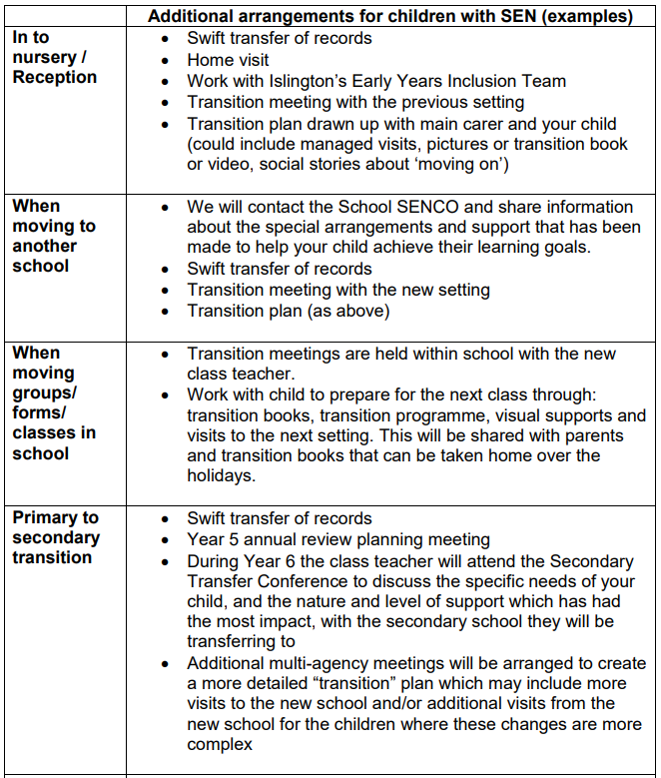

Treehouse Provision

What is Treehouse at Moreland?
Treehouse is a flexible provision for children with additional needs who present with significant speech and language, social/emotional, cognitive and/or physical/sensory needs. Within the Treehouse there is a higher ratio of adults than in mainstream and individualised plans to ensure each child makes their own progress.

Rationale
The purpose of Treehouse is to enable pupils with additional needs, who require significant adaptations to the curriculum, to make progress alongside their mainstream peers with a more individualised approach. This is with the aim to reintegrate them, as much as possible, into the mainstream classroom.

Criteria for Treehouse
- Child has is or on the pathway for an EHCP
- Is awaiting a space in a specialist provision through the local authority
- Has significantly delayed language or challenging behaviour which prevents their development in the mainstream classroom

Appendix 1 – External Agencies


