
DT Curriculum Overview and Progression Map
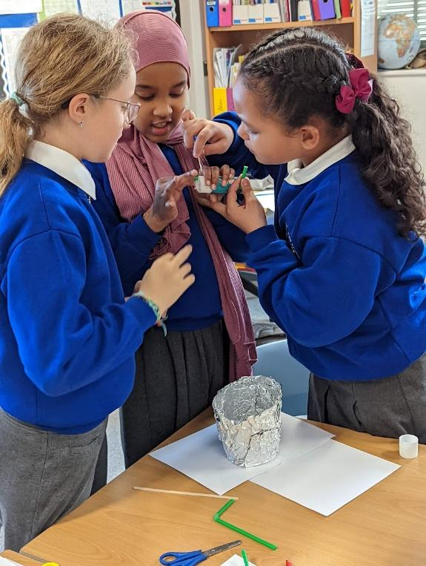

EYFS ELG’s
Expressive Arts and Design: Creating with Materials ELG
Children at the expected level of development will:
• Safely use and explore a variety of materials, tools and techniques, experimenting with colour, design, texture, form, and function;
• Share their creations, explaining the process they have used;
EYFS
Developing, planning and communicating ideas |  | Working with tools, equipment, materials and components to make quality products |  | Evaluating processes and products
- Can they make observations about the features of objects?  - Can they use their senses to explore and describe objects?  - Can they think of some ideas of their own?  - Can they plan how best to approach a task |  | - Can they explain what they are making?  - Can they select appropriate resources and tools?  - Can they explain which tools are they using and why?  - Can they use tools safely?  - Can they use tools to manipulate materials? |  | - Can they identify success and next steps?  - Can they change their strategy as needed?
Growing | Cooking |  | Nutrition |  | Enjoying Food
- Do they understand the life cycle of plants and animals?  - Do they understand that all food comes from plants or animals?  - Can they describe how food makes the journey from farm to fork?  - Do they understand what plants need to grow | - Are they aware that ingredients are available from a range of sources (shops, markets, grown at home)?  - Can they select and use appropriate tools needed for a recipe?  - Can they use tools effectively and safely?  - Can they identify and use the appropriate ingredients for a recipe?  - Can they complete basic hygiene tasks? (e.g. wash hands) |  | - Do they understand that food is a basic requirement of life?  - Do they understand that we need food to grow, be active and maintain health?  - Can they sort a selection of foods into healthy and unhealthy groups?  - Can they identify and talk about a range of fruits and vegetables? |  | - Can they talk about foods they like and dislike with reasons?  - Can they discuss the food that they eat during special occasions or cultural celebrations? (e.g. birthday, Eid, etc.)  - Are they willing to try new foods?
See EYFS Medium Term Plans for detail on teaching and learning activities provided

 | Autumn 1 | Autumn 2 |  | Spring 1 | Spring 2 |  | Summer 1 | Summer 2
EYFS
EYFS DT  Cycle 1  and 2 | Ongoing skills development  Focus on:  Choosing resources  Cutting and joining skills  Including – junk modelling, sewing, woodwork, construction and block play  Cooking and Nutrition  Seasonal foods (soups, stew, autumn fruit desserts)  Celebration foods – ( food from different cultures, making food for celebrations – Harvest festival, international evening, Diwali, Christmas fair)  Food linked to stories – gingerbread, bread  Growing  Harvesting and planting |  | Ongoing skills development  Focus on:  Designing, planning and making  Using a wider range of tools  Including – junk modelling, sewing, woodwork, construction and block play  Cooking and Nutrition  Recognising healthy and unhealthy foods (cooking healthy recipes/ change for life recipes – e.g. healthy muffins, pizzas)  Family kitchen club – enjoying cooking together  Growing  Spring planting  Understanding life cycles of animals and where food comes from – farm visit, caring for the chickens, hatching eggs – farm to fork |  |  | Ongoing skills development  Focus on:  Evaluating and presenting  Using a wider range of materials and selecting the best material for the task  Including – junk modelling, sewing, woodwork, construction and block play  Cooking and Nutrition  Designing their own simple dishes (e.g. sandwiches, salads, fruit salad, healthy fruit smoothies/ lollies)  Talking about likes and dislikes  Growing  Harvesting summer crops  Exploring life cycles of plants – sunflowers, beans  Caring for the garden and understanding what plants need to grow

Key Stage 1 National Curriculum
Through a variety of creative and practical activities, pupils should be taught the knowledge, understanding and skills needed to engage in an iterative process of designing and making. They should work in a range of relevant contexts [for example, the home and school, gardens and playgrounds, the local community, industry and the wider environment].
When designing and making, pupils should be taught to:
Design
- design purposeful, functional, appealing products for themselves and other users based on design criteria
- generate, develop, model and communicate their ideas through talking, drawing, templates, mock-ups and, where appropriate, information and communication technology
Make
- select from and use a range of tools and equipment to perform practical tasks [for example, cutting, shaping, joining and finishing]
- select from and use a wide range of materials and components, including construction materials, textiles and ingredients, according to their characteristics
Evaluate
- explore and evaluate a range of existing products
- evaluate their ideas and products against design criteria
Technical knowledge
- build structures, exploring how they can be made stronger, stiffer and more stable
- explore and use mechanisms [for example, levers, sliders, wheels and axles] in their products
Cooking and Nutrition
- use the basic principles of a healthy and varied diet to prepare dishes
- understand where food comes from

Year 1
Designing |  |  |  | Making
Understanding contexts, users and purposes |  | Generating, developing, modelling and communicating ideas |  | Planning |  | Practical skills and techniques
- work confidently within a range of contexts, such as imaginary, story-based, home, school, gardens, playgrounds, local community, industry and the wider environment  - state what products they are designing and making  - say whether their products are for themselves or other users  - describe what their products are for  - say how their products will work  - say how they will make their products suitable for their intended users  - use simple design criteria to help develop their ideas |  | - generate ideas by drawing on their own experiences  - use knowledge of existing products to help come up with ideas  - develop and communicate ideas by talking and drawing  - model ideas by exploring materials, components and construction kits and by making templates and mock ups  - use information and communication technology, where appropriate, to develop and communicate their ideas |  | - plan by suggesting what to do next  - select from a range of tools and equipment, explaining their choices  - select from a range of materials and components according to their characteristics |  | - follow procedures for safety and hygiene  - use a range of materials and components, including construction materials and kits, textiles, food ingredients and mechanical components  - measure, mark out, cut and shape materials and components  - assemble, join and combine materials and components  - use finishing techniques, including those from art and design
Evaluating |  |  |  | Technical Knowledge |  | Cooking and Nutrition
Own ideas and products |  | Existing products |  | Making products work |  | Where food comes from  Food preparation, cooking and nutrition
- talk about their design ideas and what they are making  - make simple judgements about their products and ideas against design criteria  - suggest how their products could be improved |  | - what products are  - who products are for  - what products are for  - how products work  - how products are used  - where products might be used  - what materials products are made from  - what they like and dislike about products |  | - about the simple working characteristics of materials and components  - about the movement of simple mechanisms such as levers, sliders, wheels and axles  - how freestanding structures can be made stronger, stiffer and more stable  - that a 3-D textiles product can be assembled from two identical fabric shapes  - that food ingredients should be combined according to their sensory characteristics  - the correct technical vocabulary for the projects they are undertaking |  | - that all food comes from plants or animals  - that food has to be farmed, grown elsewhere (e.g. home) or caught  - how to name and sort foods into the five groups in The Eat well plate  - that everyone should eat at least five portions of fruit and vegetables every day  - how to prepare simple dishes safely and hygienically, without using a heat source  - how to use techniques such as cutting, peeling and grating
Unit Overview
Autumn 1 | Autumn 2 |  | Spring 1 | Spring 2 | Summer 1 |  | Summer 2
Textiles  Puppets  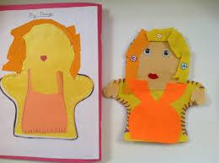  Kapow unit | Mechanisms  Wheels and Axles  Vehicles  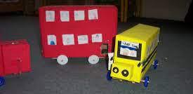  Kapow un |  | Structures  Georgian Dolls House  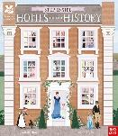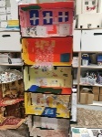  Stand alone unit |  | Structures  Woodwork – bird houses/bug hotels  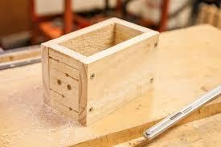 |  | Cooking and Nutrition  Fruit and Vegetables - smoothies  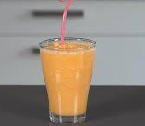  Kapow unit
Judith Hope- Puppet maker | Helen Davcock  Bentley’s Head of Laboratory  La Shirl Turner, Design Chief (Advance Color & Trim) at Fiat Chrysler Autos |  | William Kent Georgian architect  Emma Waddell – Dolls House Grand Designs owner |  | Mamo Architects / Andreu Carulla/ Paul Clark – Designers of bird houses |  | Richard Reed, Adam Balon and Jon Wright  Founders of Innocent Smoothies

Year 2
Designing |  |  |  | Making
Understanding contexts, users and purposes |  | Generating, developing, modelling and communicating ideas |  | Planning |  | Practical skills and techniques
- work confidently within a range of contexts, such as imaginary, story-based, home, school, gardens, playgrounds, local community, industry and the wider environment  - state what products they are designing and making  - say whether their products are for themselves or other users  - describe what their products are for  - say how their products will work  - say how they will make their products suitable for their intended users  - use simple design criteria to help develop their ideas |  | - generate ideas by drawing on their own experiences  - use knowledge of existing products to help come up with ideas  - develop and communicate ideas by talking and drawing  - model ideas by exploring materials, components and construction kits and by making templates and mock ups  - use information and communication technology, where appropriate, to develop and communicate their ideas |  | - plan by suggesting what to do next  - select from a range of tools and equipment, explaining their choices  - select from a range of materials and components according to their characteristics |  | - follow procedures for safety and hygiene  - use a range of materials and components, including construction materials and kits, textiles, food ingredients and mechanical components  - measure, mark out, cut and shape materials and components  - assemble, join and combine materials and components  - use finishing techniques, including those from art and design
Evaluating |  |  |  | Technical Knowledge |  | Cooking and Nutrition
Own ideas and products |  | Existing products |  | Making products work |  | Where food comes from  Food preparation, cooking and nutrition
- talk about their design ideas and what they are making  - make simple judgements about their products and ideas against design criteria  - suggest how their products could be improved |  | - what products are  - who products are for  - what products are for  - how products work  - how products are used  - where products might be used  - what materials products are made from  - what they like and dislike about products |  | - about the simple working characteristics of materials and components  - about the movement of simple mechanisms such as levers, sliders, wheels and axles  - how freestanding structures can be made stronger, stiffer and more stable  - that a 3-D textiles product can be assembled from two identical fabric shapes  - that food ingredients should be combined according to their sensory characteristics  - the correct technical vocabulary for the projects they are undertaking |  | - that all food comes from plants or animals  - that food has to be farmed, grown elsewhere (e.g. home) or caught  - how to name and sort foods into the five groups in The Eat well plate  - that everyone should eat at least five portions of fruit and vegetables every day  - how to prepare simple dishes safely and hygienically, without using a heat source  - how to use techniques such as cutting, peeling and grating
Unit Overview
Autumn 1 | Autumn 2 |  | Spring 1 | Spring 2 | Summer 1 |  | Summer 2
Mechanisms  Sliders and Levers  Great Fire of London Animation  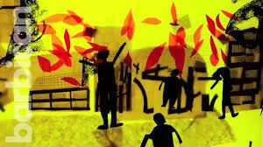  Adapted kapow unit for GFOL animation |  |  | 3D Structures  Castles  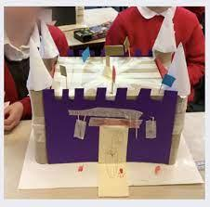  Kapow unit | Make packaging for British Bake Off  (DT/Art project)  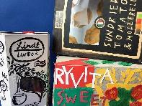  Access Art  Food: Great British Bake Off | Textiles  Making a pouch  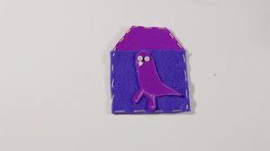  Kapow unit |  | Cooking and Nutrition  A Balanced Diet – Wrap  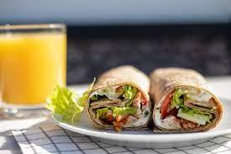  Kapow unit
Jan Pienkowski author and illustrator  Lauren Child |  |  | Gundulf (1024-1108) – Norman Romanesque Builder and Architect | Jones Knowles Richie – Brand and Packaging Designs  Ruben Rausing and Erik Wallenburg – inventors of the Tetra Pak | Alev Ozturk bag designer |  | Keith Cox and Matthew Blair  Founders of World Wrapps

National Curriculum Key Stage 2
Through a variety of creative and practical activities, pupils should be taught the knowledge, understanding and skills needed to engage in an iterative process of designing and making. They should work in a range of relevant contexts [for example, the home, school, leisure, culture, enterprise, industry and the wider environment].
When designing and making, pupils should be taught to:
Design
- use research and develop design criteria to inform the design of innovative, functional, appealing products that are fit for purpose, aimed at particular individuals or groups
- generate, develop, model and communicate their ideas through discussion, annotated sketches, cross-sectional and exploded diagrams, prototypes, pattern pieces and computer-aided design
Make
- select from and use a wider range of tools and equipment to perform practical tasks [for example, cutting, shaping, joining and finishing], accurately
- select from and use a wider range of materials and components, including construction materials, textiles and ingredients, according to their functional properties and aesthetic qualities
Evaluate
- investigate and analyse a range of existing products
- evaluate their ideas and products against their own design criteria and consider the views of others to improve their work
- understand how key events and individuals in design and technology have helped shape the world
Technical knowledge
- apply their understanding of how to strengthen, stiffen and reinforce more complex structures
- understand and use mechanical systems in their products [for example, gears, pulleys, cams, levers and linkages]
- understand and use electrical systems in their products [for example, series circuits incorporating switches, bulbs, buzzers and motors]
- apply their understanding of computing to program, monitor and control their products
Cooking and Nutrition
- understand and apply the principles of a healthy and varied diet
- prepare and cook a variety of predominantly savoury dishes using a range of cooking techniques
- understand seasonality, and know where and how a variety of ingredients are grown, reared, caught and processed

Year 3
Designing |  |  |  | Making
Understanding contexts, users and purposes |  | Generating, developing, modelling and communicating ideas |  | Planning |  | Practical skills and techniques
- work confidently within a range of contexts, such as the home, school, leisure, culture, enterprise, industry and the wider environment  - describe the purpose of their products  - indicate the design features of their products that will appeal to intended users  - explain how particular parts of their products work  - gather information about the needs and wants of particular individuals and groups  - develop their own design criteria and use these to inform their ideas |  | - share and clarify ideas through discussion  - model their ideas using prototypes and pattern pieces  - share and clarify ideas through discussion  - model their ideas using prototypes and pattern pieces  - use annotated sketches, cross-sectional drawings and exploded diagrams to develop and communicate their ideas  - use computer-aided design to develop and communicate their ideas  - generate realistic ideas, focusing on the needs of the user  - make design decisions that take account of the availability of resources |  | - select tools and equipment suitable for the task  - explain their choice of tools and equipment in relation to the skills and techniques they will be  - using  - select materials and components suitable for the task  - explain their choice of materials and components according to functional properties and aesthetic qualities  - order the main stages of making |  | - follow procedures for safety and hygiene  - use a wider range of materials and components than KS1, including construction materials and kits, textiles, food ingredients, mechanical components and electrical components  - measure, mark out, cut and shape materials and components with some accuracy  - assemble, join and combine materials and components with some accuracy  - apply a range of finishing techniques, including those from art and design, with some accuracy
Evaluating |  |  |  | Technical Knowledge |  | Cooking and Nutrition
Own ideas and products |  | Existing products |  | Making products work |  | Where food comes from  Food preparation, cooking and nutrition
- identify the strengths and areas for development in their ideas and products  - consider the views of others, including intended users, to improve their work  - refer to their design criteria as they design and make  - use their design criteria to evaluate their completed products |  | - how well products have been designed  - how well products have been made  - why materials have been chosen  - what methods of construction have been used  - how well products work  - how well products achieve their purposes  - how well products meet user needs and wants  - who designed and made the products  - where products were designed and made  - when products were designed and made  - whether products can be recycled or reused |  | - how to use learning from science to help design and make products that work  - how to use learning from mathematics to help design and make products that work  - that materials have both functional properties and aesthetic qualities  - that materials can be combined and mixed to create more useful characteristics  - that mechanical and electrical systems have an input, process and output  - the correct technical vocabulary for the projects they are undertaking  - how mechanical systems such as levers and linkages or pneumatic systems create movement  - how simple electrical circuits and components can be used to create functional products  - how to program a computer to control their products  - how to make strong, stiff shell structures  - that a single fabric shape can be used to make a 3D textiles product  - that food ingredients can be fresh, pre-cooked and processed |  | - how to prepare and cook a variety of predominantly savoury dishes safely and hygienically including, where appropriate, the use of a heat source  - how to use a range of techniques such as peeling, chopping, slicing, grating, mixing, spreading, kneading and baking  - that a healthy diet is made up from a variety and balance of different food and drink, as depicted in The eat well plate  - that to be active and healthy, food and drink are needed to provide energy for the body
Unit Overview
Autumn 1 | Autumn 2 |  | Spring 1 | Spring 2 | Summer 1 |  | Summer 2
Mechanical Systems  Pneumatic Toys  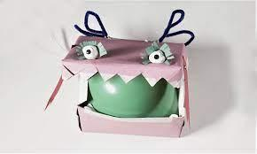  Kapow Unit |  |  | Structures  Design an earthquake proof building  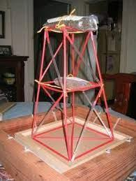 | Textiles  Fastenings  Phone Case  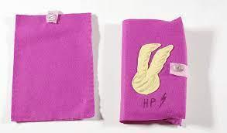  Kapow Unit | Digital World  Electronic Charm  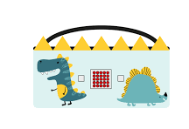  Kapow Unit |  | Cooking and Nutrition  Seasonal Foods  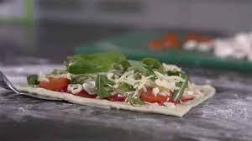  Kapow Unit
Arvind Gupta – Toy maker |  |  | Adam Smith - Burj Khalifa, Dubai  C.Y Lee & Partners - Taipei 101-Taiwan  William Pereira - Transamerica Pyramid, USA | YKK - Fastenings designer  George De Mestral – inventor of velcro | Akihiro Yokoi of WiZ and Aki Maita of Banda  Creator of Tamagotchi |  | Clare Gray  Dietician Mindful Chef
Country Trust Food discovery project runs all year in Y3

Year 4
Designing |  |  |  | Making
Understanding contexts, users and purposes |  | Generating, developing, modelling and communicating ideas |  | Planning |  | Practical skills and techniques
- work confidently within a range of contexts, such as the home, school, leisure, culture, enterprise, industry and the wider environment  - describe the purpose of their products  - indicate the design features of their products that will appeal to intended users  - explain how particular parts of their products work  - gather information about the needs and wants of particular individuals and groups  - develop their own design criteria and use these to inform their ideas |  | - share and clarify ideas through discussion  - model their ideas using prototypes and pattern pieces  - share and clarify ideas through discussion  - model their ideas using prototypes and pattern pieces  - use annotated sketches, cross-sectional drawings and exploded diagrams to develop and communicate their ideas  - use computer-aided design to develop and communicate their ideas  - generate realistic ideas, focusing on the needs of the user  - make design decisions that take account of the availability of resources |  | - select tools and equipment suitable for the task  - explain their choice of tools and equipment in relation to the skills and techniques they will be  - using  - select materials and components suitable for the task  - explain their choice of materials and components according to functional properties and aesthetic qualities  - order the main stages of making |  | - follow procedures for safety and hygiene  - use a wider range of materials and components than KS1, including construction materials and kits, textiles, food ingredients, mechanical components and electrical components  - measure, mark out, cut and shape materials and components with some accuracy  - assemble, join and combine materials and components with some accuracy  - apply a range of finishing techniques, including those from art and design, with some accuracy
Evaluating |  |  |  | Technical Knowledge |  | Cooking and Nutrition
Own ideas and products |  | Existing products |  | Making products work |  | Where food comes from  Food preparation, cooking and nutrition
- identify the strengths and areas for development in their ideas and products  - consider the views of others, including intended users, to improve their work  - refer to their design criteria as they design and make  - use their design criteria to evaluate their completed products |  | - how well products have been designed  - how well products have been made  - why materials have been chosen  - what methods of construction have been used  - how well products work  - how well products achieve their purposes  - how well products meet user needs and wants  - who designed and made the products  - where products were designed and made  - when products were designed and made  - whether products can be recycled or reused |  | - how to use learning from science to help design and make products that work  - how to use learning from mathematics to help design and make products that work  - that materials have both functional properties and aesthetic qualities  - that materials can be combined and mixed to create more useful characteristics  - that mechanical and electrical systems have an input, process and output  - the correct technical vocabulary for the projects they are undertaking  - how mechanical systems such as levers and linkages or pneumatic systems create movement  - how simple electrical circuits and components can be used to create functional products  - how to program a computer to control their products  - how to make strong, stiff shell structures  - that a single fabric shape can be used to make a 3D textiles product  - that food ingredients can be fresh, pre-cooked and processed |  | - how to prepare and cook a variety of predominantly savoury dishes safely and hygienically including, where appropriate, the use of a heat source  - how to use a range of techniques such as peeling, chopping, slicing, grating, mixing, spreading, kneading and baking  - that a healthy diet is made up from a variety and balance of different food and drink, as depicted in The eat well plate  - that to be active and healthy, food and drink are needed to provide energy for the body
Unit Overview
Autumn 1 | Autumn 2 |  | Spring 1 | Spring 2 | Summer 1 |  | Summer 2
Electrical Systems  Make a Light  Kapow Unit | Digital World  Mindful Moments  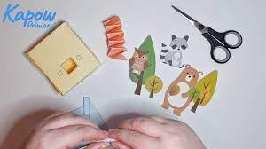  Kapow Unit |  | Mechanical Systems  Make a Shaduf  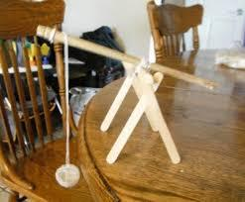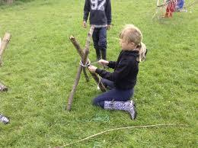 |  | Textiles  Talking Textiles  (Art/DT project)  Create a textiles piece based on a Greek Myth |  | Cooking and Nutrition  Adapting a Recipe  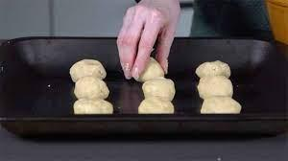  Kapow Unit
David Misell inventor of the torch | Christopher and Nicho Plowman – co founders Insight Timer |  | Ancient Egyptians |  |  |  | Chef  Nadiya Hussain
Royal Academy of Culinary Arts – Adopt a School Programme

Year 5
Designing |  |  |  | Making
Understanding contexts, users and purposes |  | Generating, developing, modelling and communicating ideas |  | Planning |  | Practical skills and techniques
- work confidently within a range of contexts, such as the home, school, leisure, culture,  - enterprise, industry and the wider environment  - describe the purpose of their products  - indicate the design features of their products that will appeal to intended users  - explain how particular parts of their products work  - carry out research, using surveys, interviews, questionnaires and web-based resources  - identify the needs, wants, preferences and values of particular individuals and groups  - develop a simple design specification to guide their thinking |  | - share and clarify ideas through discussion  - model their ideas using prototypes and pattern pieces  - use annotated sketches, cross-sectional drawings and exploded diagrams to develop and  - communicate their ideas  - use computer-aided design to develop and communicate their ideas  - generate innovative ideas, drawing on research  - make design decisions, taking account of constraints such as time, resources and cost |  | - select tools and equipment suitable for the task  - explain their choice of tools and equipment in relation to the skills and techniques they will be using  - select materials and components suitable for the task  - explain their choice of materials and components according to functional properties and aesthetic qualities  - produce appropriate lists of tools, equipment and materials that they need  - formulate step-by-step plans as a guide to making |  | - follow procedures for safety and hygiene  - use a wider range of materials and components than KS1, including construction materials  - and kits, textiles, food ingredients, mechanical components and electrical components  - accurately measure, mark out, cut and shape materials and components  - accurately assemble, join and combine materials and components  - accurately apply a range of finishing techniques, including those from art and design  - use techniques that involve a number of steps  - demonstrate resourcefulness when tackling practical problems
Evaluating |  |  |  | Technical Knowledge |  | Cooking and Nutrition
Own ideas and products |  | Existing products |  | Making products work |  | Where food comes from  Food preparation, cooking and nutrition
- identify the strengths and areas for development in their ideas and products  - consider the views of others, including intended users, to improve their work  - critically evaluate the quality of the design, manufacture and fitness for purpose of their  - products as they design and make  - evaluate their ideas and products against their original design specification |  | - how well products have been designed  - how well products have been made  - why materials have been chosen  - what methods of construction have been used  - how well products work  - how well products achieve their purposes  - how well products meet user needs and wants  - how much products cost to make  - how innovative products are  - how sustainable the materials in products are  - what impact products have beyond their intended purpose |  | - how to use learning from science to help design and make products that work  - how to use learning from mathematics to help design and make products that work  - that materials have both functional properties and aesthetic qualities  - that materials can be combined and mixed to create more useful characteristics  - that mechanical and electrical systems have an input, process and output  - the correct technical vocabulary for the projects they are undertaking  - how mechanical systems such as cams or pulleys or gears create movement  - how more complex electrical circuits and components can be used to create functional products  - how to program a computer to monitor changes in the environment and control their products  - how to reinforce and strengthen a 3D framework  - that a 3D textiles product can be made from a combination of fabric shapes  - that a recipe can be adapted by adding or substituting one or more ingredients |  | - that food is grown (such as tomatoes, wheat and potatoes), reared (such as pigs, chickens and cattle) and caught (such as fish) in the UK, Europe and the wider world  - that seasons may affect the food available  - how food is processed into ingredients that can be eaten or used in cooking
Unit Overview
Autumn 1 | Autumn 2 |  | Spring 1 | Spring 2 | Summer 1 |  | Summer 2
Textiles  Stuffed Toy  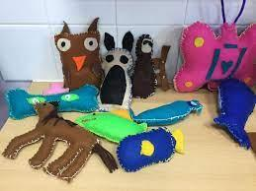  Kapow Unit |  |  | Mechanical Systems Making a Moving Toy  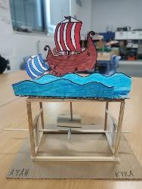  Kapow Unit |  | Digital World  Monitoring Devices  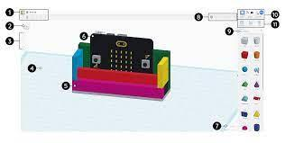  Kapow Unit |  | Cooking and Nutrition  What could be healthier?  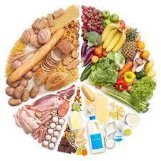  Kapow Unit
Colette Fu  https://www.colettefu.com/ | Yiying Wang- Noodoll creator and founder |  | Jacques de Vaucanson French inventor and artist  Wanda Sowry  Maker of wooden automata |  | Lazina Rahman  Technical Marketing Engineer- Future Electronics |  | Jane and Nick Somper  The Dorset Meat Company

Year 6
Designing |  |  |  | Making
Understanding contexts, users and purposes |  | Generating, developing, modelling and communicating ideas |  | Planning |  | Practical skills and techniques
- work confidently within a range of contexts, such as the home, school, leisure, culture,  - enterprise, industry and the wider environment  - describe the purpose of their products  - indicate the design features of their products that will appeal to intended users  - explain how particular parts of their products work  - carry out research, using surveys, interviews, questionnaires and web-based resources  - identify the needs, wants, preferences and values of particular individuals and groups  - develop a simple design specification to guide their thinking |  | - share and clarify ideas through discussion  - model their ideas using prototypes and pattern pieces  - use annotated sketches, cross-sectional drawings and exploded diagrams to develop and  - communicate their ideas  - use computer-aided design to develop and communicate their ideas  - generate innovative ideas, drawing on research  - make design decisions, taking account of constraints such as time, resources and cost |  | - select tools and equipment suitable for the task  - explain their choice of tools and equipment in relation to the skills and techniques they will be using  - select materials and components suitable for the task  - explain their choice of materials and components according to functional properties and aesthetic qualities  - produce appropriate lists of tools, equipment and materials that they need  - formulate step-by-step plans as a guide to making |  | - follow procedures for safety and hygiene  - use a wider range of materials and components than KS1, including construction materials  - and kits, textiles, food ingredients, mechanical components and electrical components  - accurately measure, mark out, cut and shape materials and components  - accurately assemble, join and combine materials and components  - accurately apply a range of finishing techniques, including those from art and design  - use techniques that involve a number of steps  - demonstrate resourcefulness when tackling practical problems
Evaluating |  |  |  | Technical Knowledge |  | Cooking and Nutrition
Own ideas and products |  | Existing products |  | Making products work |  | Where food comes from  Food preparation, cooking and nutrition
- identify the strengths and areas for development in their ideas and products  - consider the views of others, including intended users, to improve their work  - critically evaluate the quality of the design, manufacture and fitness for purpose of their  - products as they design and make  - evaluate their ideas and products against their original design specification |  | - how well products have been designed  - how well products have been made  - why materials have been chosen  - what methods of construction have been used  - how well products work  - how well products achieve their purposes  - how well products meet user needs and wants  - how much products cost to make  - how innovative products are  - how sustainable the materials in products are  - what impact products have beyond their intended purpose |  | - how to use learning from science to help design and make products that work  - how to use learning from mathematics to help design and make products that work  - that materials have both functional properties and aesthetic qualities  - that materials can be combined and mixed to create more useful characteristics  - that mechanical and electrical systems have an input, process and output  - the correct technical vocabulary for the projects they are undertaking  - how mechanical systems such as cams or pulleys or gears create movement  - how more complex electrical circuits and components can be used to create functional products  - how to program a computer to monitor changes in the environment and control their products  - how to reinforce and strengthen a 3D framework  - that a 3D textiles product can be made from a combination of fabric shapes  - that a recipe can be adapted by adding or substituting one or more ingredients |  | - that food is grown (such as tomatoes, wheat and potatoes), reared (such as pigs, chickens and cattle) and caught (such as fish) in the UK, Europe and the wider world  - that seasons may affect the food available  - how food is processed into ingredients that can be eaten or used in cooking  - that food is grown (such as tomatoes, wheat and potatoes), reared (such as pigs, chickens and cattle) and caught (such as fish) in the UK, Europe and the wider world  - that seasons may affect the food available  - how food is processed into ingredients that can be eaten or used in cooking
Unit Overview
Autumn 1 | Autumn 2 |  | Spring 1 | Spring 2 | Summer 1 |  | Summer 2
Electrical Systems  Steady Hand Game  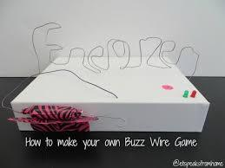  Kapow Unit | Structures  Playground  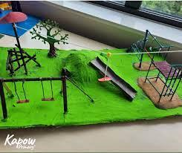  Kapow Unit |  | Textiles  Upcycled Fashion Design  (Art/DT Project)  Using a combination of textiles skills such as attaching fastenings, appliqué and decorative stitches, children design, assemble and decorate an item of clothing or accessory for a chosen purpose.  Stand Alone unit based on Kapow | Digital World  Navigating the World  Kapow Unit | n/a |  | Cooking and Nutrition  Come Dine with Me  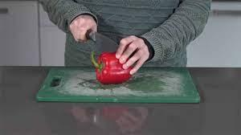  Kapow Unit
John Spinello- Designer of Operation game | Niki de Saint Phalle and  Benjamin Dominguez |  | Lulu Guiness – bag designer  Vivienne Westwood – fashion designer  Nannacay – ethical bag designs | Lars and Jens Eilstrup Rasmussen, Noel Gordon and Stephen Ma, at the Sydney-based company Where 2 Technologies – designers of google maps |  |  | Chef  Jamie Oliver

