EYFS
 | Autumn | Spring | Summer
Cycle 1 | Into the Woods | All About Me | In the Garden
Enrichment | Highgate Woods or Epping Forest  TGC Step into a Story – Bear Hunt  Bollywood Vibes  Jolly Christmas Postman (Rec)  Hampstead Heath Wild Winter Adventure (Nurs)  LSO St Lukes Concert – 0-3s | Hampstead Heath – Super Spring  City Farm  LSO St Lukes Concert (Rec) | TGC – Step into a Story (Jack and the Beanstalk)  LSO St Lukes Concert (Nurs)  TGC – What Lives in the Park or  Camley Street
Cycle 2 | Food and Festivals | Imaginary Worlds | About Town
Enrichment | TGC – Jam, Bread and Butter (Rec)  Highgate Woods  Bollywood Vibes  Hampstead Heath Wild Winter Adventure (Nurs)  LSO St Lukes Concert – 0-3s | Diana Memorial Playground  Golden Hinde (Rec)  LSO St Lukes Concert (Rec) | TGC – Step into a Story (Alfie’s Shop)  LSO St Lukes Concert (Nurs)  Royal Mews (Rec)  Hyde Park (Nurs)  London Zoo  Postal Museum
See EYFS Long Term Plans for more detail on curriculum coverage

Year 1
 | Autumn |  | Spring |  | Summer
English | Core Text: What Made Tiddalik Laugh  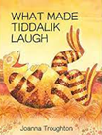 | Core Text: Katie in London  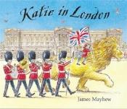 | Core Text: Stone Girl Bone Girl  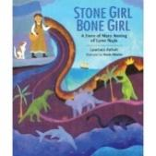 | Core Text: Little Red Riding Hood  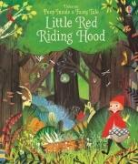 | Core Text:  Adoette  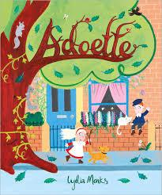 | Core Text:  Clean Up  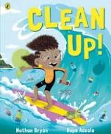
English | Writing Outcome:  To retell and perform a folk tale from another country | Writing Outcome:  To write a postcard | Writing Outcome:  To write a diary entry | Writing Outcome:  To write a Fairy Tale | Writing Outcome:  To write about the history of the school - information text | Writing Outcome:  Social Action Project
English | Poetry – See Year Group Long Term Map
Maths | Number: Place Value (Within 10)  Number: Addition and Subtraction (within 10)  Geometry : Shape  Mastering Number Term 1 |  | Number: Place Value (Within 20)  Number: Addition and Subtraction (within 20)  Number: Place Value (Within 50)  Measurement: Length and Height  Measurement: Weight and Volume  Mastering Number Term 2 |  | Number: Multiplication and Division  Number: Fractions  Geometry (Position and Direction)  Number: Place Value (Within 100)  Measurement: Money  Measurement: Time  Mastering Number Term 3
Science | Animals Including Humans  Working Scientifically:  Observation | Everyday Materials | Seasonal Changes  Plants including Trees  Science Fair Project  Working Scientifically:  Performing Simple Tests |  | Animals including humans- Revisit  Working Scientifically: Gathering and Recording Data | Plants – Revisit  Animals including humans- 2nd Revisit
Geography and History | Where in the World? | London Calling: From A to Z | Fossil Hunters | Seasons and Weather | Local History Project  Local Area Fieldwork | Field Work Week  Beside the Seaside
Computing | E safety: Media Balance and Wellbeing – Pause for People  Technology Around Us ( 2 lessons)  Home Learning platform | E Safety: Cyberbullying - Media Balance is Important  Digital Writing and Digital Painting – Busy Things and JIT | E Safety: News and Media Literacy – Media Balance is Important  Digital Writing and Digital Painting – Busy Things and JIT | E Safety: Privacy and Security - Safety in my Online Neighbourhood  Data – Busy Things | E Safety: Digital Footprint and Identity - Media Balance is Important  Bee Bots – Moving a Floor Robot | E Safety: Relationships and Communication – Media Balance is Important  Busy Things – Busy Code
Art | Painting and Collage:  Wax resist paintings/ African Masks | Drawing and Painting  London Buildings | Drawing, Printing and Sculptures:  Fossils | Drawing, Painting and Sculpture (2D-3D):  Making Birds | Painting:  Exploring watercolour | Take One Picture
DT | Textiles  Puppets | Mechanisms:  Wheels and Axles- Vehicles | Structures:  Georgian Dolls House |  | Cooking and Nutrition:  Smoothies
RE | How and why do we celebrate sacred times? | Who is a Christian and what do they believe? | What does it mean to belong to a faith community? |  | How should we care for others and the world, and why does it matter?
PSHE | Mental Health and Emotional Wellbeing  Feelings | Keeping Safe and Managing Risk  Feeling Safe | Identity, Society and Equality  Me and Others | Drug, Alcohol and Tobacco Education  What do we put into and on our bodies? | Physical Health and Wellbeing  Fun Times | Careers, Financial Capability and Economic wellbeing  My Money
PE | Games for Understanding  Running | Hands 1  Body Parts | Feet  Wide/ Narrow/ Curled | Hands 2  Forest School | Jumping  Dance | Health and Well- being/ Yoga  Rackets, Bats and Balls
Music (including music appreciation) | Jolly Music  - Recognise the pulse and rhythm  - Differentiate between pulse and rhythm. | Jolly Music  - Recognise three pitches (high, medium, low)  - Show a visual representation of the pitch and pulse | Jolly Music  - Explore the movement of pitch  - Perform pule and rhythm simultaneously | Jolly Music  - Learn the new rest gesture  - Visual representations of pulse and rhythm | Jolly Music  - Revise various songs and rhymes  - Visuals representations of pulse and rhythm | Jolly Music  - Visual representations of rhythm and pitch.  - Learn solfa names and hand signs so & mi.  - Rhythm names ta and ti-ti
Music (including music appreciation) | Developing Singing technique – Community Carol Singing |  | Developing Singing technique - Spring concert |  | Composition project linked to Take One Picture
Music (including music appreciation) | Western Classical – Early, Baroque, Renaissance, Classical Era | Western Classical Romantic and up to 1940’s | Western Classical 20th Century Music | 20th and  21st Century Music including Film and Musical Theatre | Popular Music | World Music and Folk Music
Global Citizenship | Equality and Rights  Power and Governance (4 weeks)  Social Justice and Equity (6 weeks)  Human Rights (5 weeks) |  | Respect for Others  Identity and Diversity (8 weeks)  Peace and Conflict (4 weeks) |  | Ecological Awareness  Sustainable Development (8 weeks)  Globalisation and Interdependence (6 weeks)
Emotional Literacy | Self Awareness | Self Management | Social Awareness | Relationship Skills | Responsible Decision Making | Anti Bullying/ Transition
Enrichment | Discover  National Portrait Gallery  Little Angel Theatre  Story Telling Workshop | Tower Bridge  Transport Museum  St Clements Church | Natural History Museum  Georgian Bake Off workshop | Forest School  Trip to Queen’s Wood  Garden Classroom – Trees Please Me  LSO KS1 Concert | Courtauld Gallery – Art and Colour | Linked to Take One Picture Project  Seaside trip
School, Family and Community Events | International Evening  Class Tea Party  Class led workshop – mental health and wellbeing  Take One Picture Exhibition | Interfaith Week  Children in Need  Community Carol Concert  Christmas Fair  Anti Bulling Week workshop | Museum week  Class led workshop – safer internet day | Comic Relief  Spring Concert  Science Fair  World Book Day  Mental Health workshop or lesson | World Earth Day Workshop  Learning Outside the Classroom Day  Eid Disco  Moreland’s Got Talent | National Field Work week  Summer Picnic  Sports Day  Healthy Eating week workshop or lesson

Year 2
 | Autumn |  | Spring |  | Summer
English | Core Text: Little People Big Dreams - Rosa Parks  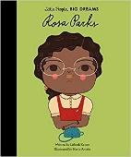 | Core Text: Toby and the Great Fire of London  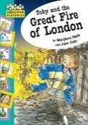 | Core Text: Paper Bag Princess  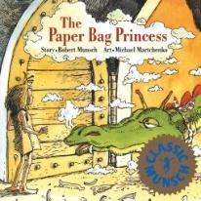 | Core Text: The Pirate Cruncher  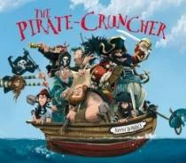 | Core Text: Discovering the United Kingdom  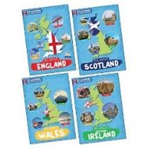 | Core Text: The Journey Home/ Our Tower/ Belonging  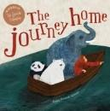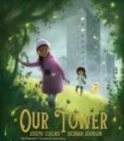  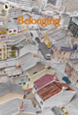
English | Writing Outcome:  To write a biography of Rosa Parks | Writing Outcome:  To write a recount of the events of the Great Fire  To write Samuel Pepys diary entry | Writing Outcome:  To write a character description  To write a fairy tale | Writing Outcome:  To write a personal narrative – letter home from on board ship  To write a setting description | Writing Outcome:  To write a non -chronological report fact-file about a country in the UK (linked to topic) | Writing Outcome:  Social Action Project
English | Poetry – See Year Group Long Term Map
Maths | Number: Place Value  Number: Addition and Subtraction  Geometry: Shape |  | Measurement : money  Number : Multiplication and Division  Measurement: Length and Height  Measurement: Mass, Capacity and Temperature |  | Number: Fractions  Measurement: Time  Statistics  Geometry: Position and Direction
Science | Animals including humans  Working Scientifically:  Comparing and  classifying | Uses of Everyday materials  Working Scientifically:  Asking simple questions | Science Fair Project  Plants  Revisit Animals, including humans and Everyday materials |  | Living things and their habitats | Revisit Plants and Living things and their habitats  Working Scientifically:  Using observations
Geography and History | Inspirational Women | Time Detectives– Great Fire of London | Kings, Queens and Castles | Land Ahoy: Pirates and Explorers | The Great British Bake Off -The UK  Field Work Week
Computing | E safety: Media Balance and Wellbeing  Digital Literacy – Common Sense Media  The Different Uses of Computers  My Busy Things – Learning Platform | E Safety: Cyberbullying  Digital Photography  Stop Animation | E Safety: News and Media Literacy  Multi Media and Digital Writing – J2 Write including online research and typing skills | E Safety: Privacy and Security  Data Pictograms – J2 Data | E Safety : Digital Footprint and Identity  JIT Turtle – Robot algorithms | E Safety: Relationships and Communication  Scratch Jnr – Sequencing Animations
Art | Drawing and Painting  Portrait of Rosa Parks  Forest School project: Nature Prints | Painting and Digital Media  Fire of London backdrop  Making animated drawings | Drawing and Sculpture  Clay Dragon’s Eyes | Textiles  Cloth, Thread and Paint | Printing  Make packaging for British Bake Off  (DT/Art project) | Take One Picture  Child Led project
DT | Mechanisms  Sliders and Levers  Great Fire of London Animation Project |  | Textiles  Making a pouch |  | 3DStructures/Design  Make packaging for British Bake Off  Food: Great British Bake Off | Cooking and Nutrition  A Balanced Diet – Wrap
RE | Who is a Muslim and what do they believe? | How and why do we celebrate special and sacred times? | Who is Jewish and what do they believe? | What can we learn from sacred books? | What makes some places sacred?
PSHE | Physical health and wellbeing  What keeps me healthy? | Mental health and emotional wellbeing  Friendship | Relationships and  health education  Boys and girls, families | Relationships and health education  Boys and girls, families | Keeping safe and managing risk  Indoors and outdoors | Drug, alcohol and tobacco education  Medicines and me
PE | Games- Dodging  Jumping | Hands 1  Pathways | Feet  Games for Understanding | Dance  Linking | Forest School  Hands 2 | Health and Wellbeing/ Yoga  Rackets, Bats and Balls
Music (including music appreciation) | Music:  Jolly Music:  - Revise so, mi  - Combine pitch and rhythm notation  - Perform pulse and rhythm simultaneously | Music:  Jolly Music/ Nativity-  - Read and write rhythms using rhythm names  - Work at internalising and pitch recognition | Music:  Jolly Music:  - Recognise and demonstrate simple phrasing  - Read rhythms | Music:  Jolly Music:  - Revise know rhythm repertoire  - Pulse-keeping/ phrasing/ written rhythms/ la–so–mi | Music:  Jolly Music:  - Explore faster/ slower pulse-keeping  - Work on pulse in songs with rests | Music:  Jolly Music:  - Preparing la and reading rhythms  - Learn la solfa name and handsigns.  - Learn notation for ta rest.
Music (including music appreciation) | Developing Singing technique – Nativity and Community Carol Singing |  | Developing Singing technique - Spring concert |  | Composition project based on Take One Picture
Music (including music appreciation) | Western Classical – Early, Baroque, Renaissance, Classical Era | Western Classical Romantic and up to 1940’s | Western Classical 20th Century Music | 20th and  21st Century Music including Film and Musical Theatre | Popular Music | World Music and Folk Music
Global Citizenship | Equality and Rights  Power and Governance (4 weeks)  Social Justice and Equity (6 weeks)  Human Rights (5 weeks) |  | Respect for Others  Identity and Diversity (8 weeks)  Peace and Conflict (4 weeks) |  | Ecological Awareness  Sustainable Development (8 weeks)  Globalisation and Interdependence (6 weeks)
Emotional Literacy | Self Awareness | Self Management | Social Awareness | Relationship Skills | Responsible Decision Making | Anti Bullying/ Transition
Enrichment | MoL Suffragettes Workshop  Tate Britain | MoL Fire Fire  Guildhall Art Gallery - GFOL  Wren 500 Workshop and Walk | Tower of London  Charterhouse Fit for a Queen  National Portrait Gallery – Meet the Tudors | KS1 LSO Concert  Golden Hinde  Diana Memorial Playground | Hampstead Heath – Heath Beasts or Garden Classroom “What Lives in the Park” | Hampstead Heath – Mad About Maps  Trip linked to Take One Picture
School, Family and Community Events | International Evening  Class Tea Party  Class led workshop – mental health and wellbeing  Art Exhibition | Interfaith Week  Children in Need  Community Carol Concert  Christmas Fair | Museum week  Class led workshop – safer internet day  Moreland’s Got Talent | Comic Relief  Spring Concert  Science Fair  World Book Day | World Earth Day  Learning Outside the Classroom Day  Sports Day  Eid Disco | National Field Work week  Summer Picnic

Year 3
 | Autumn |  | Spring |  | Summer
English | Core Text: A Long Walk to Freedom  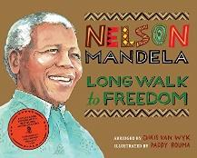 | 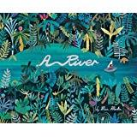  Core Texts: A River/ The Thames and Tide Club  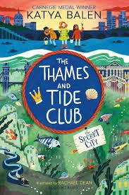 | 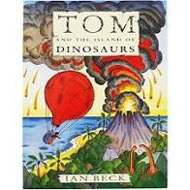  Core Texts: Asha and the Spirit Bird (WCR)/ Tom and the Island of Dinosaurs  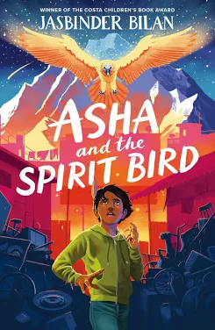 | Core Text: Around the World in 80 Days  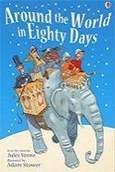 | Core Texts: The Wild Way Home (WCR) / Stone Age Boy  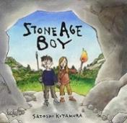  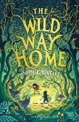 | Core Text: Fair Shares  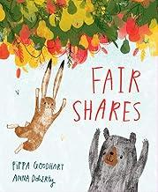
English | Writing Outcome:  To write a historical recount about Nelson Mandela  To write a poem | Writing Outcome:  To write a setting description e.g. a description of the river landscape  To write an advert | Writing Outcome:  To write an adventure story with a volcanic eruption  To write a personal narrative about the eruption of Pompei | Writing Outcome:  To write a travel blog or guide  To write an information leaflet about rocks | Writing Outcome:  To write an Historical Narrative set in the Stone Age | Writing Outcome:  Social Action Project
English | Poetry – See Year Group Long Term Map
Maths | Place Value  Addition and Subtraction  Multiplication and Division |  | Multiplication and Division  Length and Perimeter  Fractions  Mass, Capacity and Temperature |  | Fractions  Money  Time  Shape  Statistics
Science | Animals including humans  Working Scientifically:  Comparative  tests | Forces and Magnets  Working Scientifically:  Recording  findings | Rocks | Revisit Animals Including Humans  Science Fair Project | Light  Revisit Rocks | Plants  Working Scientifically: Using data to draw simple conclusions
Geography and History | Nelson Mandela and Apartheid | Go with the Flow: Waterways of London | Active Planet | 80 Days Around the World | Stone Age to Iron Age | Local History Project City Basin Now and Then  Field Work Week
Computing | E Safety : Media Balance and Well Being  Connecting Computers | E Safety: Cyber Bullying  Putting a STOP to Online Meanness  Google Docs | E Safety: News and Media Literacy  We, the Digital Citizens  Data and Information – Branching Database (J2 Data- J2 Branch) | E Safety: Privacy and Security  That's Private!  J2 Animate  Creating Media- Desktop Publishing and Blogging (J25) | E Safety: Digital Footprint and Identity  Digital Trails (UK)  Code.org – Course B | E Safety: Relationships and Communication  Who Is in Your Online Community?  Sequencing with Scratch Animation
Art | Textiles:  Inspired by Africa | Painting /  Sculpture:  Reflections on water (colour mixing) | Drawing and Painting:  Landscapes |  | Take One Picture  Child Led Project
DT | Mechanical Systems  Pneumatic Toys |  | Structures  Design an earthquake proof building | Textiles  Applique | Cooking and Nutrition  Seasonal Foods
RE | Why are festivals important to religious communities? | What do different people believe about God? | Why do people pray? | What does it mean to be a Hindu in Britain today? | Why do some people think that life is a journey? What significant experiences mark this?
PSHE | Drug, alcohol and tobacco education  Tobacco is a drug | Mental health and emotional wellbeing  Strengths and challenges | Identity, society and equality  Celebrating difference | Physical health and wellbeing  What helps me choose? | Careers, financial capability and economic wellbeing  Saving, spending and budgeting | Keeping safe and managing risk  Bullying – see it, say it, stop it
PE | Games – Netball  Forest School | Games – Football  Dance | Games – Netball  Orienteering | Games – Tag Rugby  Gymnastics- Symmetry / Asymmetry | Games – Tennis  Swimming | Games –Cricket  Athletics
Music (including music appreciation) | Developing Singing technique – Nativity Play  Kapow Unit: Reggae Rhythms: Playing in a band  Instrumental Lessons – Glockenspiel or Keyboards |  | Developing Singing technique - Spring concert  Kapow Unit: Inspired by India  Instrumental Lessons – Keyboards or glockenspiel |  | Composition project linked to Take One Picture working with the Musicians Company (Summer 2)  Kapow Unit: Baroque Meets Pop or Reading Rhythms: Patterns and Layers  Instrumental Lessons – Keyboards or glockenspiel
Music (including music appreciation) | Western Classical – Early, Baroque, Renaissance, Classical Era | Western Classical Romantic and up to 1940’s | Western Classical 20th Century Music | 20th and 21st Century Music including Film and Musical Theatre | Popular Music | World Music and Folk Music
Spanish | Phonetics 1  I am Learning Spanish | Animals | I Know How To… | Fruits | Ice-Creams
Global Citizenship | Equality and Rights  Power and Governance (4 weeks)  Social Justice and Equity (6 weeks)  Human Rights (5 weeks) |  | Respect for Others  Identity and Diversity (8 weeks)  Peace and Conflict (4 weeks) |  | Ecological Awareness  Sustainable Development (8 weeks)  Globalisation and Interdependence (6 weeks)
Emotional Literacy | Self Awareness | Self Management | Social Awareness | Relationship Skills | Responsible Decision Making | Anti Bullying/ Transition
Enrichment | Anti Apartheid Legacy Centre  TGC – Citizens of the World Unite | Museum of Docklands – Locks, Lifting and Loads  Thames Explorer Trust  City Basin – field work  Port of London – Thames and Trade workshop  Courtauld Gallery – Art and Impressionism | Geobus – Hazards  Natural History Museum – volcanoes and earthquakes  John Soanes Museum – Rocks and Soils or  Hampstead Heath – Soil Detectives or TGC – The Rock Show | British Library – Voyage into Maps  TGC – The World Came to my place today  Wallace Collection – Landscapes and Seascapes  Hindu Temple | John Soanes Museum – Light  Hampstead Heath – Stone Age Survivors or Celtic Harmony | National Gallery  TGC – Know How Plants Grow
School, Family and Community Events | International Evening  Class Tea Party  Class led workshop – mental health and wellbeing  Art Exhibition | Interfaith Week  Children in Need  Community Carol Concert  Christmas Fair | Museum week  Class led workshop – safer internet day  Moreland’s Got Talent | Comic Relief  Spring Concert  Science Fair  World Book Day | World Earth Day  Learning Outside the Classroom Day  Sports Day  Eid Disco | National Field Work week  Summer Picnic

Year 4
 | Autumn |  | Spring |  | Summer
English | Core Text: Coming to England  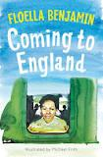 | Core Text: The Journey/ The Boy at the Back of the Class (WCR)  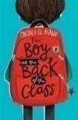  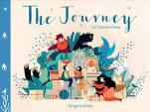 | Core Text:  Secrets of The Sun King  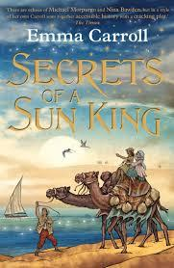 |  | Core Text:  Greek Myths  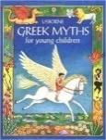 | Core Text: Reek  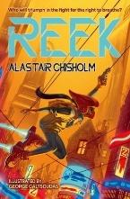
English | Writing Outcome:  Historical Recount – write a recount of coming to Britain on Windrush | Writing Outcome:  Personal Narrative – diary of a refugee | Writing Outcome:  Newspaper article –Newswise project or | Writing Outcome:  Mystery Story set in Egypt | Writing Outcome:  Write a Greek Myth | Writing Outcome:  Social Action Project
English | Poetry – See Year Group Long Term Map
Maths | Place Value  Addition and Subtraction  Area  Multiplication and Division |  | Multiplication and Division  Length and Perimeter  Fractions  Decimals |  | Decimals  Money  Time  Shape  Statistics  Position
Science | Electricity  Working Scientifically:  Identifying suitable types of enquiry | Animals including Humans  Working Scientifically: Gather data in a variety of ways | States of matter | Science Fair project | Sound  Working Scientifically: Making systematic and careful-observations and measurements | Living things and their habitats
Geography and History | Windrush | People of London | Egyptians | Egyptians  The Water Cycle | Europe- Focus on the Mediterranean Region  Ancient Greece | The Earth’s Natural Resources  Field Work Week
Computing | E Safety: Media Balance and Wellbeing -  Your Rings of Responsibility  Digital Literacy -Common Sense Media  Computing Systems and Networks – The Internet | E Safety: Cyber Bullying  The Power of Words  Google Slides | E Safety: News and Media Literacy  Is Seeing Believing  Creating Media – Audio Editing -Audacity  3 Discovery Project – News broadcast | E Safety: Privacy and Security  Password Power-Up  Data Logging - NCCE | E Safety: Digital Footprint and Identity  This Is Me  Multiple Scenes and Dialogue | E safety: Relationships and Communication  Our Digital Citizenship Pledge  Repetition Scratch Shapes
Art | Painting :  Lorna Simpson style Collage | Digital Media:  Portraits | Printing, collage, design:  Exploring Pattern |  | Take One Picture
DT | Electrical Systems:  Make a Light | Digital World:  Mindful Moments | Mechanical Systems:  Make a Shaduf |  | Textiles:  Fastenings | Cooking and Nutrition:  Adapting a Recipe  With Chef Jana
RE | What does it mean to be a Christian in Britain today? | How do people from religious and non-religious  communities celebrate key festivals? | Why is Jesus inspiring to some people? | Why is the Bible important for Christians today? | What can we learn from religions about deciding what is right and wrong?
PSHE | Identity, society  and equality:  Democracy | Drug, alcohol and  tobacco education:  Making choices | Physical health  and wellbeing:  What is important to  me? | Keeping safe and  managing risk:  Playing safe | Relationships and  health education:  Growing up and  changing | Relationships and  health education  Growing up and  changing
PE | Dance  Games-Football | Games – Tag Rugby  Gymnastics- Bridges | Games –Football  Games- Netball | Swimming  Games - Cricket | Athletics  Forest School | Games – Tennis  Orienteering
Music (including music appreciation) | Developing Singing technique – Community Carol Singing  Kapow Unit: Singing in Parts (5 lessons)  Instrumental Lessons – Keyboards |  | Developing Singing technique - Spring concert  Kapow Unit: Musical Motifs Reading the Stave  Instrumental Lessons – Keyboards |  | Composition project – Harmonise London  Kapow Unit: Reggae Rhythms: Playing in a band  Instrumental Lessons – Keyboards
Music (including music appreciation) | Western Classical – Early, Baroque, Renaissance, Classical Era | Western Classical Romantic and up to 1940’s | Western Classical 20th Century Music | 20th and 21st Century Music including Film and Musical Theatre | Popular Music | World Music and Folk Music
Spanish | Phonetics 1-2  Seasons (E) | Vegetables (E) | Presenting Myself (I) | My Family (I) | In the Classroom (I)
Global Citizenship | Equality and Rights  Power and Governance (4 weeks)  Social Justice and Equity (6 weeks)  Human Rights (5 weeks) |  | Respect for Others  Identity and Diversity (8 weeks)  Peace and Conflict (4 weeks) |  | Ecological Awareness  Sustainable Development (8 weeks)  Globalisation and Interdependence (6 weeks)  ClimateED
Emotional Literacy | Self Awareness | Self Management | Social Awareness | Relationship Skills | Responsible Decision Making | Anti Bullying/ Transition
Enrichment | Portrait Gallery –Significant People in Black British History  Black Cultural Archives – Windrush Journeys | Migration Museum  or  Hackney Museum – Suitcase Stories  Science Museum – It takes Guts  Brick Lane Heritage Walk | TGC- The Ground Beneath our Feet  Petrie Museum or John Soanes Museum | The British Museum- Excavating Egypt  John Wesley Chapel – Easter workshop  Countryside Day | The Wallace Collection - Classical Myths, Gods, Heroes and Monsters  The British Museum – Question for the People | LSO KS2 Concert  National Gallery  Camley Street Natural Park – Habitats  Adventure Playground
School, Family and Community Events | International Evening  Class Tea Party  Class led workshop – mental health and wellbeing  Art Exhibition | Interfaith Week  Children in Need  Community Carol Concert  Christmas Fair | Museum week  Class led workshop – safer internet day  Moreland’s Got Talent | Comic Relief  Spring Concert  Science Fair  World Book Day | World Earth Day  Learning Outside the Classroom Day  Sports Day  Eid Disco | National Field Work week  Summer Picnic

Year 5
 | Autumn |  | Spring |  | Summer
English | Core Text: Freedom  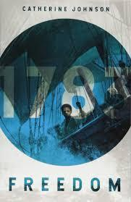 | Core Text: The Time Traveller Diaries  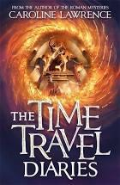 | Core Text: Beowulf  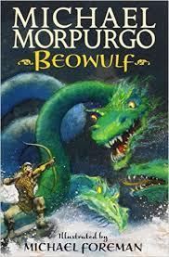 | Core Text: Macbeth  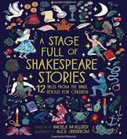 | Core Text: Shackleton’s Journey  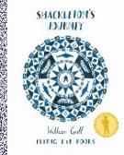 | Core Text: The Last Wild  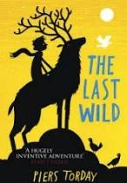
English | Writing Outcome:  Persuasive writing – abolition of slavery  Write a poem | Writing Outcome:  Write a time travel adventure story set in Roman London  Write a setting description – Miithraeum | Writing Outcome:  Write a myth or legend  Write a character description | Writing Outcome:  Macbeth – 2 sided argument  Design and write a science experiment | Writing Outcome:  Write a historical recount of Shackleton’s expedition  Persuasive writing on an aspect of climate change/ advert | Writing Outcome:  Social Action Project
English | Poetry – See Year Group Long Term Map
Maths | Place Value  Addition and Subtraction  Multiplication and Division  Fractions A |  | Multiplication and Division  Fractions B  Decimals and Percentages  Perimeter and Area  Statistics |  | Shape  Position and Direction  Decimals  Negative Numbers  Converting Units  Volume
Science | Living things and their habitats | Properties and changes in materials  Working Scientifically: Recognising and  controlling variables | Forces | Revisit Living Things and their Habitats  Science Fair Project | Animals including Humans  Working Scientifically: Measuring  accurately | Earth and Space  Working Scientifically: Drawing & explaining conclusions
Geography and History | The Trans Atlantic Slave Trade | Roman London | Anglo Saxons, Scots and Vikings | Where We Live – The UK | Weather and Climate – Focus on Antarctica | Field Work Week  Farm to Fork (Uk Farming)
Computing | E Safety: Media Balance and Wellbeing -  My Media Choices  History of Computing | E Safety: Cyber Bullying-  Be a Super Digital Citizen  Vector Drawing – Google Drawings | E Safety: News and Media Literacy -  A Creator's Rights and Responsibilities  iMovie – Camera Angles, Frames and Editing | E Safety: Privacy and Security -  Private and Personal Information  Data and Information -J2E | E Safety: Digital Footprint and Identity-  Our Online Tracks  Selection in Quizzes | E Safety: Relationships and Communication -  Keeping Games Fun and Friendly  Scratch- Variables in Games
Art | 3D Collage:  Layered Silhouettes | Drawing / Sculpture:  Roman Portraits  Clay Pots | Drawing:  Architecture – Buildings  cityscapes |  | Take One Picture
DT | Textiles:  Design Stuffed Toy | Digital World:  Monitoring Devices | Structures: Design a Playground |  | Design Project - Climate Change All Change | Cooking and Nutrition:  Developing a Recipe
RE | What does it mean to be a Muslim in Britain today? | Why do some people believe God exists? | What would Jesus do?(Can we live by the values of Jesus in the 21st century) |  | Green religion? What do religious and nonreligious worldviews teach about caring for the Earth? | If God is everywhere why go to a place of worship?
PSHE | Mental health and  emotional wellbeing  Dealing with feelings | Drug, alcohol and  tobacco education  Different influences | Identity, society  and equality  Stereotypes,  discrimination and  prejudice | Physical health  and wellbeing  In the media | Keeping safe and  managing risk  Making safer choices | Careers, financial  capability and  economic wellbeing  Borrowing and earning  money
PE | Games- Tag Rugby  Swimming | Games – Football  Games – Netball | Dance  Games – Netball | Gymnastics  Orienteering | Athletics  Games – Cricket | Games-Tennis  Forest School
Music (including music appreciation) | Developing Singing technique –Young Voices  Kapow unit: West Africa Rhythms  Instrumental Lessons – Keyboards |  | Developing Singing technique –Young Voices/ Spring Concert  Kapow Unit: Three Chord Pop - Playing in a Band  Instrumental Lessons – Keyboards |  | Composition Project linked to Take One Picture using keyboards  Kapow: Stage and Song  Instrumental Lessons – Keyboards
Music (including music appreciation) | Western Classical – Early, Baroque, Renaissance, Classical Era | Western Classical Romantic and up to 1940’s | Western Classical 20th Century Music | 20th and 21st Century Music including Film and Musical Theatre | Popular Music | World Music and Folk Music
Spanish | Phonetics 2-3  The Date (I) |  | At the Café | Do You Have a Pet? (I) | What is the Weather? (I) | My Home (I)
Global Citizenship | Equality and Rights  Power and Governance (4 weeks)  Social Justice and Equity (6 weeks)  Human Rights (5 weeks) |  | Respect for Others  Identity and Diversity (8 weeks)  Peace and Conflict (4 weeks) |  | Ecological Awareness  Sustainable Development (8 weeks)  Globalisation and Interdependence (6 weeks)
Emotional Literacy | Self Awareness | Self Management | Social Awareness | Relationship Skills | Responsible Decision Making | Anti Bullying/ Transition
Enrichment | Queen’s House – Diversity, Art and Citizenship (if available)  Museum of Docklands – Trans Atlantic Slave Trade  Museum of Methodism– Radical Islington | London Mithraeum  Museum of London – Introducing Roman London/ Roman Soldier workshop  London Guildhall – Amphitheatre Experience  LSO KS2 Concert | Young Voices -O2  British Museum – Sutton Hoo  Tower Bridge – Designing London’s Skyline | Zaha Hadid Studio visit  Hampstead Heath – Maps and Orienteering  The Globe – Lively Action Macbeth | National Maritime Museum – Polar Explorers  Hyde Park – Weather fieldwork  BAS – Meet a scientist  Geobus – Arctic, Sea Ice and Climate workshop | Geobus – Planets and the Solar System  National Gallery  Mosque visit  LMA – In your own backyard (if available)  The Royal Observatory Greenwich  Residential – South Downs (Country Trust)
School, Family and Community Events | International Evening  Class Tea Party  Class led workshop – mental health and wellbeing  Art Exhibition | Interfaith Week  Children in Need  Community Carol Concert  Christmas Fair | Museum week  Class led workshop – safer internet day  Moreland’s Got Talent | Comic Relief  Spring Concert  Science Fair  World Book Day | World Earth Day  Learning Outside the Classroom Day  Sports Day  Eid Disco | National Field Work week  Summer Picnic

Year 6
 | Autumn |  | Spring |  | Summer
English | Core Text: Hidden Figures  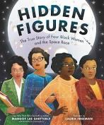 | Core Text: A Christmas Carol  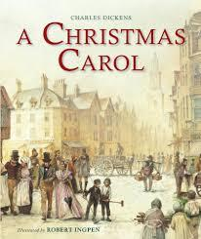 | Core Text: Kick  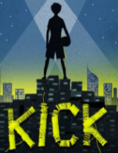 | Core Text: Holes  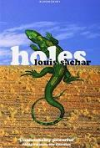 | Core Text: Children of the Benin Kingdom  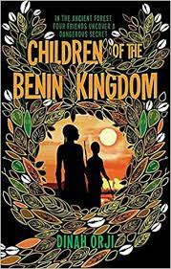 | Core Text: Save our Forests/ Rain Forest Warrior  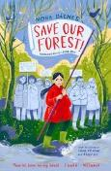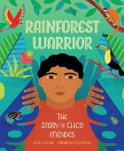
English | Writing Outcome: Write an autobiographical account of a figure from the civil rights movement.  Write a poem | Writing Outcome: Write a suspense story set in Victorian times.  Write a character or setting description | Writing Outcome:  Write a journalistic piece.  Write a persuasive letter about an aspect of global trade | Writing Outcome:  Write an Adventure Story  Write a non- chronological report on lizards | Writing Outcome:  Write a discussion piece/ 2 sided argument about the Benin Bronzes. | Writing Outcome:  Social Action Project
English | Poetry – See Year Group Long Term Map
Maths | Place Value  Four operations  Fractions A  Fractions B  Converting Units |  | Ratio  Algebra  Decimals  Fractions, Decimals and Percentages  Area, Perimeter and Volume  Statistics |  | Shape  Position and Direction  Themed Projects, Consolidation and Problem Solving
Science | Electricity  Working Scientifically:  Identifying and explaining anomalies in data  Using test results to raise questions and make predictions | Light | Animals including humans | Animals including humans cont.  Science Fair Project  Working Scientifically:  Recording data and results using different graphs | Evolution and inheritance | Living Things and Their Habitats
Geography and History | Civil Rights | Victorian London | Going Global | The USA | AD900 – Benin Kingdom | The Amazon  Field Work Week
Computing | E Safety: Media Balance and Wellbeing -  Finding My Media Balance  Computing Systems and Networks | E Safety: Cyber Bullying-  Is It Cyberbullying?  Creating Web Pages- Google Sites | E Safety: News and Media Literacy -  Reading News Online  Creating Media – 3D Modelling - Tinkercad | E Safety: Privacy and Security -  You Won't Believe This!  Sensing -Microbit – Step Counter – link to DT project | E Safety: Digital Footprint and Identity - Beyond Gender Stereotypes  Scratch – Variables in Games | E Safety: Relationships and Communication -Digital Friendships  Data and Information – Flat File Databases (Excel+ sheets)
Art | Printing (stencils)/ Graffiti:  Protest Art / Activism | Painting and Collage:  The Art of the Book Cover | Fashion Design: Upcycled Fashion Design  (Art/DT project) | Drawing and Painting:  Self Portraits- Identity | Sculpture :  Benin Art-  Clay masks/ sculptures | Take One Picture
DT | Electrical Systems:  Steady Hand Game | Mechanical Systems: Making a Moving Toy | Textiles:  Upcycled Fashion Design  (Art/DT project) | Digital World:  Navigating the World  (link to computing) | n/a | Cooking and Nutrition:  Come Dine with Me
RE | What can be done to reduce racism? What can we learn from religious and non-religious worldviews? | What do religions say to us when life gets hard? | Is it better to express your religion in arts and architecture or in charity and generosity? | What matters most to Christians and Humanists? | What difference does it make to believe in Ahimsa (harmlessness), Grace and Ummah (community)?
PSHE | Mental health and  emotional wellbeing:  Healthy minds | Identity, society  and equality:  Human rights | Drug, alcohol and  tobacco education:  Weighing up risk | Relationships and  health education:  Healthy relationships | Keeping safe and  managing risk:  Keeping safe - out and  about  FGM (female genital  Mutilation) | Relationships and  health education:  Healthy relationships
PE | Games – Football  Forest School | Games- Netball  Gymnastics | Games – Tag Rugby  Swimming | Games - Cricket  Games – Football | Athletics  Games – Tennis | Dance  Kayaking
Music (including music appreciation) | Developing Singing technique –Young Voices  Kapow unit: Songs that Speak  Instrumental Lessons – Music Production |  | Developing Singing technique –Young Voices/ Spring Concert  Kapow Unit: Film Soundtracks  Instrumental Lessons – Music Production |  | Developing Singing technique - Year 6 Show  Kapow Unit: Our Story in a Song / Composition  Instrumental Lessons – Music Production
Music (including music appreciation) | Western Classical – Early, Baroque, Renaissance, Classical Era | Western Classical Romantic and up to 1940’s | Western Classical 20th Century Music | 20th and 21st Century Music including Film and Musical Theatre | Popular Music | World Music and Folk Music
Spanish | Phonetics 3-4  The Date (I) | Clothes (I) | At School (P) |  | At the Weekend (P)
Global Citizenship | Equality and Rights  Power and Governance (4 weeks)  Social Justice and Equity (6 weeks)  Human Rights (5 weeks) |  | Respect for Others  Identity and Diversity (8 weeks)  Peace and Conflict (4 weeks) |  | Ecological Awareness  Sustainable Development (8 weeks)  Globalisation and Interdependence (6 weeks)
Emotional Literacy | Self Awareness | Self Management | Social Awareness | Relationship Skills | Responsible Decision Making | Anti Bullying/ Transition
Enrichment | Tate Modern – P is for Position or  Banksy street art walk  PGL -Residential  3 Discovery - coding | Ragged School  Charles Dickens Museum – Christmas Carol  National Archives – Black Victorians (online)  Royal Courts of Justice – Victorian Children on Trial  Old Vic – A Christmas Carol (evening) | Cutty Sark- Global Trade  Young Voices | Courtauld Gallery- Art, Portraits and Identity  LSO KS2 Concert  TGC – Tree Eye-d | London Zoo – Evolution workshop (if available)  British Museum – AD900 | Ben Kinsella Exhibition  Chessington  3 Discovery- podcasting
School, Family and Community Events | International Evening  Class Tea Party  Class led workshop – mental health and wellbeing  Art Exhibition | Interfaith Week  Children in Need  Community Carol Concert  Christmas Fair | Museum week  Class led workshop – safer internet day  Moreland’s Got Talent | Comic Relief  Spring Concert  Science Fair  World Book Day | World Earth Day  Learning Outside the Classroom Day  Sports Day  Eid Disco | National Field Work week  Summer Picnic  Year 6 Show  Prom

