
Year 1 Long Term Curriculum Map 26 - 27
Autumn Term |  | Spring Term |  | Summer Term:
Autumn 1  Where in the World? | Autumn 2  London Calling: From A to Z | Spring 1  Fossil Hunters | Spring 2  Enchanted Woodlands | Summer 1  Beside the Seaside | Summer 2  Take One Picture
Core Text: A Year Full of Stories/ What Made Tidilik Laugh  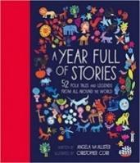  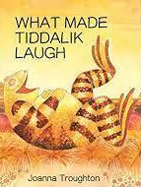 | Core Text: Katie in London  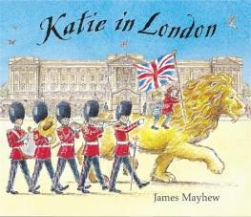 | Core Text: Stone Girl Bone Girl  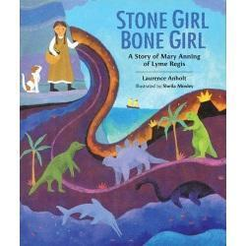 | Core Text: Little Red Riding Hood  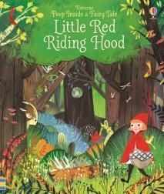 | Core Text: Adoette  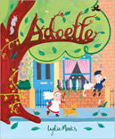 | Core Text: Clean Up  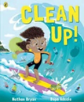
Writing Outcome:  To retell (verbally or in writing) and perform a folk tale from another country  Write a poem linked to National Poetry Day | Writing Outcome:  To write a postcard | Writing Outcome:  To write a diary entry  . | Writing Outcome:  To write a Fairy Tale | Writing Outcome:  To write about the history of the school - recount | Writing Outcome:  Social Action Project
Other Suggested Texts: All Aboard the Bobo Road | Other Suggested Texts:  The Tower Bridge Cat  Rosie Revere Engineer  This is London  The Queen’s Hat  Paddington  A Walk in London | Other Suggested Texts: Tyrannosaurus Drip, | Other Suggested Texts: Hansel and Gretel – Rachel Isadora  Into the Forest -- Anthony Browne  Red and the City  Lon Po Po | Other Suggested Texts: Flotsam  Clean Up  The Blue Giant  On the Reef  Splash, Anna Hibiscus  Lucy and Tom at the Seaside  Swashby and the Sea  The Wide Wide Sea | Other Suggested Texts:  Flotsam  Clean Up  The Blue Giant  On the Reef  Splash, Anna Hibiscus  Lucy and Tom at the Seaside  Swashby and the Sea  The Wide Wide Sea
Poetry: Children in Year 1 should revisit the rhymes learnt in the EYFS and continue to build a bank of songs, rhymes, chants and poems through daily poems and rhyme times and listening to and joining in with rhyming texts.
Poetry:  All the Wild Wonders  Travel by Book – Laura Mucha | Poetry: Buckingham Palace - AA Milne | Poetry:  Dinosaur poems | Poetry:  I am the Seed that Grew the Tree  Little Red Riding Hood and the Wolf- Roald Dahl  The Book – Micheal Rosen | Poetry:  Playgrounds – Berlie Doherty | Poetry:  Maggie and Milly and Molly and May – EE Cummings  Seashell – James Berry  Over My Toes – Micheal Rosen
White Rose Maths:  Number: Place Value (Within 10)  Number: Addition and Subtraction (within 10)  Geometry : Shape  Mastering Number:  Pupils will have an opportunity to consolidate the  Early Learning Goals and continue to explore the  composition of numbers within 10, and the  position of these numbers in the linear number  system. |  | White Rose Maths:  Number: Place Value (Within 20)  Number: Addition and Subtraction (within 20)  Number: Place Value (Within 50)  Measurement: Length and Height  Measurement: Weight and Volume  Mastering Number:  Pupils will continue to explore the composition  of numbers within 10 and explore addition and  subtraction structures and the related language  (without the use of symbols). |  | White Rose Maths:  Number: Multiplication and Division  Number: Fractions  Geometry (Position and Direction)  Number: Place Value (Within 100)  Measurement: Money  Measurement: Time  Mastering Number:  Pupils will explore the composition of numbers  within 20 and their position in the linear number  system. They will connect addition and  subtraction expressions and equations to  ‘number stories’).
Science:  Animals Including Humans  Working Scientifically:  Observation | Science:  Everyday Materials | Science:  Seasonal Changes  Plants including Trees  Science Fair Project  Working Scientifically:  Performing Simple Tests |  | Science:  Animals including humans- Revisit  Working Scientifically: Gathering and Recording Data | Science:  Plants – Revisit  Animals including humans- 2nd Revisit
Topic Enquiry:  Geography : Where in the World?  - The differences and similarities in human and physical geography of a country in Africa (Kenya) and the UK  - How to find countries, the continents and oceans using a Globe and Atlas  - The Location of hot and cold places in the world in relation to the Poles and the Equator.  History: Who was Mary Seacole and what did she achieve?  - To find out about the life and achievements of Mary Seacole. | Topic Enquiry: London Calling – London A to Z  Geography :  - The geography of the school and grounds.  - The geography of the local area through field work and maps.  - Finding out about famous London landmarks.  History:  - Transport in London past and present. | Topic Enquiry: Fossil Hunters  Geography:  - The geography of the Jurassic Coast and the formation of fossils.  History :  - To find out about the life and achievements of Mary Anning  - To find out how fossils provide evidence of extinct species. | Topic Enquiry: Enchanted Woodlands  Geography: Weather and Seasons  - Identifying seasonal and daily weather patterns in the United Kingdom and the location of hot and cold areas of the world in relation to the Equator and the North and South Poles.  - How to use basic geographical language to refer to: key physical features, including: season and weather.  Weekly Forest School including local woodland habitat investigation linked to Science  History: n/a | Topic Enquiry:  Geography :  Local Fieldwork project.  History:  Local History Project – Our School  - Finding out about the history of the school and changes to school life | Topic Enquiry:  Geography :  - Know the Seas around the UK.  - Location of coastal resorts and the nearest coastal town to London.  - Study the human and physical geography of a UK seaside location.  History:  - Find out about seaside holidays in the past and make comparisons to the present day.
Computing:  E safety: Media Balance and Wellbeing – Pause for People  Technology Around Us ( 2 lessons) | Computing:  E Safety: Cyberbullying - Media Balance is Important  Digital Writing and Digital Painting – Busy Things and JIT | Computing:  E Safety: News and Media Literacy – Media Balance is Important  Digital Writing and Digital Painting – Busy Things and JIT | Computing:  E Safety: Privacy and Security - Safety in my Online Neighbourhood  Data – Busy Things | Computing:  E Safety: Digital Footprint and Identity - Media Balance is Important  Home Learning platform | Computing:  E Safety: Relationships and Communication – Media Balance is Important  Bee Bots – Moving a Floor Robot  Busy Things – Busy Code
Art:  Painting and Collage:  Wax resist paintings/ African Masks  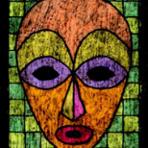  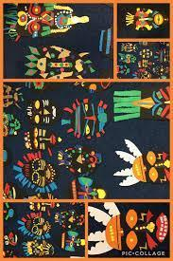  Focus Artist:  Lois Mailou Jones | Art:  Drawing and Painting  London Buildings  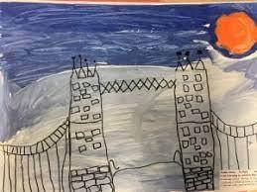  Focus Artists:  Vincent Alexander Booth  Joe Peel  Look | Art:  Drawing, Printing and Sculptures  Fossils  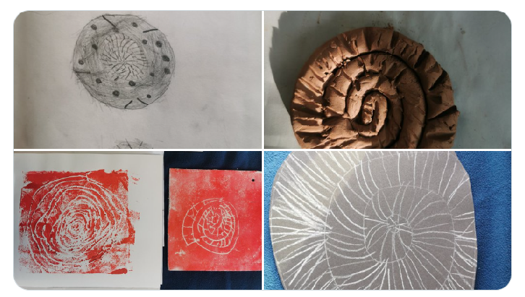  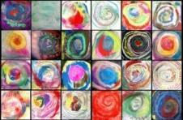  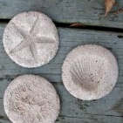  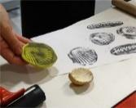  Access Art Units adapted  Focus Artist:  Hamish Mackie | Art:  Drawing, Painting and Sculpture (2D-3D)  Making Birds  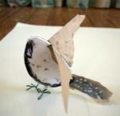  Access Art Unit  Focus Artist:  Andrea Butler  Forest School Project:  Making Nests  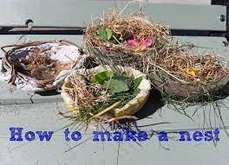 | Art:  Painting  Exploring watercolour  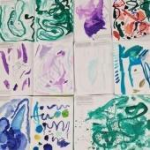  Access Art Unit  Focus Artists:  Paul Klee  Emma Burleigh  Quentin Blake | Art:  Take One Picture
DT:  Textiles :  Puppets  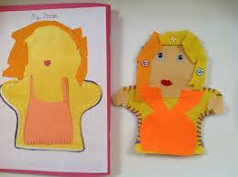  Kapow unit | DT:  Mechanisms:  Wheels and Axles- Vehicles  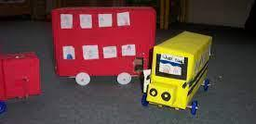  Kapow unit | DT:  Structures:  Georgian Dolls House  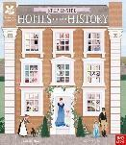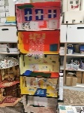  Stand alone unit |  | DT:  Cooking and Nutrition:  Smoothies  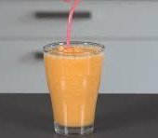  Kapow unit
Music:  Jolly Music  - Recognise the pulse and rhythm  - Differentiate between pulse and rhythm. | Music:  Jolly Music  - Recognise three pitches (high, medium, low)  - Show a visual representation of the pitch and pulse | Music:  Jolly Music  - Explore the movement of pitch  - Perform pule and rhythm simultaneously | Music:  Jolly Music  - Learn the new rest gesture  - Visual representations of pulse and rhythm | Music:  Jolly Music  - Revise various songs and rhymes  - Visuals representations of pulse and rhythm | Music:  Jolly Music  - Visual representations of rhythm and pitch.  - Learn solfa names and hand signs so & mi.  - Rhythm names ta and ti-ti  Composition linked to Take One Picture
Western Classical – Early, Baroque, Renaissance, Classical Era | Western Classical Romantic and up to 1940’s | Western Classical 20th Century Music | 20th and  21st Century Music including Film and Musical Theatre | Popular Music | World Music and Folk Music
PSHE: Mental Health and Emotional Wellbeing  Feelings | PSHE: Keeping Safe and Managing Risk  Feeling Safe | PSHE: Identity, Society and Equality  Me and Others | PSHE: Drug, Alcohol and Tobacco Education  What do we put into and on our bodies? | PSHE: Physical Health and Wellbeing  Fun Times | PSHE: Careers, Financial Capability and Economic wellbeing  My Money
RE:  Who is a Christian and what do they believe? | RE:  How and why do we celebrate? | RE:  What does it mean to belong to a faith community? |  | RE:  How should we care for others and the world, and why does it matter?
PE:  Games for understanding  Dance | PE:  Hands 1  Body Parts | PE:  Wide/ Narrow/ Curled  Feet | PE:  Hands 2  Forest School | PE:  Jumping  Dance | PE:  Health and Wellbeing/ Yoga  Rackets, Bats and Balls
Global Citizenship:  Equality and Rights  Power and Governance (4 weeks)  How can I be involved in making and changing the rules at school?  How can we be Ready, Respectful and Safe?  Project Outcome: School Elections  Social Justice and Equity (6 weeks)  What does the word fair mean?  Can you think about what is unfair?  What does rich and poor mean to you?  How can we help people who don’t have enough?  Project Outcome: Social Enterprise – Raise money for Children in Need  Human Rights (5 weeks)  What are the basic rights we should have?  How should we treat others?  What should we do if we see someone treated badly?  Can kindness change the world?  Project Outcome: Create posters for the school on the theme of kindness |  | Global Citizenship:  Respect for Others  Identity and Diversity (8 weeks)  Who am I?  What are some ways we are alike and different?  Do we all think the same things?  Why is it important to celebrate differences?  Peace and Conflict (4 weeks)  Why don’t we always agree?  How can we keep things fair?  How can we end an argument? |  | Global Citizenship:  Ecological Awareness  Sustainable Development (8 weeks)  Starting Point: Whole School Earth Day  What is our local environment?  How do we feel about our local environment and what would we like to change?  What things make our local environment better or worse?  How can we make a positive difference to our local environment?  How can we care for living creatures in our school/ local environment?  Globalisation and Interdependence (6 weeks)  Where does our plastic go, and how can it travel to places far away?  What could we do in our classroom to use less plastic and help nature?  How can looking after our local area help animals and people in other places too?  How can children help make a difference to plastic pollution on their own and when they work with others?  How can we speak up or take action when something in our environment doesn’t feel right or fair?  Social Action project
Global Citizenship Links:  International Day of Democracy  International Day of Peace  Black History Month – celebrating diversity  Dyslexia awareness week | Global Citizenship Links:  Universal Children’s Day  Anti- Bullying Week  Human Rights Day  Remembrance Day  Children in Need  Road Safety Week  World Philosophy Day  Inter Faith Week | Global Citizenship Links:  International Women’s Day  International Mother Language Day  Children’s Mental Health Week | Global Citizenship Links:  Autism Awareness Day  Comic Relief  Fair Trade Fortnight  Mothering Sunday | Global Citizenship Links:  International Mother Earth Day  World Bee Day  Walk to school week  National Children’s Gardening Week | Global Citizenship Links:  BNF Healthy Eating Week  World Environment Day  World Oceans Day  World Refugee Day  Oxfam water week  Recycle Awareness Week  National School Grounds Week
P4C:  The Feast (in A Year Full of Stories); what does it mean to ‘value’ hospitality? Should you have to contribute to get something ‘free’? | P4C:  Compare photos of a local street now & then: what’s the same/what’s different; how do the changes affect us; are the changes good? | P4C:  Dinosaurs and All That Rubbish (Foreman): are we taking care of our planet? Would it be a good idea if dinosaurs were still alive today? | P4C:  Not Now Bernard: what is a monster? Who is the monster here? How do we know what is real? | P4C:  Flotsam: can ‘flotsam’ be ‘treasure’? Could a photo be a magic mirror? Will the links go on forever? | P4C:  The Artist Who Painted A Blue Horse – Eric Carle  Is it okay to paint the ‘wrong’ colours?
Emotional Literacy:  Self Awareness  Emotional Literacy Autumn 1 Booklet  Associated Skills  - Identifying emotions  - Accurate self-perception  - Recognising strengths  - Self-confidence  - Self-efficacy  Contents  Introduction: The RULER Anchor Tools – What are emotions, mood meter, class charter, Moreland moment, Best self.  Lesson 1: How am I feeling? – Cheerful  Lesson 2: How am I feeling? - Sad  Lesson 3: How am I feeling? - Angry  Lesson 4: How am I feeling? - Calm  Lesson 5: Recognising and celebrating our strengths  Lesson 6: Self-efficacy | Emotional Literacy:  Self Management  Emotional Literacy Autumn 2 Booklet  Associated Skills  - Impulse control  - Stress management  - Self-discipline  - Self-motivation  - Goal setting  - Organisational skills  - Growth Mindset  Contents  Lesson 1: How do you want to feel?  Lesson 2: Moving out of the red – angry  Lesson 3: Tool Kit to regulate emotions - angry  Lesson 4: Growth Mindset- introduction  Lesson 5: Growth Mindset – making mistakes  Lesson 6: Setting Goals | Emotional Literacy:  Social Awareness  Emotional Literacy Spring Booklet  Associated Skills  - Understanding emotions  - Empathy/sympathy  - Appreciating diversity  - Respect for others  Contents  Lesson 1: How do you want to feel? - Revisiting the class charter  Lesson 2: Recognising and understanding other people’s emotions  Lesson 3: Kindness  Lesson 4: Belonging and Community | Emotional Literacy:  Relationship Skills  Emotional Literacy Spring 2 Booklet  Associated Skills  - Communication  - Social engagement  - Relationship building  - Teamwork  Contents  Lesson 1: Thinking about friendship  Lesson 2: Conflict resolution  Lesson 3: Asking for help  Lesson 4: Good listening skills  Lesson 5: Team work | Emotional Literacy:  Responsible Decision Making  Emotional Literacy Summer 1 booklet  Associated Skills  - Identifying problems  - Analysing solutions  - Solving problems  - Evaluating  - Reflecting  - Ethical responsibility  Contents  Lesson 1: Identifying Problems  Lesson 2: Solving Problems – Brainstorm  Lesson 3: Solving Problems – What will happen?  Lesson 4: Making Choices  Lesson 5: Evaluating and Reflecting – Using the blueprint | Emotional Literacy:  Anti Bullying/ Transition  SEAL – Say No to Bullying  - I can tell you what bullying is.  - I can tell you some ways in which I am the same as and different from my friends.  - I am proud of the ways in which I am different. I can tell you how someone who is bullied feels.  - I can be kind to children who are bullied.  - I know that when you feel sad, it affects the way you behave and how you think.  - I know some people in and out of school who I could talk to if I was feeling unhappy or being bullied.  - I know what to do if I am bullied.
Personal Safety:  - Introduction to the PANTS rule  - Being safe in the classroom/ school environment  - What to do when the fire alarm sounds | Personal Safety:  - Firework safety  - Fire Safety  - Road Safety Be Safe Be Seen  - Keeping safe at home and outside the home (see PSHE/RSE) | Personal Safety:  - Dog Safety  - Stranger Danger  - Review PANTS rule | Personal Safety:  - Staying Safe at Home  - First Aid | Personal Safety:  - Road Safety- Green Cross Code  - Who keeps us safe  - Sun Safety (See PSHE/RSE)  - Review PANTS rule | Personal Safety:  - Water safety  - Cycle and Scooter Safety
Enrichment Opportunities:  Little Angel Theatre or  Discover  Story Telling workshop  Portrait Gallery – Mary Seacole | Enrichment Opportunities:  Local area field work  London Transport Museum  Tower Bridge  St Clements Church visit | Enrichment Opportunities:  Natural History Museum  Wesley Chapel - Georgian life workshop  Local walk looking at Georgian houses  3 Discovery Workshop | Enrichment Opportunities:  Forest School  Trip to Queen’s/ Highgate Wood  Garden Classroom – Trees Please Me | Enrichment Opportunities:  Seaside trip  Punch and Judy show  Courtauld Gallery | Enrichment Opportunities:  Linked to Take One Picture
School, Family and Community Events:  International Evening  Class Tea Party  Class led workshop – mental health and wellbeing  Take One Picture Exhibition | School, Family and Community Events:  Interfaith Week  Children in Need  Community Carol Concert  Christmas Fair  Anti Bulling Week workshop | School, Family and Community Events:  Museum week  Class led workshop – safer internet day | School, Family and Community Events:  Comic Relief  Spring Concert  Science Fair  World Book Day  Mental Health workshop or lesson | School, Family and Community Events:  World Earth Day Workshop  Learning Outside the Classroom Day  Eid Disco  Moreland’s Got Talent | School, Family and Community Events:  National Field Work week  Summer Picnic  Sports Day  Healthy Eating week workshop or lesson

