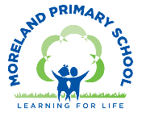
Year 2 Long Term Curriculum Map 26-27
Autumn Term |  | Spring Term |  | Summer Term:
Autumn 1  Inspirational Women | Autumn 2  Time Detectives: The Great Fire of London | Spring 1  Kings, Queens and Castles | Spring 2  The Great British Bake-off | Summer 1  Land Ahoy: Pirates and Explorers | Summer 2  Take One Picture
Core Text: Little People Big Dreams - Rosa Parks  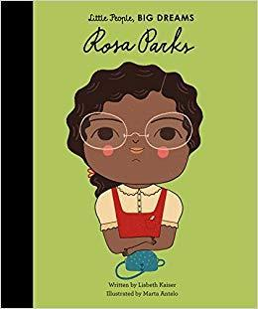 | Core Text: Toby and the Great Fire of London  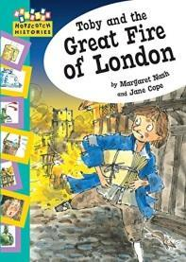 | Core Text: Paper Bag Princess  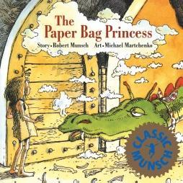 | Core Text: The Pirate Cruncher  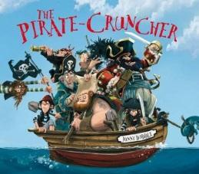 | Core Text: Discovering the United Kingdom  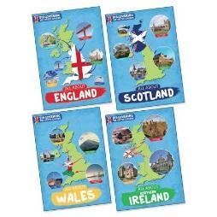 | Core Text: The Journey Home/ Our Tower/ Belonging  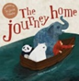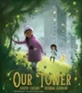  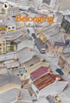
Writing Outcome:  To write a biography of Rosa Parks  Poem - National Poetry Day | Writing Outcome:  To write a recount of the events of the Great Fire  To write Samuel Pepys diary entry | Writing Outcome:  To write a character description  To write a fairy tale | Writing Outcome:  To write a personal narrative – letter home from on board ship  To write a setting description | Writing Outcome:  To write a non -chronological report fact-file about a country in the UK (linked to topic) | Writing Outcome:  Social Action Project
Other Suggested Texts:  Amazing Grace  Secret Suffragette  100 Women who made History  Goodnight Stories for Rebel Girls  Little People Big Dreams Emmeline Pankhurst  Little People Big Dreams Malala Yousafzai  Malala’s Magic Pencil  What If  Shout Out | Other Suggested Texts:  Raven Boy  The Great Fire of London =Non Fiction | Other Suggested Texts:  Traditional Tales – Sleeping Beauty, Rapunzel, Cinderella  What are you playing at? (PSHE link: gender roles)  Get Up Elizabeth  Two Weeks with the Queen  Rapunzel, The Princess and the Pea – Rachel Isadora  The Worst Princess  The Water Princess  Once Upon a World Fairy Tales  The Lost Fairy Tales | Other Suggested Texts: Captain Flynn and the Pirate Dinosaurs  Peter Pan  The Night Pirates  The Pirate Mums | Other Suggested Texts:  Folk Tales around the UK | Other Suggested Texts:
Poetry:  Autumn Gift – Valerie Bloom  Blue Bottle – Judith Nicholls  Cat Rap – Grace Nichols  Double Trouble – Jackie Kay | Poetry: | Poetry:  The Adventures of Isabel – Ogden Nash  A Small Dragon – Brian Patten  Dear Ugly Sisters – Laura Mulch | Poetry:  My Bed is a Boat – Robert Louis Stephenson  Mermaids Lament – Rachel Rooney  Pirate Pete – James Carter | Poetry: | Poetry:
Maths:  White Rose:  Number: Place Value  Number: Addition and Subtraction  Geometry: Shape  Mastering Number:  Pupils will have an opportunity to consolidate  their understanding and recall of number bonds  within 10; they will re-cap the composition of the  numbers 11 to 20 and reason about their position  within the linear number system |  | Maths:  White Rose:  Measurement : money  Number : Multiplication and Division  Measurement: Length and Height  Measurement: Mass, Capacity and Temperature  Mastering Number:  Pupils will have an opportunity to use their  knowledge of the composition of numbers within  10 to calculate within 20; they will explore the  links between the numbers in the linear number  system within 10 to numbers within 100,  focusing on multiples of 10 and the midpoint of  50 |  | Maths:  White Rose:  Number: Fractions  Measurement: Time  Statistics  Geometry: Position and Direction  Mastering Number:  Pupils will have further opportunities to use their  knowledge of the composition of numbers within  10 to calculate within 20 and to reason about  equations and inequalities.
Science:  Animals including humans  Working Scientifically:  Comparing and  classifying | Science:  Uses of Everyday materials  Working Scientifically:  Asking simple questions | Science:  Plants | Science:  Revisit – Animals including humans and Everyday materials  Science Fair Project | Science:  Living things and their habitats | Science:  Revisit Plants and Living things and their habitats  Working Scientifically:  Using observations
Topic Enquiry: Inspirational Women  History:  - Finding out about and comparing the lives of Rosa Parks and Emily Davison.  - Looking at the impact and changes that resulted from their actions.  - Thinking about activism today- Malala Yousafzai. | Topic Enquiry: Time Detectives – Great Fire of London  Geography:  - Mapping the Great Fire of London.  History:  - Investigating the historical sources that tell us about the Great Fire of London.  - Finding out about what caused it, the main events and its impact on London | Topic Enquiry: Kings, Queens and Castles  Geography:  - Finding the best locations to build a castle.  History:  - Finding out about the Kings and Queens of Great Britain.  - Focusing in on Elizabeth I and comparing her to Elizabeth II.  - Learning about castles – castles through time, how they were built, attack and defence, life in a medieval castle. | Topic Enquiry: Land Ahoy – Explorers and Pirates  Geography:  - Finding out about the oceans and continents of the world through map work.  - Learning about the points of the compass and how to find our way using a compass.  - Mapping Sir Francis Drake’s voyage around the world.  History:  - Finding out about Sir Francis Drake and his voyages. Was he a Pirate or a Privateer?  - Finding out about the lives of pirates and some famous pirates. | Topic Enquiry: Great British Bake Off  Geography:  - Finding out about the geography of the 4 countries of the UK .  - Finding out about daily weather patterns in the UK  - Holding a Great British Bake off to showcase recipes from all 4 countries.  Orienteering  - Learning about the points of the compass and how to find our way using a compass.  Local Fieldwork Project
Computing:  E safety: Media Balance and Wellbeing  The Different Uses of Computers | Computing:  E Safety: Cyberbullying  Digital Photography  Stop Animation | Computing:  E Safety: News and Media Literacy  Multi Media and Digital Writing – J2 Write including online research and typing skills | Computing:  E Safety: Privacy and Security  Data Pictograms – J2 Data | Computing:  E Safety : Digital Footprint and Identity.  JIT Turtle – Robot algorithms | Computing:  E Safety: Relationships and Communication  Scratch Jnr – Sequencing Animations
Art:  Drawing and Painting:  Portrait of Rosa Parks  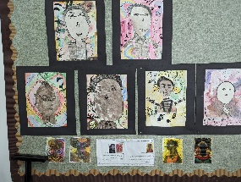  Forest School project:  Nature Prints  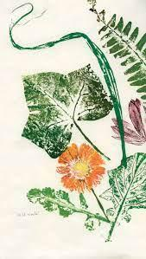  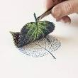  Focus Artist:  Chris Ofilli | Art:  Painting and Digital Media:  Wax and watercolours paintings  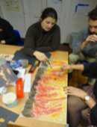  Making animated drawings  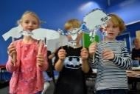  Access Art unit adapted to GFOL project  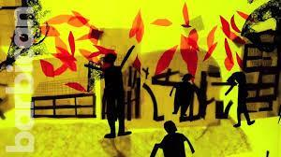  Focus Artists:  Lieve Verschuier, Holly Summerson, Lauren Child, | Art:  Drawing and Sculpture:  Clay Dragon’s Eyes  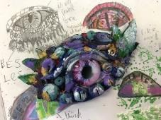  Focus Artists:  Gustave Moreau | Art:  Textiles: - Cloth, Thread and Paint  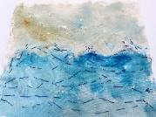  Focus Artists :  Charlie French  Van Gogh  Alice Kettle  Hannah Rae | Art:  Printing:  Make packaging for British Bake Off  (DT/Art project)  Access Art | Art:  Take One Picture
DT:  DT  Mechanisms:  Sliders and Levers  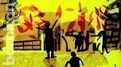  Adapted kapow unit for GFOL animation |  | DT:  Textiles:  Making a pouch  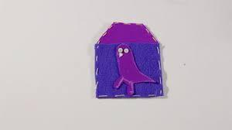  Kapow unit |  | DT:  3D Structures/ Design:  Packaging  DT/Art project)  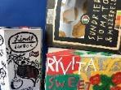  Access Art  Food: Great British Bake Off | DT:  Food:  A Balanced Diet – Wrap  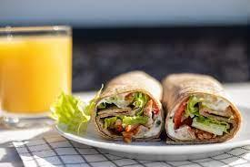  Kapow unit
Music:  Jolly Music:  - Revise so, mi  - Combine pitch and rhythm notation  - Perform pulse and rhythm simultaneously | Music:  Jolly Music/ Nativity-  - Read and write rhythms using rhythm names  - Work at internalising and pitch recognition | Music:  Jolly Music:  - Recognise and demonstrate simple phrasing  - Read rhythms | Music:  Jolly Music:  - Revise know rhythm repertoire  - Pulse-keeping/ phrasing/ written rhythms/ la–so–mi | Music:  Jolly Music:  - Explore faster/ slower pulse-keeping  - Work on pulse in songs with rests | Music:  Jolly Music:  - Preparing la and reading rhythms  - Learn la solfa name and handsigns.  - Learn notation for ta rest.  Composition linked to Take One Picture
Western Classical – Early, Baroque, Renaissance, Classical Era | Western Classical Romantic and up to 1940’s | Western Classical 20th Century Music | 20th and  21st Century Music including Film and Musical Theatre | Popular Music | World Music and Folk Music
PSHE:  Physical health and wellbeing  What keeps me healthy? | PSHE:  Mental health and emotional wellbeing  Friendship | PSHE:  Relationships and  health education  Boys and girls, families | PSHE:  Relationships and health education  Boys and girls, families | PSHE:  Keeping safe and managing risk  Indoors and outdoors | PSHE:  Drug, alcohol and tobacco education  Medicines and me
RE:  Who is a Muslim and what do they believe? | RE:  How and why do we celebrate special and sacred times? | RE:  Who is Jewish and what do they believe? | RE:  What can we learn from sacred books? | RE:  What makes some places sacred?
PE:  Games – Dodging  Jumping | PE:  Pathways  Hands 1 | PE:  Feet  Games for Understanding | PE:  Dance  Linking | PE:  Hands 2  Forest School | PE:  Health and Wellbeing/Yoga  Rackets, Bats and Balls
Global Citizenship:  Equality and Rights  Power and Governance (4 weeks)  Who gets to make the rules? How can we make it fair?  How can people change rules that they think are not fair?  Project Outcome: School Elections  Social Justice and Equity (6 weeks)  What is equality?  Why do some people have more than others?  Why don’t some children have clean water to drink?  How can we help people who don’t have enough  Project Outcome – Social Enterprise : Raise money for Water Aid  Human Rights (5 weeks)  What are your rights at school?  Rights and responsibilities. How can you respect the rights of other people at school?  How should we treat someone with different beliefs?  Does everyone have the right to Education?  Project Outcome: Create a School Charter of Rights and Responsibilities (gather views from other classes to include) |  | Global Citizenship:  Respect for Others  Identity and Diversity (8 weeks)  What would the world be like if we were all the same?  Where do I belong? What does belonging mean?  Why do you think it’s important to treat each other fairly?  Project Outcome: Kindness Postcards  Peace and Conflict (4 weeks)  What causes arguments?  What can we do when we don’t agree?  How can we express our point of view without offending others? |  | Global Citizenship:  Ecological Awareness  Sustainable Development (8 weeks)  Starting Point: Whole School Earth Day  How do the choices we make every day help or harm the environment?  Why is it important not to waste things?  How can we care for the environment and reduce our negative impact on it?  What questions can we ask to help us understand how to reduce, reuse and recycle better?  How can we listen to different ideas about looking after the environment and decide which ones might work best?  Globalisation and Interdependence (6 weeks)  How can looking after nature in our city help protect nature and the environment in other countries too?  What can we do in our school or neighbourhood to help protect local habitats like parks, rivers, gardens or green spaces?  How can small changes we make in our community help the planet as a whole?  How can we show others why protecting habitats is important?  How can we help make our school and local area a better place for people, plants and animals?
Global Citizenship Links:  International Day of Democracy  International Day of Peace  Black History Month – celebrating diversity  Dyslexia awareness week | Global Citizenship Links:  Universal Children’s Day  Anti- Bullying Week  Human Rights Day  Remembrance Day  Children in Need  Road Safety Week  World Philosophy Day | Global Citizenship Links:  International Women’s Day  International Mother Language Day  Children’s Mental Health Week | Global Citizenship Links:  Autism Awareness Day  Comic Relief  Fair Trade Fortnight  Mothering Sunday | Global Citizenship Links:  International Mother Earth Day  World Bee Day  Walk to school week  National Children’s Gardening Week | Global Citizenship Links:  BNF Healthy Eating Week  World Environment Day  World Oceans Day  World Refugee Day  Oxfam water week  Recycle Awareness Week  National School Grounds Week
Personal Safety:  - Introduction to the PANTS rule  - Being safe in the classroom/ school environment  - What to do when the fire alarm sounds  - Staying healthy – germs (see PSHE/RE) | Personal Safety:  - Firework safety  - Fire Safety  - Road Safety Be Safe Be Seen | Personal Safety:  - Dog Safety  - Stranger Danger  - Review PANTS rule | Personal Safety:  - Staying Safe at Home  - First Aid | Personal Safety:  - Road Safety- Green Cross Code  - Who keeps us safe  - Review PANTS rule | Personal Safety:  - Water safety  - Staying Safe in the Sun  - Cycle and Scooter Safety
P4C:  How Frog Lost his Tail (African tale in First Stories for Thinking) re ‘ugly’, ‘selfish’ & sharing | P4C:  Beegu: how do we/ should we respond to others who are ‘different’? who gets left out & why? | P4C:  Where the Wild Things Are: why do the Wild Things make Max king? What qualities (should) make a king/queen/ruler? | P4C:  The Storm Whale: where do we/whales ‘belong’?  also  St Columba & the Loch Ness Monster (in First Stories for Thinking) | P4C:  This is Not My Hat – Jon Klassen: is it ever okay to steal or lie? Link to writing: can pirates be ‘heroes’ if they steal? | P4C:  Ish or Dot by Peter Reynolds: who decides what is good art?
Emotional Literacy:  Self Awareness  Emotional Literacy Autumn 1 Booklet  Associated Skills  - Identifying emotions  - Accurate self-perception  - Recognising strengths  - Self-confidence  - Self-efficacy  Contents  Introduction: The RULER Anchor Tools – What are emotions, mood meter, class charter, best self.  Lesson 1: How am I feeling? - Excited  Lesson 2: How am I feeling? - Frustrated  Lesson 3: How am I feeling? - Bored  Lesson 4: How am I feeling? - Peaceful  Lesson 5: Recognising and celebrating our strengths  Lesson 6: Self-efficacy and self confidence | Emotional Literacy:  Self Management  Emotional Literacy Autumn 2 Booklet  Associated Skills  - Impulse control  - Stress management  - Self-discipline  - Self-motivation  - Goal setting  - Organisational skills  - Growth Mindset  Contents  Lesson 1: How do you want to feel?  Lesson 2: Moving out of the red – worried  Lesson 3: Tool Kit to regulate emotions – worried  Lesson 4: Tool Kit to regulate emotions – worried  Lesson 5: Growth Mindset – resilience and the power of yet  Lesson 6: Setting Goals | Emotional Literacy:  Social Awareness  Emotional Literacy Spring 1 Booklet  Associated Skills  - Understanding emotions  - Empathy/sympathy  - Appreciating diversity  - Respect for others  Contents  Lesson 1: How do you want to feel? - Revisiting the class charter  Lesson 2: Solving a problem with the blueprint  Lesson 3: Recognising and understanding other people’s feelings  Lesson 4: Kindness  Lesson 5: Belonging and Community | Emotional Literacy:  Relationship Skills  Emotional Literacy Spring 2 Booklet  Associated Skills  - Communication  - Social engagement  - Relationship building  - Teamwork  Contents  Lesson 1: Thinking about friendship  Lesson 2: Giving someone a compliment  Lesson 3: Seeing something from another point of view  Lesson 4: Working well in a group | Emotional Literacy:  Responsible Decision Making  Emotional Literacy Summer 1 Booklet  Associated Skills  - Identifying problems  - Analysing solutions  - Solving problems  - Evaluating  - Reflecting  - Ethical responsibility  Contents  Lesson 1: Identifying Problems- Big problems and small problems  Lesson 2: Solving Problems – Brainstorm  Lesson 3: Solving Problems – What will happen?  Lesson 4: Making Choices  Lesson 5: Evaluating and Reflecting – Using the blueprint | Emotional Literacy:  Anti Bullying/ Transition  SEAL – Say No to Bullying  - I can tell you what bullying is.  - I can tell you some ways in which I am the same as and different from my friends.  - I am proud of the ways in which I am different. I can tell you how someone who is bullied feels.  - I can be kind to children who are bullied.  - I know that when you feel sad, it affects the way you behave and how you think.  - I know some people in and out of school who I could talk to if I was feeling unhappy or being bullied.  I know what to do if I am bullied.
Enrichment Opportunities:  Museum of London – Suffragettes workshop  Tate Britain  KS1 LSO Discovery Concert | Enrichment Opportunities:  Wren 500 Great Fire of London Walk  Guildhall Gallery  3 Discovery Animation Project  Museum of Methodism | Enrichment Opportunities:  Tower of London  Charterhouse -Fit for a Queen  Synagogue | Enrichment Opportunities:  The Golden Hinde  Diana Memorial Playground  Garden Classroom – Treetops and Treasure Trails | Enrichment Opportunities:  Science:  Hampstead Heath – Heath Beasts | Enrichment Opportunities:  Linked to Take One Picture  Hampstead Heath – Mad About Maps
School, Family and Community Events:  International Evening  Class Tea Party  Class led workshop – mental health and wellbeing  Art Exhibition | School, Family and Community Events:  Interfaith Week  Children in Need  Community Carol Concert  Christmas Fair | School, Family and Community Events:  Museum week / Banquet  Class led workshop – safer internet day | School, Family and Community Events:  Comic Relief  Spring Concert  Science Fair  World Book Day  Pirate Treasure HUnt | School, Family and Community Events:  World Earth Day  Learning Outside the Classroom Day  Eid Disco  Moreland’s Got Talent | School, Family and Community Events:  National Field Work week  Summer Picnic  Sports Day

