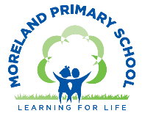
Year 3 Long Term Curriculum Map 2025-26
Autumn Term |  | Spring Term |  | Summer Term:
Autumn 1  Nelson Mandela and Apartheid | Autumn 2  Go with the Flow-Waterways of London | Spring 1  Active Planet | Spring 2  80 Days Around the World | Summer 1  Stone Age to Iron Age | Summer 2  Take One Picture
Core Text: A Long Walk to Freedom  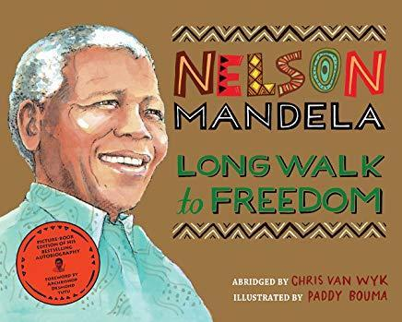 | Core Texts: A River/ The Thames and Tide Club  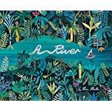  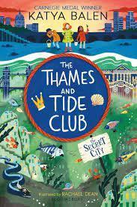 | Core Texts: The Fire Maker’s Daughter (WCR)/ Tom and the Island of Dinosaurs  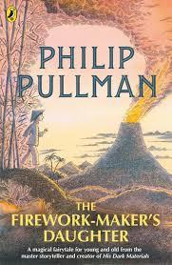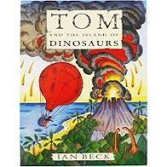 | Core Text: Around the World in 80 Days  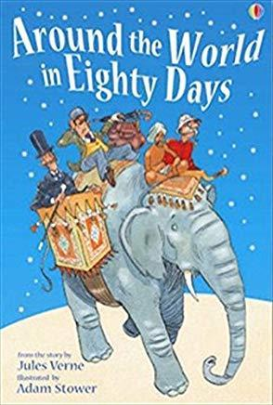 | Core Texts: The Wild Way Home (WCR) / Stone Age Boy  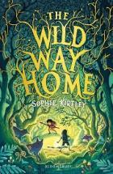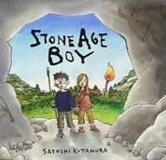 | Core Text: Fair Shares  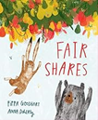
Writing Outcome:  To write a historical recount about Nelson Mandela  To write a poem | Writing Outcome:  To write a setting description e.g. a description of the river landscape  To write an advert | Writing Outcome:  To write an adventure story with a volcanic eruption  To write a personal narrative about the eruption of Pompei | Writing Outcome:  To write a travel blog or guide  To write an information leaflet about rocks | Writing Outcome:  To write an Historical Narrative set in the Stone Age | Writing Outcome:  Social Action Project
Other Suggested Texts:  Journey to Jo’burg  Grandad Mandela  The Akimbo Adventures  Freedom We Sing  The White Giraffe  Africa Amazing Africa  Change Sings | Other Suggested Texts:  Wind in the Willows  The City of Secret Rivers  The Frost Fair  Journey to the River Sea | Other Suggested Texts:  Escape from Pompeii  King of the Cloud Forests  A pebble in my Pocket  When the Giant Stirred  When the Mountains Roared  Running on the Roof of the World  Into the Volcano | Other Suggested Texts:  Asha and the Spirit Bird  The Boy Who Cycled the World  Tales from India  Jasmine Skies  The Wheel of Surya  Adventures on Trains  Girl on a Motorcycle  A Gift for Amma: Market Day in India | Other Suggested Texts:  Ug  Wolf Brother  The Boy with the Bronze Axe  The Wild Way Home  The First Drawing | Other Texts:
Poetry:  Child of Africa – Wayne Visser  The Sound Collector – Roger McGough  Walking with My Iguana – Brian Moses | Poetry:  Duck’s Ditty – Kenneth Graham  The River –Valerie Bloom  My Shadow – Robert Louis Stephenson  When Daddy Fell into the Pond - | Poetry:  Don’t be Bored Rock – Zaro Weil | Poetry:  Geography Lesson –Brian Patten  From a Railway Carriage – Robert Louis Stephenson  The Owl and the Pussycat – Edward Lear | Poetry:  The Harvest Moon – Ted Hughes | Poetry:
White Rose Maths:  Place Value  Addition and Subtraction  Multiplication and Division |  | White Rose Maths:  Multiplication and Division  Length and Perimeter  Fractions  Mass, Capacity and Temperature |  | White Rose Maths:  Fractions  Money  Time  Shape  Statistics
Science:  Animals including humans  Working Scientifically:  Comparative tests | Science:  Forces and Magnets  Working Scientifically:  Recording findings | Science:  Rocks | Science:  Revisit Animals Including Humans  Science Fair project | Science:  Light  Revisit Rocks | Science:  Plants  Working Scientifically: Using data to draw simple conclusions
Topic Enquiry: Nelson Mandela and Apartheid  History:  - Finding out about apartheid in S Africa  - Finding out about the life of Nelson Mandela  - Looking at the impact and changes that resulted from his actions.  Geography: South Africa  - Finding out about the Geography of South Africa | Topic Enquiry: Go with the Flow – Waterways of London  History:  - Investigating the historical sources that tell us about the impact of the River Thames on London’s history.  Geography:  - Understanding the course of a river  - Identifying key features of a river  - Finding out about the River Thames including the journey of the river and its effect on the physical and human geography of London. | Topic Enquiry: Active Planet  History: Pompei  - Finding out about the eruption of Mount Vesuvius and its impact on the city of Pompeii.  Geography: Plate Tectonics  Finding out:  - How the earth is constructed and plate tectonics.  - How mountains are formed, where the main mountain ranges are located in the UK and the world and the geographical features of a mountain (Mount Everest).  - The different types of volcanoes, how and why they erupt and the structure of a volcano.  - Why people choose to live near volcanoes.  - How and why earthquakes occur and the effects they have.  - Learning about the San Andreas Fault and the Japanese earthquake of 2011. | Topic Enquiry: 80 Days Around the World  Geography:  Finding out about:  - The journey Phileas Fogg took, finding the countries and cities using different maps and plotting his journey.  - The history of the atlas.  - Climate zones.  - Lines of latitude and longitude, time zones, the equator and the northern and southern hemisphere and how these relate to the journey taken by Phileas Fogg.  - How to compare an area of Europe (French Alps) visited by Fogg with an area in the UK (Lake District)  - Some of the countries visited by Fogg on his journey | Topic Enquiry: Stone Age to Iron Age  History:  - Finding out about life in the Stone age, Bronze Age and Iron Age.  - Looking at sources of evidence to support our enquiries.  Geography: Applying Skills  - Finding out about the location of iron age settlements | Topic Enquiry:  Geography:  Local Fieldwork Project  - Exploring changes in land use through local fieldwork at the City Road Basin  History:  Local History Enquiry  - Finding out about the history of the Regent’s Canal and City Road Basin.
Computing:  E Safety : Media Balance and Well Being -  Device-Free Moments (UK)  Connecting Computers | Computing:  E Safety: Cyber Bullying -  Putting a STOP to Online Meanness  Google Docs | Computing:  E Safety: News and Media Literacy -  We, the Digital Citizens (UK)  Data and Information –Branching Database (J2 Data- J2 Branch) | Computing:  E Safety: Privacy and Security -  That's Private! (UK)  J2 Animate  Creating Media- Desktop Publishing and Blogging (J25) | Computing:  E Safety: Digital Footprint and Identity -  Digital Trails (UK)  Code.org – Course B | Computing:  E Safety: Relationships and Communication -  Who Is in Your Online Community?  Sequencing with Scratch Animation
Art:  Textiles:  Inspired by Africa  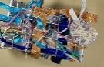  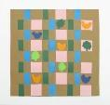  Focus Artists:  Ibrahim Mahama, Adekunle Adeleke, Siwa Mgoboza | Art:  Painting /Sculpture:  Reflections on water (colour mixing)    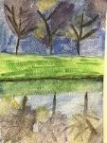  Focus Artists:  Monet | Art:  Painting:  Landscapes  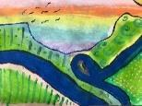  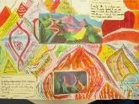  Focus Artists:  Turner, Hockney  Forest School Project: Making Rafts  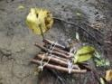 |  | Art:  Take One Picture
DT:  Mechanical Systems:  Pneumatic Toys  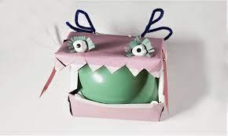  Kapow Unit |  | DT:  Structures :  Design an earthquake proof building  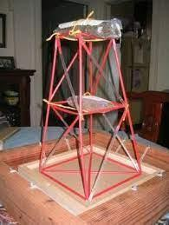 | DT:  Textiles:  Applique  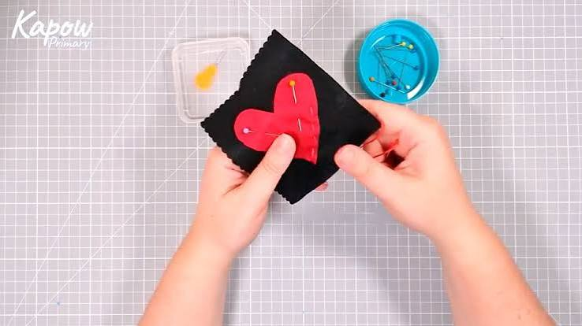  Kapow Unit | DT:  Food:  Seasonal Foods  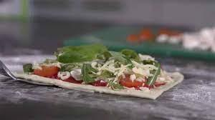  Kapow Unit
Country Trust Project – runs all year. Children explore growing, cooking, hold a market, prepare a harvest feast and visit a farm.
Music:  Developing Singing technique – Nativity Play  Kapow Unit: Reggae Rhythms: Playing in a band  Instrumental Lessons – Glockenspiel or Keyboards |  | Music:  Developing Singing technique - Spring concert  Kapow Unit: Inspired by India  Instrumental Lessons – Keyboards |  | Music:  Composition project linked to Take One Picture working with the Musicians Company (Summer 2)  Kapow Unit: Baroque Meets Pop or Reading Rhythms: Patterns and Layers  Instrumental Lessons – Keyboards
Western Classical – Early, Baroque, Renaissance, Classical Era | Western Classical Romantic and up to 1940’s | Western Classical 20th Century Music | 20th and 21st Century Music including Film and Musical Theatre | Popular Music | World Music and Folk Music
Spanish:  Phonetics 1  I am Learning Spanish | Spanish:  Animals (E) | Spanish:  I Know How To… | Spanish:  Fruits (E) | Spanish:  Ice-Creams (E)
PSHE:  Drug, alcohol and tobacco education  Tobacco is a drug | PSHE:  Mental health and emotional wellbeing  Strengths and challenges | PSHE:  Identity, society and equality  Celebrating difference | PSHE:  Physical health and wellbeing  What helps me choose? | PSHE:  Careers, financial capability and economic wellbeing  Saving, spending and budgeting | PSHE:  Keeping safe and managing risk  Bullying – see it, say it, stop
RE:  Why are festivals important to religious communities? | RE:  What do different people believe about God? | RE:  Why do people pray? | RE:  Why do some people think that life is a journey? What significant experiences mark this? | RE:  What does it mean to be a Hindu in Britain today?
PE:  Games – Netball  Forest School | PE:  Games – Football  Dance | PE:  Games – Netball  Orienteering | PE:  Games – Tag Rugby  Gymnastics | PE:  Games – Tennis  Swimming | PE:  Games - Cricket  Athletics
Global Citizenship:  Equality and Rights  Power and Governance (4 weeks)  Why do we need rules at school?  How can people take part in making and changing the rules at school?  Project Outcome: School Elections  Social Justice and Equity (6 weeks)  What causes inequality?  Should we all be equal? Is this always fair?  Should boys and girls be treated the same?  What is gender inequality?  (The Pay Gap, Education gap)  How would Gender equality change your life and change the world?  Project Outcome – Social Enterprise: Raise money for the Malala Fund  Human Rights (5 weeks)  What is the UN Convention on the Rights of the Child?  Why do some people have their Human Rights denied?  What can we do when someone is treated badly?  What is a consequence? Why do we have them?  Project Outcome: Amnesty International Campaign (weighing it up) – presentation to the Head Teacher |  | Global Citizenship:  Respect for Others  Identity and Diversity (8 weeks)  What does culture mean to me?  How do our differences help make the world a more interesting and better place?  How do I celebrate different cultures?  Does a person have to earn respect, or do all people deserve it?  What role does respect play in your relationships with friends and family?  Project Outcome: Link to International Mother Tongue Day – organise a celebration of different languages across the school  Peace and Conflict (4 weeks)  How do my actions impact others?  How can I solve arguments effectively and fairly?  What can we learn from disagreements? |  | Global Citizenship:  Ecological Awareness  Sustainable Development (8 weeks)  Starting Point: Whole School Earth Day  What do we need from our planet?  How do people, plants and animals depend on the environment to survive and thrive?  Why are we responsible for our planet?  What can we do as individuals and a community to take responsibility and look after the planet?  How can we share our ideas with people who make decisions?  Globalisation and Interdependence (6 weeks)  How is the food we eat connected to people and places all over the world?  In what ways does our local community rely on other countries for the food we enjoy every day?  What does “fair trade” mean, and why does it matter for the people who grow our food?  How can choosing certain foods (local, seasonal, fair trade) help people and the planet?  How do the everyday choices we make about food have global consequences?  How can young people make their voices heard on issues like fair trade, food waste or school food choices?  Social Action Project
Global Citizenship Links:  International Day of Democracy  International Day of Peace  Black History Month – celebrating diversity  Dyslexia awareness week | Global Citizenship Links:  Universal Children’s Day  Anti- Bullying Week  Human Rights Day  Remembrance Day  Children in Need  Road Safety Week  World Philosophy Day | Global Citizenship Links:  International Women’s Day  International Mother Language Day  Children’s Mental Health Week | Global Citizenship Links:  Autism Awareness Day  Comic Relief  Fair Trade Fortnight  Mothering Sunday | Global Citizenship Links:  International Mother Earth Day  World Bee Day  Walk to school week  National Children’s Gardening Week | Global Citizenship Links:  BNF Healthy Eating Week  World Environment Day  World Oceans Day  World Refugee Day  Oxfam water week  Recycle Awareness Week  National School Grounds Week
P4C:  Something Else: how do we/ should we treat others who are or seem ‘different’? | P4C:  The World Belongs to You – Bozzi/Zagnoli: what does it mean to be free? What are the limits to freedom? | P4C:  Mizilca or other tale in Lurie’s Clever Gretchen: can girls be ‘heroic’? Why so few heroines in adventures & folk tales? | P4C:  BBC film, What Makes Me Me? raises ‘big idea’ questions. Are you the same person from birth to old age? | P4C:  Compare cave drawings and contemporary graffiti: Why draw? What makes it ‘art’ or ‘vandalism’? | P4C:  ‘The Forgotten Treasure’ (First Stories for Thinking): what do we ‘treasure’? could a flower be more valuable than gold?
Emotional Literacy:  Self-Awareness  Emotional Literacy Booklet Autumn 1  Associated Skills  - Identifying emotions  - Accurate self-perception  - Recognising strengths  - Self-confidence  - Self-efficacy  Contents  Introduction: The RULER Anchor Tools – What are emotions, mood meter, class charter, best self.  Lesson 1: How am I feeling? - Joyful  Lesson 2: How am I feeling? - Furious  Lesson 3: How am I feeling? - Jealous  Lesson 4: How am I feeling? - Relaxed  Lesson 5: Recognising and celebrating our achievements and reflecting on our strengths  Lesson 6: Self-efficacy and self confidence | Emotional Literacy:  Self Management  Emotional Literacy Booklet Autumn 2  Associated Skills  - Impulse control  - Stress management  - Self-discipline  - Self-motivation  - Goal setting  - Organisational skills  - Growth Mindset  Contents  Lesson 1: How do you want to feel?  Lesson 2: Moving out of the red – scared  Lesson 3: Tool Kit to regulate emotions – scared  Lesson 4: Managing Change  Lesson 5: Growth Mindset – grow your brain  Lesson 6: Aspiration and Setting Goals | Emotional Literacy:  Social Awareness  Emotional Literacy Spring 1 Booklet  Associated Skills  - Understanding emotions  - Empathy/sympathy  - Appreciating diversity  - Respect for others  Contents  Lesson 1: How do you want to feel? - Revisiting the class charter  Lesson 2: Recognising and understanding other people’s feelings  Lesson 3: Solving a problem with the blueprint  Lesson 4: Kindness – Giving and receiving compliments  Lesson 5: Belonging and Community | Emotional Literacy:  Relationship Skills  Emotional Literacy Booklet Spring 2  Associated Skills  - Communication  - Social engagement  - Relationship building  - Teamwork  Contents  Lesson 1: Friendship Skills  Lesson 2: Revisiting Anger  Lesson 3: Peaceful problem solving  Lesson 4: Asking for help  Lesson 5: Working in a group | Emotional Literacy:  Responsible Decision Making  Emotional Literacy Booklet Summer 1  Associated Skills  - Identifying problems  - Analysing solutions  - Solving problems  - Evaluating  - Reflecting  - Ethical responsibility  Contents  Lesson 1: Identifying Problems  Lesson 2: Identifying Solutions  Lesson 3: Analysing solutions – consequences  Lesson 4: Taking Action  Lesson 5: Evaluating and Reflecting | Emotional Literacy:  Anti Bullying/ Transition  SEAL – Say No to Bullying  - I can tell you what bullying is.  - I know what it means to be a witness to bullying. I know that witnesses can make the situation better or worse by what they do.  - I know how it might feel to be a witness to and a target of bullying.  - I can tell you why witnesses sometimes join in with bullying or don’t tell.  - I can tell you some ways of helping to make someone who is bullied feel better.  - I know that sometimes bullying is hard to spot and I know what to do if I think it is going on but I am not sure.  - I can problem solve a bullying situation with others.
Personal Safety:  - Introduction to the PANTS rule  - Being safe in the classroom/ school environment  - What to do when the fire alarm sounds  - Drugs, alcohol and tobacco (see PSHE/RE) | Personal Safety:  - Firework safety  - Fire Safety  - Road Safety Be Safe Be Seen | Personal Safety:  - Dog Safety  - Stranger Danger  - Review PANTS rule | Personal Safety:  - Staying Safe at Home  - First Aid | Personal Safety:  - Road Safety- Green Cross Code  - Who keeps us safe  - Review PANTS rule | Personal Safety:  - Water safety  - Staying Safe in the Sun  - Cycle and Scooter Safety
Enrichment Opportunities:  Anti Apartheid Legacy Centre  TGC – Citizens of the World Unite | Enrichment Opportunities:  Museum of Docklands – Locks, Lifting and Loads  Thames Explorer Trust  City Basin – field work  Port of London – Thames and Trade workshop  Courtauld Gallery – Art and Impressionism | Enrichment Opportunities:  Geobus – Hazards  Natural History Museum – volcanoes and earthquakes  Hampstead Heath – Soil Detectives | Enrichment Opportunities:  British Library – Voyage into Maps  TGC – The World Came to my place today  Wallace Collection – Landscapes and Seascapes  Hindu Temple  3 Discovery workshop | Enrichment Opportunities:  John Soanes Museum – Light  Hampstead Heath – Stone Age Survivors/ Celtic Harmony | Enrichment Opportunities:  National Gallery  TGC – Know How Plants Grow
School, Family and Community Events:  International Evening  Class Tea Party  Class led workshop – mental health and wellbeing  Art Exhibition | School, Family and Community Events:  Interfaith Week  Children in Need  Community Carol Concert  Christmas Fair  Nativity Play | School, Family and Community Events:  Museum week  Class led workshop – safer internet day  Moreland’s Got Talent | School, Family and Community Events:  Comic Relief  Spring Concert  Science Fair  World Book Day | School, Family and Community Events:  World Earth Day  Learning Outside the Classroom Day  Sports Day  Eid Disco | School, Family and Community Events:  National Field Work week  Summer Picnic

