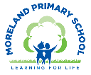
Year 5 Long Term Curriculum Map 25-26
Autumn Term |  | Spring Term |  | Summer Term:
Autumn 1  The Trans Atlantic Slave Trade | Autumn 2  Londinium: Roman London | Spring 1  Anglo Saxons, Scots and Vikings | Spring 2  Where we live | Summer 1  Weather and Climate | Summer 2  Take One Picture
Core Text: Freedom  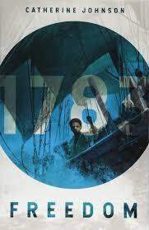 | Core Text: The Time Traveller Diaries  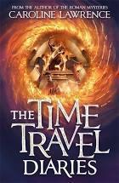 | Core Text: Beowulf  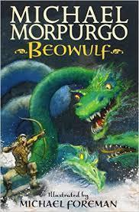 | Core Text: Choice of Shakespeare Play  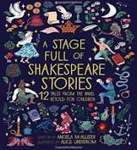 | Core Text: Shackleton’s Journey  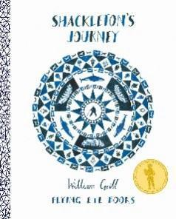 | Core Text: The Last Wild  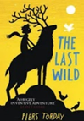
Writing Outcome:  Persuasive writing – abolition of slavery  Write a poem | Writing Outcome:  Write a time travel adventure story set in Roman London  Write a setting description – Miithraeum | Writing Outcome:  Write a myth or legend  Write a character description | Writing Outcome:  Linked to chosen play (e.g. Macbeth – 2 sided argument  Design and write a science experiment | Writing Outcome:  Write a historical recount of Shackleton’s expedition  Persuasive writing on an aspect of climate change/ advert | Writing Outcome:  Social Action project
Other Suggested Texts:  Oh Freedom  Journey Back to Freedom  Two Sisters : A story of Freedom  A Nest of Vipers  Chains  Pirates | Other Suggested Texts:  The Orchard Book of Roman Myths  The Roman Quests  Empire’s End : A Roman Story | Other Suggested Texts:  How to Train Your Dragon  The Hobbit  The Girl of Ink and Stars  The Buried Crown  Arthur  Norse Myths  Norse Mythology – Neil Gaiman  Viking Boy | Other Suggested Texts:  Playing with Plays Series  King of Shadows | Other Suggested Texts:  Floodland  The Last Wild  Race to the Frozen North  Sky Song  The Polar Bears Explorers club  Dear Greenpeace  Song of the Dolphin Boy  The Extraordinary colours of Auden Dare | Other Suggested Texts:
Poetry:  Rap Poetry - Tennessee  Caged Bird- Maya Angelou  Linked to National Poetry Day (writing a poem)  The Lost Words | Poetry:  The Tyger-  William Blake | Poetry:  A Small Dragon- Brian Patten  The Highway Man – Alfred Noyes | Poetry:  Shall I Compare Thee to a Summer’s Day – William Shakespeare  City of My Birth | Poetry:  I am a Writer - Joseph Coelho | Poetry:
White Rose Maths:  Place Value  Addition and Subtraction  Multiplication and Division  Fractions A |  | White Rose Maths:  Multiplication and Division  Fractions B  Decimals and Percentages  Perimeter and Area  Statistics |  | White Rose Maths:  Shape  Position and Direction  Decimals  Negative Numbers  Converting Units  Volume
Science:  Living things and their habitats | Science:  Properties and changes in materials  Working Scientifically: Recognising and  controlling variables | Science:  Forces | Science:  Revisit Living Things and their Habitats  Science Fair Project | Science:  Animals including Humans  Working Scientifically: Measuring  accurately | Science:  Earth and Space  Working Scientifically: Drawing & explaining conclusions
Topic Enquiry: The Trans Atlantic Slave Trade  History:  Find out about:  - The history of the Trans- Atlantic Slave Trade  - The role of Britain in the Slave Trade  - Key historic figures such as Harriet Tubman and Olaudah Equiano, William Wilberforce  - The abolitionist movement and its impact  Geography: Application of skills  - The location of the major countries involved in the Slave Trade  - How to use maps to understand the slave trade routes  - The impact on human geography of the slave trade | Topic Enquiry: Londinium- Roman London  History:  Find out about:  - The Roman Empire  - The Roman invasion of Britain  - The growth of Roman London  - Life in Roman London  - Why the Romans left Britain  Geography:  Find out about:  - The impact of Roman life on the Geography of London  - The location of Roman sites in London and the UK. | Topic Enquiry: Anglo Saxons, Scots and Vikings  History:  Find out about:  - The reasons for the Anglo Saxons and Scots coming to Britain (compare to Romans)  - Where the tribes came from, where the Anglo Saxons and Scots settled and how we know this.  - Anglo Saxon rule in Britain  - The Vikings- who they were, why they invaded and how the Saxons were able to see off the threat  - The achievements of King Alfred and his daughter Aethelflaed  Geography: Application of skills to identify:  - Where the Saxons and Vikings settled.  - Where the main Anglo Saxon Kingdoms developed  - How place names give us clues as to who lived there.  - The countries that the Vikings invaded, raided and traded with | Topic Enquiry: Where we Live  Geography:  Find out about:  - The human and physical geography of the UK and its 4 constituent countries.  - How to use aerial photography to identify features of topography and human land use in the UK  - The industrial origin of settlement in the UK.  - How to use maps to locate features of the local area and how to create maps of the local area.  - How to use a compass for directions and how to locate things on a map using 6 figure grid references | Topic Enquiry: Weather and Climate – focus on Antarctica  History: Shackleton  Find out about Shackleton’s Antarctic expedition.  Geography:  Find out about:  - The difference between weather and climate  - The world’s main climate zones – locating and describing their main features  - Polar climates focusing on Antarctica  - How to use sources of geographical information to find out information.  - The longitude, latitude, weather, time zones and seasons of Antarctica.  - Antarctic exploration including Ernest Shackleton’s expedition to Antarctica.  - Current exploration and scientific investigation of Antarctica  - Climate change, its effects and the impact of this on Antarctica  - How climate change can be prevented | Topic Enquiry: Farm to Fork  Geography:  Find out about:  - Farming and food production in the UK  - How local climate, landscape and traditions shape farming practices  - The importance of seasonal eating and buying local produce  - Environmentally sustainable farming practices  - A local fieldwork project  History :  Local History Field Work Study linked to Geography  - How to carry out local field work focused on changes to the built environment over time
Computing:  E Safety: Media Balance and Wellbeing -  My Media Choices  History of Computing | Computing:  E Safety: Cyber Bullying-  Be a Super Digital Citizen  Vector Drawing – Google Drawings | Computing:  E Safety: News and Media Literacy -  A Creator's Rights and Responsibilities  iMovie – Camera Angles, Frames and Editing | Computing:  E Safety: Privacy and Security -  Private and Personal Information  Data and Information -J2E | Computing:  E Safety: Digital Footprint and Identity-  Our Online Tracks  Selection in Quizzes | Computing:  E Safety: Relationships and Communication -  Keeping Games Fun and Friendly  Scratch- Variables in Games
Art:  3D Collage:  Layered Silhouettes  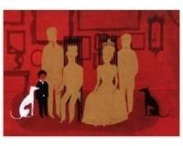  Focus Artist:  Kara Walker, Vanessa Marsh | Art:  Drawing / Sculpture:  Roman Portraits  Clay Pots  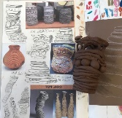  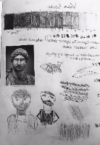  Focus Art:  Roman Sculpture and Pots  Forest School Project: Decorate a Tree  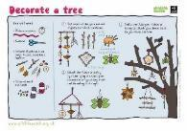 | Art:  Drawing  Architecture – Buildings  cityscapes  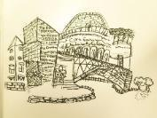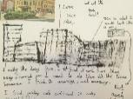  Focus Artists:  LS Lowry  Zaha Hadid  Shoreditch Sketcher |  | Art:  Take One Picture
DT:  Textiles - Design Stuffed Toy  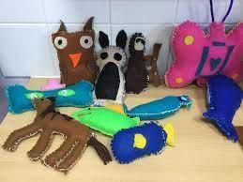  Kapow Unit | DT:  Digital World  Monitoring Devices  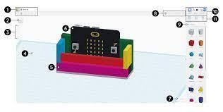  Kapow Unit | DT:  Structures: Design a Playground  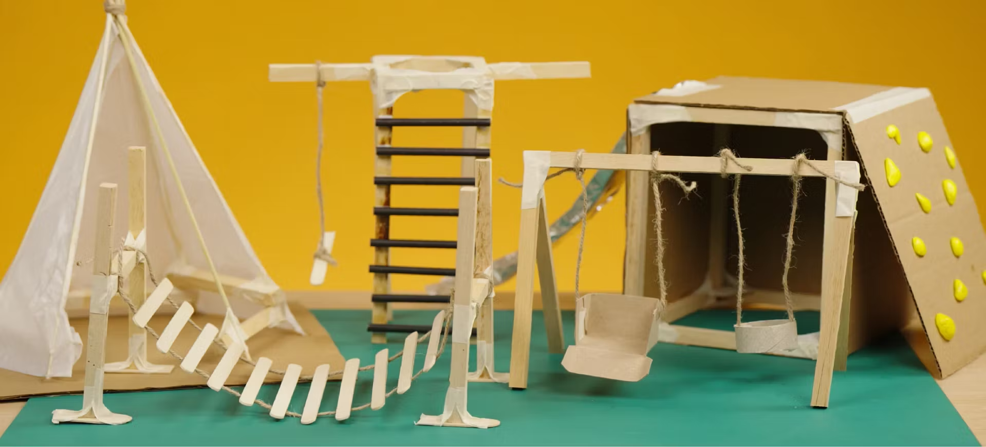  Kapow Unit |  | Design Project - Climate Change All Change | DT:  Food  Developing a Recipe  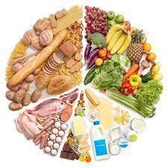  Kapow Unit
Music:  Developing Singing technique –Young Voices  Kapow Unit: West Africa Rhythms  Instrumental Lessons – Keyboards |  | Music:  Developing Singing technique –Young Voices/ Spring Concert  Kapow Unit: Three Chord Pop - Playing in a Band  Instrumental Lessons – Keyboards |  | Music:  Composition Project linked to Take One Picture using keyboards  Kapow Unit : Stage and Song  Instrumental Lessons – Keyboards
Western Classical – Early, Baroque, Renaissance, Classical Era | Western Classical Romantic and up to 1940’s | Western Classical 20th Century Music | 20th and 21st Century Music including Film and Musical Theatre | Popular Music | World Music and Folk Music
Spanish:  Phonetics 2-3  The Date (I) |  | Spanish:  At the Café | Spanish:  Do You Have a Pet? (I) | Spanish:  What is the Weather? (I) | Spanish:  My Home (I)
PSHE:  Mental health and  emotional wellbeing  Dealing with feelings | PSHE:  Drug, alcohol and  tobacco education  Different influences | PSHE:  Identity, society  and equality  Stereotypes,  discrimination and  prejudice | PSHE:  Physical health  and wellbeing  In the media | PSHE:  Keeping safe and  managing risk  Making safer choices | PSHE:  Careers, financial  capability and  economic wellbeing  Borrowing and earning  money
RE:  What does it mean to be a Muslim in Britain today? | RE:  Why do some people believe God exists? | RE:  What would Jesus do?(Can we live by the values of Jesus in the 21st century) |  | RE:  Green religion? What do religious and nonreligious worldviews teach about caring for the Earth? | RE:  If God is everywhere, why go to a place of worship?
PE:  Games – Tag Rugby  Swimming | PE:  Games – Netball  Games -Football | PE:  Dance  Games – Football | PE:  Orienteering  Gymnastics | PE:  Athletics  Games-Cricket | PE:  Forest School  Tennis
Global Citizenship:  Equality and Rights  Power and Governance (4 weeks)  How is the UK governed?  How are other countries governed? What differences are there?  Project Outcome: School Elections  Social Justice and Equity (6 weeks)  What is poverty? How can we measure it?  Can there be one definition of poverty? Why not?  Why are some people richer than others?  Why are some countries richer than others?  Why do we pay taxes?  Project Outcome – Social Enterprise : Raise money for Oxfam  Human Rights (5 weeks)  What rights do we have as Human Beings?  What is the Universal Declaration of Human Rights?  How do some systems treat people badly?  How could we act when a system treats people badly?  What did we learn about Human Rights from learning about the Trans- Atlantic Slave Trade?  Project Outcome: Amnesty International campaign (letter) |  | Global Citizenship:  Respect for Others  Identity and Diversity (8 weeks)  What is a stereotype?  What impact do prejudice and discrimination have?  What is gender equality?  How can we be more aware of the rights of groups that are more vulnerable than ourselves?  (Identify groups)  How could I make the world more inclusive?  Project Outcome: Link to International Women’s Day- create a display of Women Who Changed the World  Peace and Conflict (4 weeks)  How can I take responsibility for my actions?  Why is it important to compromise?  What is a fair way of resolving conflicts? |  | Global Citizenship:  Ecological Awareness  Sustainable Development (8 weeks)  Starting Point: Whole School Earth Day  Why is biodiversity essential for the health of our planet and for human life?  What are the deeper causes of climate change, and how might its impacts shape the future for people and ecosystems?  How are people and the planet interconnected, and why does this interdependence matter?  Should we worry about the impact of people’s lifestyle on the planet?  What do you think “We must be the change we want to see in the world” means?  How can young people identify meaningful actions and find ways to make their voices heard locally and globally?  Globalisation and Interdependence (6 weeks)  How does what happens in one part of the world affect people and environments somewhere else?  How are global changes—like climate change, trade, or technology—shaping the way people grow, buy, and eat food?  How do decisions made by governments, supermarkets, or consumers affect people and environments across national boundaries?  What happens when local choices create global consequences?  Who holds power in global food systems, and who doesn’t?  What does it mean to be an ethical consumer, and how can our food choices reflect our values?  How can our class or school create change in our community’s food habits?  Social Action Project
Global Citizenship Links:  International Day of Democracy  International Day of Peace  Black History Month – celebrating diversity  Dyslexia awareness week | Global Citizenship Links:  Universal Children’s Day  Anti- Bullying Week  Human Rights Day  Remembrance Day  Children in Need  Road Safety Week  World Philosophy Day | Global Citizenship Links:  International Women’s Day  International Mother Language Day  Children’s Mental Health Week | Global Citizenship Links:  Autism Awareness Day  Comic Relief  Fair Trade Fortnight  Mothering Sunday | Global Citizenship Links:  International Mother Earth Day  World Bee Day  Walk to school week  National Children’s Gardening Week | Global Citizenship Links:  BNF Healthy Eating Week  World Environment Day  World Oceans Day  World Refugee Day  Oxfam water week  Recycle Awareness Week  National School Grounds Week
P4C:  Slavery poem (see Poetry): can a slave keep a free mind? can we ever know another’s mind - or even our own? | P4C:  I have the right to be a child – Serres et al: rights & responsibilities, rules and laws – how do they overlap (or not)? | P4C:  Folk tales – moral dilemmas  The Red Tree – Shaun Tan: irritation to despair, dream to hope … link to PSHE | P4C:  Dangle film (youtube or literacyshed): on temptation and unintended consequences | P4C:  The Promise – Davies & Carlin: how a few stolen seeds transform a world. Is it a crime if the outcome is good? | P4C:  The Fun Theory 1 (piano stairs): is ‘goodvertising’ manipulative? Can/should fun change behaviour?
Emotional Literacy:  Self Awareness  Emotional Literacy Booklet Autumn 1  Associated Skills  - Identifying emotions  - Accurate self-perception  - Recognising strengths  - Self-confidence  - Self-efficacy  Contents  Introduction: The RULER Anchor Tools – What are emotions, mood meter, class charter, best self.  Lesson 1: How am I feeling? - Aspirational  Lesson 2: How am I feeling? - Anxious  Lesson 3: How am I feeling? - Embarrassed  Lesson 4: How am I feeling? – Grateful  Lesson 5: Recognising and celebrating our strengths and those of others  Lesson 6: Self-efficacy and self confidence | Emotional Literacy:  Self Management  Emotional Literacy Booklet Autumn 2  Associated Skills  - Impulse control  - Stress management  - Self-discipline  - Self-motivation  - Goal setting  - Organisational skills  - Growth Mindset  Contents  Lesson 1: How do you want to feel?  Lesson 2: Moving out of the red – dealing with feeling anger  Lesson 3: Tool Kit to regulate emotions – angry  Lesson 4: The importance of sleep  Lesson 5: Growth Mindset – Making mistakes  Lesson 6: Aspiration and Dreams | Emotional Literacy:  Social Awareness  Emotional Literacy Booklet Spring 1  Associated Skills  - Understanding emotions  - Empathy/sympathy  - Appreciating diversity  - Respect for others  Contents  Lesson 1: How do you want to feel? - Revisiting the class charter  Lesson 2: Social Awareness  Lesson 3: Solving a problem with the blueprint  Lesson 4: Kindness - Empathy  Lesson 5: Belonging and Community | Emotional Literacy:  Relationship Skills  Emotional Literacy Booklet Spring 2  Associated Skills  - Communication  - Social engagement  - Relationship building  - Teamwork  Contents  Lesson 1: Levels of friendship  Lesson 2: Managing conflict  Lesson 3: Making up  Lesson 4: Working in a group  Lesson 5: Who helps us keep healthy and safe?  Lesson 6: Peer pressure | Emotional Literacy:  Responsible Decision Making  Emotional Literacy Booklet Summer 1  Associated Skills  - Identifying problems  - Analysing solutions  - Solving problems  - Evaluating  - Reflecting  - Ethical responsibility  Contents  Lesson 1: Identifying Problems  Lesson 2: Identifying Solutions  Lesson 3: Analysing solutions – critical thinking  Lesson 4: Critical Thinking  Lesson 5: Making a Choice and Taking Action – Ethical Decision Making  Lesson 6: Evaluating and Reflecting | Emotional Literacy:  Anti Bullying/ Transition  SEAL – Say No to Bullying  - I understand how rumour-spreading and name-calling can be bullying behaviours.  - I can explain the difference between direct and indirect types of bullying.  - I can explain some of the ways in which one person (or group of people) can have power over another.  - I know some of the reasons why people use bullying behaviours.  - I know some ways to encourage children who use bullying behaviours to make other choices.  - I can tell you a range of strategies which I have for managing my feelings in bullying situations, and for problem solving when I am part of one.
Personal Safety:  - Introduction to the PANTS rule  - Being safe in the classroom/ school environment  - What to do when the fire alarm sounds | Personal Safety:  - Firework safety  - Fire Safety  - Road Safety Be Safe Be Seen  - Drug, alcohol and tobacco education (see PSHE/RSE) | Personal Safety:  - Dog Safety  - Stranger Danger  - Review PANTS rule | Personal Safety:  - Staying Safe at Home  - First Aid | Personal Safety:  - Road Safety- Green Cross Code  - Who keeps us safe  - Review PANTS rule | Personal Safety:  - Water safety  - Staying Safe in the Sun  - Cycle and Scooter Safety – Bikeability Course
Enrichment Opportunities:  Queen’s House – Diversity, Art and Citizenship  Museum of Docklands – Trans Atlantic Slave Trade  LMA – The Struggle Against Slavery  LSO KS2 Concert | Enrichment Opportunities:  London Mithraeum  Museum of London – Introducing Roman London  London Guildhall – Amphitheatre Experience | Enrichment Opportunities:  Young Voices -O2  British Museum – Sutton Hoo  3 Discovery Workshop | Enrichment Opportunities:  Zaha Hadid Studio visit  Tower Bridge – Designing London’s Skyline  Hampstead Heath – Maps and Orienteering  The Globe – Lively Action Macbeth | Enrichment Opportunities:  National Maritime Museum – Polar Explorers  BAS – Meet a scientist  Geobus – Arctic, Sea Ice and Climate workshop | Enrichment Opportunities:  Geobus – Planets and the Solar System  National Gallery  Country Trust Residential – South Downs  LMA – In your own backyard  Mosque visit  Royal Observatory Greenwich
School, Family and Community Events:  International Evening  Class Tea Party  Class led workshop – mental health and wellbeing  Art Exhibition | School, Family and Community Events:  Interfaith Week  Children in Need  Community Carol Concert  Christmas Fair | School, Family and Community Events:  Museum week  Class led workshop – safer internet day  Moreland’s Got Talent | School, Family and Community Events:  Comic Relief  Spring Concert  Science Fair  World Book Day | School, Family and Community Events:  World Earth Day  Learning Outside the Classroom Day  Sports Day  Eid Disco | School, Family and Community Events:  National Field Work week  Summer Picnic

