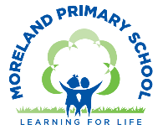
Year 6 Long Term Curriculum Map 26-27
Autumn Term |  | Spring Term |  | Summer Term:
Autumn 1  Civil Rights | Autumn 2  Victorian London | Spring 1  Going Global | Spring 2  The USA | Summer 1  AD900 | Summer 2  Take One Picture
Core Text: Hidden Figures  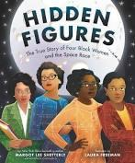 | Core Text: A Christmas Carol  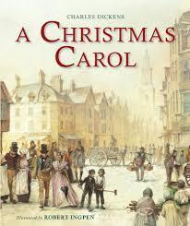 | Core Text: Kick  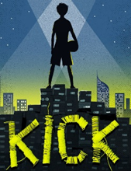 | Core Text: Holes  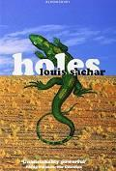 | Core Text: Children of the Benin Kingdom  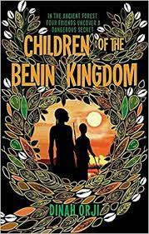 | Core Text: Save our Forests/ Rain Forest Warrior  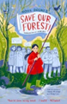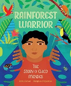
Writing Outcome: Write an autobiographical account of a figure from the civil rights movement.  Write a poem | Writing Outcome: Write a suspense story set in Victorian times.  Write a character or setting description | Writing Outcome:  Write a journalistic piece about an aspect of global trade e.g fair trade , the use of child labour, the impact on the environment of cotton production.  Write a persuasive letter | Writing Outcome:  Write an Adventure Story  Write a non- chronological report on lizards | Writing Outcome:  Write a discussion piece/ 2 sided argument about the Benin Bronzes. | Writing Outcome:  Social Action Project
Other Suggested Texts:  Katherine Johnson: A Life Story  Lies We Tell Ourselves  Brown Girl Dreaming  Becoming  Listen Layla  How High the Moon  Noughts and Crosses  A Change is Gonna Come  Lions of Little Rock  One Crazy Summer | Other Suggested Texts:  Cogheart  Street Child  Coram Boy  Ruby in the Smoke  Son of the Circus: A Victorian Boy  Oliver Twist  Gaslight  Twelve minutes to Midnight | Other Suggested Texts:  Trash | Other Suggested Texts:  Little House on the Prairie  Tom Sawyer  Children on the Oregon Trail  Grand Canyon – Jason Chin | Other Suggested Texts:  Tomb raiders  Kingdom of Benin short stories  Middle Earth | Other Suggested Texts:
Poetry:  Linked to National Poetry Day (poetry writing)  A Change is Gonna Come  Jamaican British  Reggae Head – Benjamin Zephaniah | Poetry:  Lewis Carroll – The Jaberwokky  The Charge of the Light Brigade Tennyson - | Poetry:  Sea Fever – John Masefield  A Smuggler’s Song – Rudyard Kipling | Poetry:  In beauty may I walk – Navajo prayer  I am a writer - Joseph Coelho | Poetry:  Micheal Rosen – Chocolate Cake | Poetry:
White Rose Maths:  Place Value  Four operations  Fractions A  Fractions B  Converting Units |  | White Rose Maths:  Ratio  Algebra  Decimals  Fractions, Decimals and Percentages  Area, Perimeter and Volume  Statistics |  | White Rose Maths:  Shape  Position and Direction  Themed Projects, Consolidation and Problem Solving
Science:  Electricity  Working Scientifically:  Identifying and explaining anomalies in data  Using test results to raise questions and make predictions | Science:  Light | Science:  Animals including humans | Science:  Animals including humans cont.  Science Fair project  Working Scientifically:  Recording data and results using different graphs | Science:  Evolution and inheritance | Science:  Living Things and Their Habitats
Topic Enquiry: Civil Rights  History:  Find out about:  - Life for African Americans in the USA before, during and after the Civil Rights movement  - The Jim Crow Laws  - Segregation in schools in the USA and Brown vs the Board of Education  - Key events in the civil rights movement – Little Rock and Greensboro and comparing them to civil rights movement in the UK – The Bristol Bus Boycott  - The key people in the civil rights movement such as Martin Luther King, Katherine Johnson, Rosa Parks  - The legacy of the civil rights movement  Geography: Application of skills  Find out about:  - the location of key civil rights activities in the USA and design an tour of the key sites using Digimaps. | Topic Enquiry: Victorian London  History:  Find out about:  - The reign of Queen Victoria  - Life in Victorian London : where people lived, what jobs they did, how they entertained themselves, what they wore and ate  - Childhood in Victorian London  - Development of industry and science in Victorian times  - The growth of the railways in Victorian times and the impact of this  - Crime and Punishment in Victorian times  - How the local area changed during Victorian times  Geography:  Find out about:  - The location of the British Empire.  - How the Victorians impacted on the Geography of London  - The growth of London using maps. | Topic Enquiry: Going Global  History:  Find out about :  - The history of global trade, looking at the trade of one commodity as an example e.g tea.  Geography:  Find out about:  - What trade is and how and why it has become global.  - The import and export of food to the UK and where the food we buy in the supermarket comes from.  - The global supply chain and the multi-stop journeys different products travel before reaching our shops.  - What products the UK exports, and which countries the UK exports the most to.  - The positive impact that buying fairtrade products has on communities in other countries. | Topic Enquiry: USA  Geography:  Find out about:  - The name and location of key features in the USA  - The distribution of population across the USA and factors that affect this pattern.  - The geographical similarities and differences of different places within USA.  - The diversity of physical landscapes in the USA.  - The location and formation of key physical features in the USA including the Grand Canyon.  - The location and features of key settlements in the USA.  - The impact of the environment on humans | Topic Enquiry: AD900 Benin  History:  Find out about:  - Why the Benin civilisation was of historical significance  - What life was like in Benin 1000 years ago and explain how we know about this  - The Benin Bronzes and the arguments for and against them being returned. | Topic Enquiry: The Amazon  Geography:  Find out about:  - The location of the continent of South America and some of its key physical and human features.  - The location of the Amazon basin and Amazon rainforest.  - The climate of South America.  - Tropical rainforest biomes.  - What it is like to live in the Amazon rainforest and the indigenous people who live there.  - The importance of the Amazon rainforest.  - The causes and consequences of deforestation in the Amazon.  - A local fieldwork project  History:  A local history enquiry (if not completed in Autumn 2)  - How the local area changed during Victorian times
Computing:  E Safety: Media Balance and Wellbeing  Finding My Media Balance  Digital Literacy – Common Sense Media  Computing Systems and Networks | Computing:  E Safety: Cyber Bullying  Is It Cyberbullying? (UK)  Creating Web Pages- Google Sites | Computing:  E Safety: News and Media Literacy  Reading News Online (UK)  Creating Media – 3D Modelling - Tinkercad | Computing:  E Safety: Privacy and Security  You Won't Believe This! (UK)  Sensing -Microbit – Step Counter (link to DT project) | Computing:  E Safety: Digital Footprint and Identity - Beyond Gender Stereotypes  Scratch – Variables in Games | Computing:  E Safety: Relationships and Communication -Digital Friendships  Data and Information – Flat File Databases (Excel+ sheets)
Art:  Printing (stencils)/ Graffiti:  Protest Art / Activism  Access Art Unit  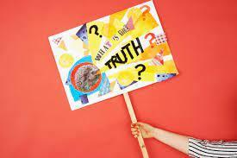  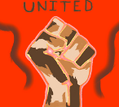  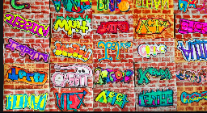  Focus Artists:  Faith Ringgold, Luba Lukova, Bob and Roberta Smith, Banksy | Art:  Painting/ Collage:  The Art of the Book Cover  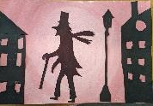  Focus Artist:  Ben Goodman | Art:  Upcycled Fashion Design  (Art/DT project)  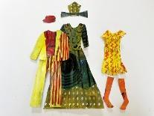  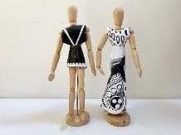  Access Art Unit  Focus Artists:  Alice Fox, Rahul Mishra  Pyer Moss, Tatyana Antoun, Hormazd Narielwalla,  Vivienne Westwood | Art:  Drawing/ Painting  Self Portraits - Identity  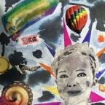  Focus Artists:  Nijideka Akunyili Crosby, Yinka Shonibare, Thandiwe Muriu, Mike Barrett, Jean Micheal Basquiet | Art:  Sculpture :  Benin Art- Clay masks/ sculptures  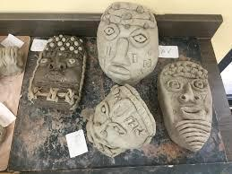  Focus Art:  Benin Bronzes | Art:  Take One Picture
DT:  Electrical Systems:  Steady Hand Game  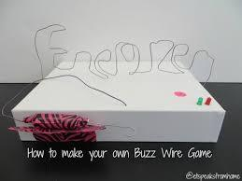  Kapow Unit | DT:  Making a Moving Toy  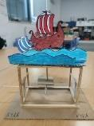  Kapow Unit | DT:  Textiles:  Upcycled Fashion Design  (Art/DT project) | DT:  Digital World:  Navigating the World  Kapow Unit | n/a | DT:  Food:  Come Dine with Me  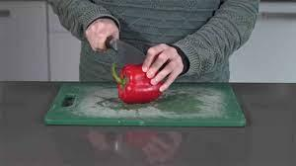  Kapow Unit
Music:  Developing Singing technique –Young Voices  Kapow unit: Songs that Speak  Instrumental Lessons – Music Production |  | Music:  Developing Singing technique –Young Voices/ Spring Concert  Kapow Unit: Film Soundtracks  Instrumental Lessons – Music Production |  | Music:  Developing Singing technique - Year 6 Show  Kapow Unit: Our Story in Song - Composition  Instrumental Lessons – Music Production
Western Classical – Early, Baroque, Renaissance, Classical Era | Western Classical Romantic and up to 1940’s | Western Classical 20th Century Music | 20th and 21st Century Music including Film and Musical Theatre | Popular Music | World Music and Folk Music
Spanish:  Phonetics 3-4  The Date (I) | Spanish:  Clothes (I) | Spanish:  At School (P) |  | Spanish:  At the Weekend (P)
PSHE:  Mental health and  emotional wellbeing:  Healthy minds | PSHE:  Identity, society  and equality:  Human rights | PSHE:  Drug, alcohol and  tobacco education:  Weighing up risk | PSHE:  Relationships and  health education:  Healthy relationships | PSHE:  Keeping safe and  managing risk:  Keeping safe - out and  about  FGM (female genital  mutilation) | PSHE:  Relationships and  health education:  Healthy relationships
RE:  What can be done to reduce racism? What can we learn from religious and non-religious worldviews? | RE:  What do religions say to us when life gets hard? | RE:  Is it better to express your religion in arts and architecture or in charity and generosity? | RE:  What matters most to Christians and Humanists? | RE:  What difference does it make to believe in Ahimsa (harmlessness), Grace and Ummah (community)?
PE:  Forest School  Games – Football | PE:  Games – Netball  Gymnastics | PE:  Games – Tag Rugby  Swimming | PE:  Games- Cricket  Games – Football | PE:  Athletics  Games – Tennis | PE:  Dance  Adventurous Activity – Kayaking
Global Citizenship:  Equality and Rights  Power and Governance (4 weeks)  What happens if some people or groups of people don’t get a say in how the country is run?  How can people work together to change things? (collective and direct action)  Project Outcome: School Elections - Write Head Girl/ Boy Manifesto, Hustings, Campaign teams  Social Justice and Equity (6 weeks)  What are some of the historical reasons for global inequalities?  What are the Global Goals for Sustainable Development?  How can we make a difference to social justice and inequality?  If you were in charge of the world for a day how would you spend the money?  Project Outcome: Social Enterprise - Raise money for UNICEF  Human Rights (5 weeks)  Why do we need to respect and defend people’s Human Rights?  Does anyone have a duty to protect my rights? Anyone else’s rights?  How can we exercise human rights?  Should we speak out when we feel something is wrong?  ‘With rights comes responsibility’. What does this mean?  What did we learn about Human Rights from learning about the Civil Rights Movement in the USA?  Project Outcome: Anti Racism poster campaign |  | Global Citizenship:  Respect for Others  BREE Project  Identity and Diversity (8 weeks)  What are some of the benefits and challenges of having a diverse community?  What are some things that define a culture?  What effect does my background have on my life?  How can I manage extremist views?  Project Outcome : Present an assembly or create a podcast about “Fake News” – Link to Safer Internet Day  Peace and Conflict (4 weeks)  What effect does conflict have on the wider world?  When has conflict led to positive change?  Can conflict lead to social and political change? |  | Global Citizenship:  Ecological Awareness  Sustainable Development (8 weeks)  Starting Point: Whole School Earth Day Celebration  How do different people and countries define a “good quality of life”, and how can it be measured fairly?  Whose responsibility is it to future proof our environment?  What are the UN sustainable development goals? How is the world doing in meeting them?  How can we evaluate media and other sources for bias, stereotypes, and missing voices?  How do our own assumptions — and other people’s — influence the way we understand issues?  Why is it important to challenge ideas or viewpoints that lead to inequality or injustice?  Globalisation and Interdependence (6 weeks)  How are different places interdependent?  How do actions in one place have consequences in another (e.g. deforestation,)?  How do decisions made locally (in our homes, schools or communities) link to environmental changes happening thousands of miles away?  What influences us and, in turn, what can we influence?  How do the everyday choices we make have global consequences?  Why do people often make a bigger difference when they take action together rather than acting alone?  How can we challenge viewpoints or decisions that lead to environmental damage, inequality or injustice?  Social Action Project
Global Citizenship Links:  International Day of Democracy  International Day of Peace  Black History Month – celebrating diversity  Dyslexia awareness week | Global Citizenship Links:  Universal Children’s Day  Anti- Bullying Week  Human Rights Day  Remembrance Day  Children in Need  Road Safety Week  World Philosophy Day | Global Citizenship Links:  International Women’s Day  International Mother Language Day  Children’s Mental Health Week | Global Citizenship Links:  Autism Awareness Day  Comic Relief  Fair Trade Fortnight  Mothering Sunday | Global Citizenship Links:  International Mother Earth Day  World Bee Day  Walk to school week  National Children’s Gardening Week | Global Citizenship Links:  BNF Healthy Eating Week  World Environment Day  World Oceans Day  World Refugee Day  Oxfam water week  Recycle Awareness Week  National School Grounds Week
P4C:  We Shall Overcome civil rights anthem here:  Is it ever right to disobey? Is violence ever justified?  Also: Selma film trailer | P4C:  Christmas ad: link to RE on the meaning of Christmas, significance of gifts, magic v miracle | P4C:  Blob Tree image to identify emotions  The Giving Tree:  love, sacrifice, use of ‘natural’ resources | P4C:  The Zoo – Anthony Browne: compare animal/human behaviour; zoos as prisons or preserves | P4C:  If the World Were a Village: vividly shows key facts on our global village; provokes questions on ‘fair’ access to learning, earning, water, food… | P4C:  Dove ad ‘Evolution’ (youtube: artificial beauty time lapse.  Magritte or Dali painting: should art ‘make sense’?
Emotional Literacy:  Self Awareness  Emotional Literacy Booklet Autumn 1  Associated Skills  - Identifying emotions  - Accurate self-perception  - Recognising strengths  - Self-confidence  - Self-efficacy  Contents  Introduction: The RULER Anchor Tools – What are emotions, mood meter, class charter, best self.  Lesson 1: How am I feeling? - Optimistic  Lesson 2: How am I feeling? - Apprehensive  Lesson 3: How am I feeling? - Stressed  Lesson 4: How am I feeling? – Balanced  Lesson 5: Celebrating people in our lives  Lesson 6: Self-efficacy and self confidence | Emotional Literacy:  Self Management  Emotional Literacy Booklet Autumn 2  Associated Skills  - Impulse control  - Stress management  - Self-discipline  - Self-motivation  - Goal setting  - Organisational skills  - Growth Mindset  Contents  Lesson 1: How do you want to feel?  Lesson 2: Listening and responding to emotions – dealing with feeling stressed and anxious  Lesson 3: Tool Kit to regulate emotions – anxious  Lesson 4: Tool Kit to regulate emotions – stressed about SATS  Lesson 5: Screens and Sleep  Lesson 6: Growth Mindset – Reflecting  Lesson 6: Goal Setting | Emotional Literacy:  Social Awareness  Emotional Literacy Booklet Spring 1  Associated Skills  - Understanding emotions  - Empathy/sympathy  - Appreciating diversity  - Respect for others  Contents  Lesson 1: How do you want to feel? - Revisiting the class charter  Lesson 2: Kindness  Lesson 3: Empathy  Lesson 4: The benefits of kindness  Lesson 5: Solving a problem with the blueprint  Lesson 6: Belonging and Community | Emotional Literacy:  Relationship Skills  Emotional Literacy Booklet Spring 2  Associated Skills  - Communication  - Social engagement  - Relationship building  - Teamwork  Contents  Lesson 1: Difference a barrier to friendship  Lesson 2: Conflict Resolution and revisiting anger  Lesson 3: Working in a group  Lesson 4: Peer pressure | Emotional Literacy:  Responsible Decision Making  Emotional Literacy Booklet Summer 1  Associated Skills  - Identifying problems  - Analysing solutions  - Solving problems  - Evaluating  - Reflecting  - Ethical responsibility  Contents  Lesson 1: Identifying Problems  Lesson 2: Identifying Solutions  Lesson 3: Analysing solutions  Lesson 4: Risk taking  Lesson 5: Ethical Decision Making  Lesson 6: Taking Action  Lesson 7: Evaluating and Reflecting | Emotional Literacy:  Anti Bullying/ Transition  SEAL – Say No to Bullying  - I understand how rumour-spreading and name-calling can be bullying behaviours.  - I can explain the difference between direct and indirect types of bullying.  - I can explain some of the ways in which one person (or group of people) can have power over another.  - I know some of the reasons why people use bullying behaviours.  - I know some ways to encourage children who use bullying behaviours to make other choices.  - I can tell you a range of strategies which I have for managing my feelings in bullying situations, and for problem solving when I am part of one
Personal Safety:  - Consent/ PANTS  - Being safe in the classroom/ school environment  - What to do when the fire alarm sounds  - Self Harm and Mental Health | Personal Safety:  - Firework safety  - Fire Safety  - Road Safety Be Safe Be Seen | Personal Safety:  - Dog Safety  - Stranger Danger  - Drug, Alcohol and tobacco (See PSHE/RSE)  - Review Consent/PANTS | Personal Safety:  - Staying Safe at Home  - First Aid  - Domestic Violence | Personal Safety:  - Road Safety- Green Cross Code  - Who keeps us safe  - Keeping Safe and Manging Risk ( See PSHE/RSE)  - FGM (See PSHE/RSE | Personal Safety:  - Water safety  - Staying Safe in the Sun  - Cycle and Scooter Safety – Bikeability Course
Enrichment Opportunities:  Tate Modern – P is for Position or  Banksy street art walk  PGL-Residential  3 Discovery Workshop | Enrichment Opportunities:  Ragged School  Charles Dickens Museum – Christmas Carol  National Archives – Black Victorians (online)  Royal Courts of Justice – Victorian Children on Trial  House of Illustration  Old Vic – A Christmas Carol (evening) | Enrichment Opportunities:  Cutty Sark- Global Trade  London Port Authority – Trade workshop  Young Voices  TGC – Tree Eye-d | Enrichment Opportunities:  V and A | Enrichment Opportunities:  London Zoo – Evolution workshop  British Museum – AD900  Courtauld Gallery- Art, Portraits and Identity Or Tate Modern | Enrichment Opportunities:  LSO KS2 Concert  National Gallery  Ben Kinsella Exhibition  Chessington
School, Family and Community Events:  International Evening  Class Tea Party  Class led workshop – mental health and wellbeing  Art Exhibition | School, Family and Community Events:  Interfaith Week  Children in Need  Community Carol Concert  Christmas Fair | School, Family and Community Events:  Museum week  Class led workshop – safer internet day  Moreland’s Got Talent | School, Family and Community Events:  Comic Relief  Spring Concert  Science Fair  World Book Day | School, Family and Community Events:  World Earth Day  Learning Outside the Classroom Day  Sports Day  Eid Disco | School, Family and Community Events:  National Field Work week  Summer Picnic  Year 6 Show  Prom

