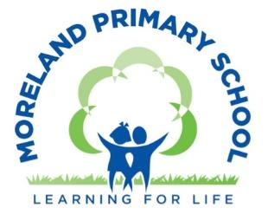
EYFS Curriculum Map
 | Autumn | Spring | Summer 1
Cycle 1 | Into the Woods | All about me | In the Garden
Cycle 2 | Food and Festivals | Imaginary worlds | About Town
EYFS Baby Room Long Term Curriculum Map Cycle 2
Autumn Term  Global Citizenship Theme:  Equality and Rights |  | Spring Term  Global Citizenship Theme:  Respect for Others |  | Summer Term  Global Citizenship Theme:  Ecological Awareness
Autumn  Food and Festivals |  | Spring  Imaginary Worlds |  | Summer  About Town
Autumn 1 | Autumn 2 | Spring 1 | Spring 2 | Summer 1 | Summer 2
Core Texts:  - Baby Goes to Market  - Handa’s Surprise  - Meg and Mog  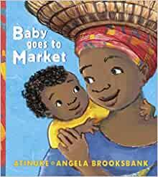  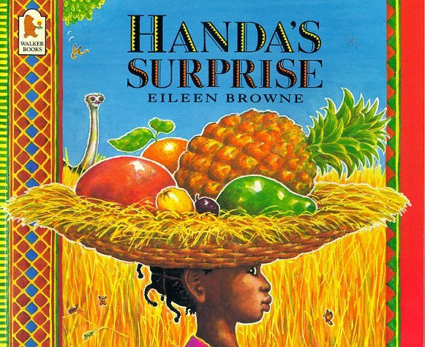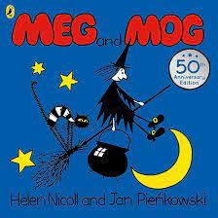 | Core Texts:  1.Don’t Put Your Finger in the Jelly Nelly  2. The Gingerbread Man  3. Dear Santa  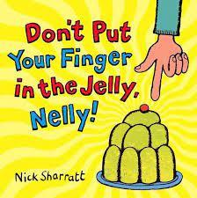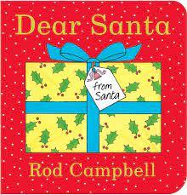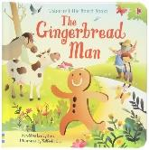 | Core Texts:  - Rainbow Fish  - Hooray for Fish  - Lost and Found  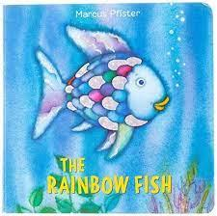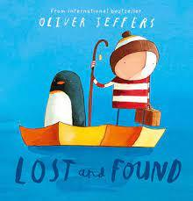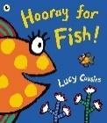 | Core Texts:  1.Dinosaur Roar  2. I Want My Potty?  3. Whatever Next  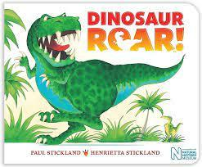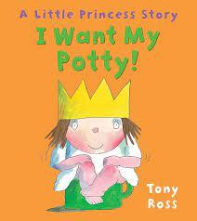  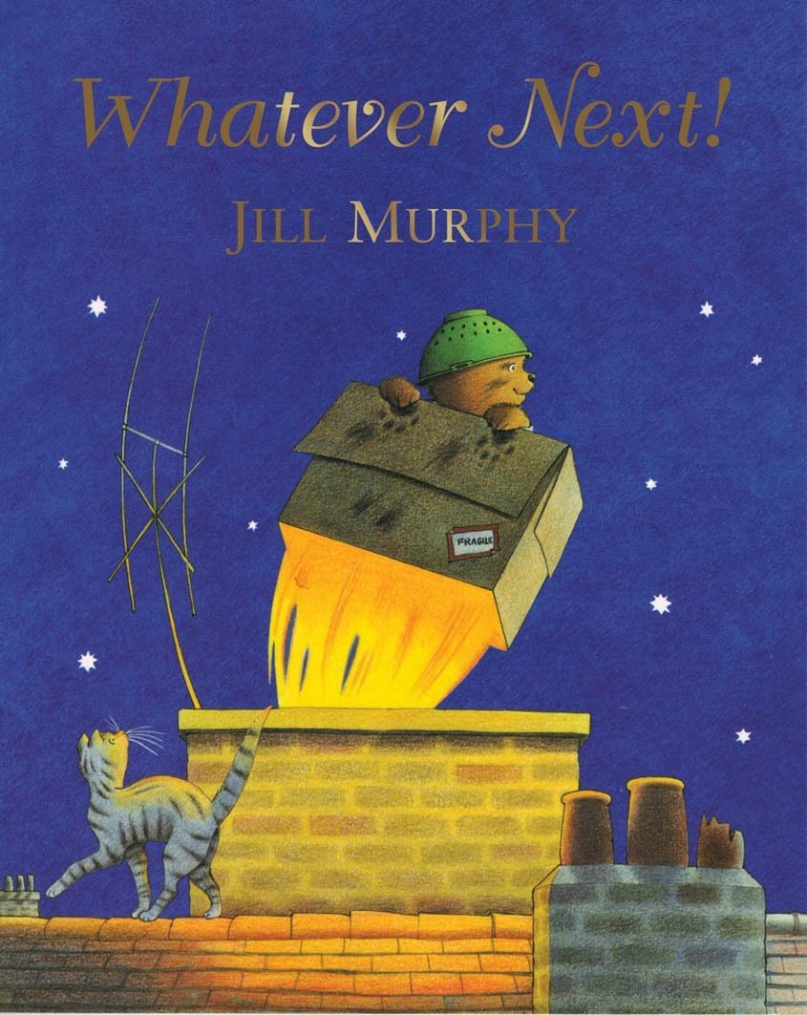 | Core Texts:  - The Three Little Pigs  - Where’s Spot?  - The Wheels on the Bus  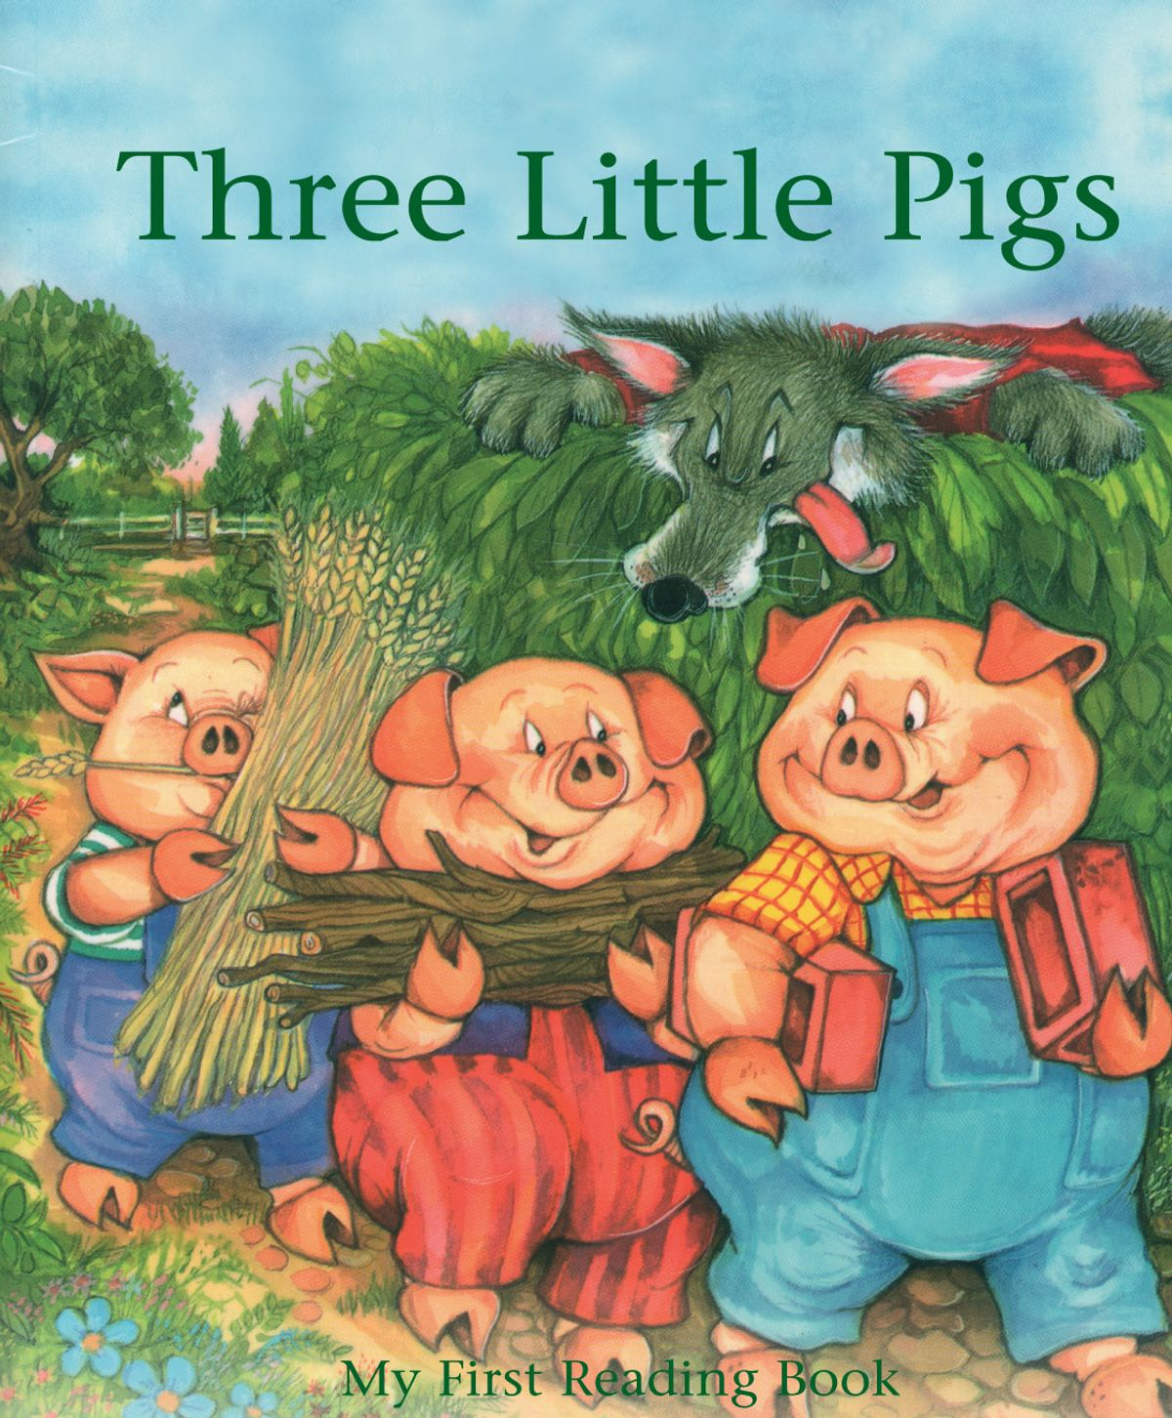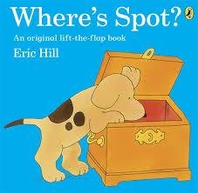  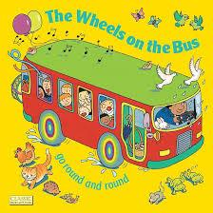 | Core Texts:  - Toddle Waddle  - Dear Zoo  - Hairy Mclairy  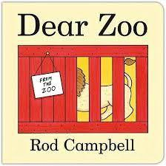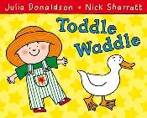  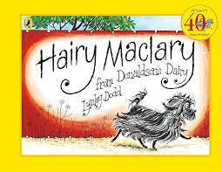
Songs and Rhymes  If You’re Happy and you know it  Incy Wincy Spider  5 fat Sausages | Songs and Rhymes  Jumping Bean  Head, Shoulders, Knees and Toes | Songs and Rhymes  1,2,3,4,5  A slippery fish  Five Little Ducks | Songs and Rhymes  Zoom Zoom Zoom  Twinkle Twinkle | Songs and Rhymes  The Wheels on the Bus  Faster, Faster! Nice and Slow!  Can you hear the train? | Songs and Rhymes:  Old MacDonald  Down in the jungle
Communication and Language:
How do we develop communication and language?
Babies learn new language skills over time and at different ages and we recognise babies and young children develop at different rates. Babies and toddlers develop language skills through play and playing together with them gives opportunities to interact and talk together and hear more words. They have the chance to learn how sounds, words and conversations work improving their language and cognitive skills. Language development is not only associated with spoken words. Listening and understanding also form a huge part of early language development. Children need to understand what is being asked of them or the meaning of words before using these themselves. Research shows that children develop their language skills by being exposed to a language-rich environment full of stories, songs, rhymes, signs, talk and imaginative play. Hands-on experiences encourage learning and provide a context for new words to be explored. For example, it’s easier for children to learn vegetable names when they are touching or tasting them.

Our language rich environment includes:
- reading stories and storytelling
- singing and rhymes
- looking at non fiction books
- playing with words and sounds
- using gestures to support language
- adults narrating their actions to children
- engaging with babies’ babbling - making eye contact, joining them at their level, smiling
- repeating children’s sounds and words back to them – back and forth interactions
- narrating children’s play –describing what children are doing, expanding on what children say adding one or two words, recasting or modelling back what a child says, pausing and allowing children time to respond
- role play
- small world play
- imaginary play
- exploring objects and places
- joining in with children’s play, responding to their interests and allowing them to lead
- playing language games

Literacy

How do we develop literacy skills?

Reading:

Reading with children from an early age builds a solid foundation for literacy. It also promotes building relationships and supports language development like the ability to listen to and understand words and the ability to focus. Reading stories stimulates babies and toddlers imagination and helps them learn about the world.
Reading with children:
- shows them that books can give both pleasure and information
- helps them learn the sounds of letters in spoken language
- helps them understand that stories come from words printed on the page
- helps them learn new words and develop a larger vocabulary
- improves their thinking and problem-solving skills
- can get children thinking and talking about new concepts, events or interests
- helps them learn about their community, society and world.

Children have a rich reading experience and adults share stories and books, sing songs and rhymes and play with sounds and words. This includes the core texts and rhymes listed above.

When exploring books with children adults will:
- Include a wide range of books including lift-the flap books, touch-and-feel books or books with rhyming or repeating words.
- Build a love of books by reading favourite books regularly
- Encourage children to hold the book the right way up and turn the pages in the right direction.
- Sometimes point out each word as they read. This shows children that we start on the left and move to the right when reading English.
- Point out pictures and talk about the pictures when the child points to them.
- Ask children open ended questions about the story or book, like ‘What do you think is going to happen next? What can you see?’’
- Make connections between the book and the child’s life. For example, you might point to a picture and say, ‘There’s a squirrel. That’s like the squirrel we saw at the park’.
- Introduce new words and explain their meaning.
- Play games that involve rhyming to help children appreciate beginning, middle and ending sounds – for example, ‘cat, pat and mat’.
- Play games that involve the sound and rhythm of words.
.

Reading Outcomes:

- Notices and engages with sounds and images in the environment
- As part of sensory exploration, may touch and handle books and digital reading devices
- Enjoys looking at books and other suitable printed or digital material with familiar people, and being read to
- Show interest in stories and listen to stories one to one and in a small group.
- Begin to have favourite books, songs and rhymes and characters and talk about them.
- To start to know how to hold a book correctly, start at the beginning and turn pages.
- Handles books, printed and digital reading material with interest
- Responds to sounds in the environment such as cars, sirens and birds
- Is interested in and explores the sounds made by banging and tapping familiar objects and simple instruments
- Waves and taps arms, bounces or stamps to simple rhythms in songs and rhymes
- Notices pictures and symbols and beginning to recognise what they stand for in their familiar experiences

Mark making:

Babies and toddlers are given a wide range of mark making opportunities using different materials and resources (including paint, sand, cornflour, shaving foam, chalk, crayons, clay, dough) from an early age as this gives them the foundations that will later help them with early literacy skills.
These activities and resources promote ‘open ended’ mark making as they are ideal for young children. There is no ‘fixed’ outcome to these activities and a child can use their imagination and expression to create whatever they feel like. This is especially useful for young children where they can explore and develop their own skills at their own pace.

Writing (mark making) Outcomes:
From Around 18 months:

Begin to understand the cause and effect involved in their mark making
Enjoy the sensory experience of making marks
Experiment with making marks with different tools and materials.
Know the marks they make are of value

Role Play enhancement:  Familiar Places - Café/Shop, Celebrations in Home Corner |  | Role Play enhancement:  Sensory spaces - Under the sea. Sensory caves |  | Role Play enhancement:  Big box play – vehicles, Dear Zoo, making houses
PSED

PSED is important in helping children to learn to recognise their feelings and those of others, begin to learn to manage their feelings, interact with others and develop positive relationships with their family, peers and key adults at nursery. Adults act as role models for children, teaching and illustrating appropriate behaviour.

PSED is broken down into 3 aspects:
- Making relationships
- Self-confidence and self awareness
- Managing feelings and behaviour

How do we develop personal, social and emotional learning?
- Ensuring we assign the appropriate key person so that there is always a person in the setting who is ‘holding’ the child
- Ensuring that our induction and settling process is tailored to meet both the parents and children’s needs so they are introduced to the nursery setting in a positive way and form positive attachments
- Developing positive relationships with parents
- Encouraging children, developing a growth mindset and perseverance, helping them to recognise their success.
- Valuing children and helping them to feel pride in their achievments
- Implementing routines reassure children as they begin to understand the structure of the day and predict what is coming next.
- Using a visual timetable to support children with routines understanding what comes next
- Planning for encouraging children to be independent, for example, feeding themselves, wiping their nose
- Thinking about spaces where they can play in role and re-enact home life situations’ to develop a positive self-image
- Opportunities to explore emotions in pictures, stories, games and songs
- Activities that involve collaboration, sharing and turn-taking
- Being a role model and praising children who demonstrate pro-social behaviours
- Ensuring that there are resources which support positive images of all, cultures, beliefs, genders, disabilities etc.
- Promoting awareness and respect for the natural environment.
- Providing opportunities for children to make their own choices, lead their play and engage in sustained periods of play
- Having spaces where children can have ‘quiet’ time and feel enclosed and cosy
- Sensory spaces both inside and outside

Emotional Literacy - RULER

Our PSED curriculum is supported by our Emotional Literacy Curriculum using the RULER approach. RULER is a whole school programme used to teach mental health and well being.
RULER was created by The Yale Centre for Emotional Intelligence and is supported by extensive research in the USA and Australia.
RULER stands for:
- Recognising emotions in yourself and others
- Understanding the causes and consequences of emotions
- Labeling emotions accurately – if you can name it you can tame it
- Expressing emotions appropriately
- Regulating emotions effectively

The children are taught these skills through a series of tools, known as anchor tools. This approach is underpinned by an understanding of trauma informed practice.

Physical Development

How do we develop motor skills and movement?

Getting babies moving through play is good for their motor skills development.
Physical play helps babies:
- strengthen the neck and upper body muscles they need to hold their head up and move around
- practise reaching and grasping
- strengthen muscles for movements like rolling, crawling and pulling to stand.
- With learning to walk - cruising, toddling and walking
- Learn to climb and balance

A range of different physical play activities allow babies to move in different ways, which builds their strength and helps them learn how to use different body parts and develop their motor skills. Quieter, gentle activities are also important, especially for developing babies fine motor skills. For example, picking up smaller objects, collecting objects in containers, filling and emptying are all good for practising small finger movements.

Activities include:
- Encouraging babies to move to music and sound by singing songs and rhymes, moving to music or shaking rattles and instruments.
- Tummy time
- Placing toys just out of a baby’s reach to encourage reaching and moving. Using simple toys like rattles to encourage touching and holding.
- Giving babies things to bang and shake - wooden spoons to bang on pots and pans, or sealed containers with beads inside to shake.
- Sitting and supporting babies upright on the floor, and moving a ball or toy in front of them to encourage them to follow the toy with their eyes, reach for it and grasp it.
- Encouraging babies to pull to stand.
- Encouraging babies to squat from standing. Placing toys on the ground in front of a standing baby so they have to squat to pick them up.
- Push-and-pull toys.
- Making tunnels for babies to enjoy crawling and moving through.
- Simple climbing, balancing and sliding equipment.
- Ride on and rocking toys
- Stacking and building toys – blocks, stacking cups, etc
- Puzzles, shapes sorters, posting toys, simple construction toys
- Heuristic play with natural resources and collections of objects
- Malleable play – playdough, cornflour, food play
- Sand and water play- filling, emptying, pouring, moulding
- Mark making activities – playing with paint, crayons, chalks, making marks with their hands, fingers and simple tools
- Exploring food and meal times – feeding themselves, using utensils

Maths
How do we develop mathematical skills?
Children are given age appropriate opportunities through planned activities and play opportunities within the learning environment to develop knowledge and skills in:
Comparison - Beginning to understanding words that describe quantities (more, bigger, enough)
Spatial Awareness - Exploring spaces to move, roll and stretch. Start to develop an awareness of their own bodies and that their body has different parts and where these are in relation to each other.
Shape – Explores different sized and shaped objects. Beginning to put objects of similar shape inside others and take them out again.
Pattern – Shows interest in patterned songs and rhymes, perhaps with repeated actions.
Measures – Responds to size, reacting to very big or very small items that they see or try to pick up

Activities include:
- Playing peek a boo
- Clapping games
- Exploring songs, music and rhythms
- Pop up toys to explore object permanence
- Puzzles
- Sorting and matching objects
- Building with blocks and other construction toys
- Stacking toys
- Shape sorter toys
- Sand and water play – pouring, filling, emptying exploring capacity
- Exploring natural objects
- Physical play – crawling, rolling, climbing, jumping, throwing, ball games
- Finger play
- Number songs and rhymes
- Number stories and books
- Cooking

EAD – Creative and Imaginative Development

How do we develop creativity and imagination?
Between birth and 12 months, babies become more and more interested in the world. Play is the main way that babies develop, learn and explore the world.
As babies explore through play, their imaginations develop. And as their imaginations develop, they can experiment with new sounds, sights, objects and activities. They also learn to solve simple problems, and they start being able to understand their own and other people’s feelings
Dressing up and pretend play start at around 15-18 months. Young toddlers enjoy pretending to be a grown-up, using props like old clothes and hats. For example, they might imagine they’re driving a bus or serving in a shop. They will also start creating their own pretend play stories and games. These might be from books they have heard read or experiences they’ve had, like seeing a monkey at the zoo. Babies and young toddlers enjoy the sensory experiences of messy play using and exploring different materials and beginning to make marks.
It is important creative and imaginative activities are open ended and that babies and young toddlers can decide what to make and how to use the materials.

Some ways that we support this development are:
- Exploring and enjoying looking at pictures in books. A baby’s expanding imagination helps them learn that pictures in books relate to things in the world around them.
- Exploring the environment inside and outside. Babies are naturally curious about the environment and are keen to explore, especially once they can crawl.
- Using their senses - touching and tasting are how a baby explores and expands their imagination, seeing what happens when they bang things together or use their voice,
- Exploring and creating with materials through messy play. Digging sand, filling and pouring water, building with mud and clay or exploring paint.
- Imitation – copying sounds, using their imagination to copy what they’ve seen others do, for example, they might pretend to cook dinner using leaves and grass they’ve found in the garden They might say things like ‘You be baby, I’m mum’ or ‘I go to work, bye bye’.
- Listening to and creating music of all sorts supports babies and young toddlers in imagining fantastic things like flying or floating in space. They will express themselves by singing, dancing and moving to their favourite songs and rhymes

Activities include:
- Playing peekaboo with objects like scarves or blankets.
- Looking in mirrors and end exploring reflective objects.
- Exploring books, objects and toys.
- Looking at photos of people and places. Talking with babies about what you see together.
- Reading books , sharing stories and singing songs and nursery rhymes using actions together.
- Exploring places, creatures and objects through books
- Listening to various styles of music and exploring making sounds with different objects and instruments.
- Encouraging children to make up their own songs and actions
- Exploring treasure baskets and heuristic play.
- Open ended play resources such as block play
- Tasting different foods
- Exploring natural objects with their senses inside and outside in nature.
- Exploring the wider world – the park, the woods, the canal
- Messy and sensory play using water, sand, mud, clay, playdough and paints.
- Exploring simple open ended mark making, art and craft materials and activities. This can include finger paint, crayons and paper, coloured chalk for drawing and writing on outdoor paths, scrap materials or playdough.
- Home corner, dressing up, role play and deconstructed role play.
UW - Understanding the World

How do we develop understanding of the world?
Play is important for a baby’s cognitive development – their ability to think, understand, communicate, remember, imagine and work out what might happen next- giving babies many ways to learn about their world. As babies develop into young toddlers they learn best when they’re interested in an activity and are able to lead their play. Toddlers are determined to try everything, trying to figure out how things work for example– banging, dropping, pushing and shaking objects to see what happens to them. They begin to understand that there are groups of things in the world to sort objects into types – for example, by colour, shape or size which also helps early scientific and mathematical thinking.
At this age babies and toddlers don’t know how all the concepts fit together and an important role of the adult is to take time to explaining these concepts and discovering things together.

Activities include:
- Playing peekaboo with objects like scarves or blankets.
- Looking in mirrors and end exploring reflective objects.
- Exploring books, objects and toys.
- Looking at photos of people and places. Talking with babies about what you see together.
- Building relationships with others
- Playing with water and sand - dunking, filling, emptying, measuring, sinking, floating, pouring, scooping, moulding and exploring what changes their properties.
- Exploring cause and effect with toys and objects such as those with buttons to push to make things happen, or activities like shaking or banging objects.
- Playing with stacking blocks and toys that they can roll or push across the floor.
- When reading with babies, exploring what they can see in the pictures, naming things and using different voices for different characters or making the sounds of different animals.
- Exploring books with flaps, sliders, sounds and textures
- Exploring treasure baskets and heuristic play.
- Open ended play resources such as block play
- Completing simple puzzles and games
- Tasting different foods
- Exploring natural objects with their senses inside and outside in nature.
- Exploring the wider world – the park, the woods
- Messy and sensory play using water, sand, mud, clay, playdough and paints.
- Singing simple songs and rhymes that involve actions or animal sounds. For example, ‘Heads and shoulders’ or ‘Old MacDonald’.
- Sorting objects, like coloured blocks, shapes or pegs, or plastic cups and containers of different sizes.
- Playing outside and in local green spaces and exploring and experiencing the changes in the weather and the seasons, looking at the sky and the world around them
- Going on trips to different places – the woods, the farm, an interactive museum, a puppet show, the shops and other local places

UW Lines of Enquiry:  Who is in our family?  Who takes care of us?  What special times do we share?  How are we similar and how are we different?  What do we eat?  What do different foods taste, look, smell, feel like?  Where can we get food from?  How do we look after our bodies? |  | UW Lines of Enquiry:  How do we create stories about what we know?  How can we use our imagination to create a story?  How do we find things out from pictures, stories and books?  How can we explore different places?  What can we find out about water when we play with it?  What animals live in the water?  How can we explore the things that interest and fascinate us?  How can we challenge ourselves to try something new? |  | UW Lines of Enquiry:  What do different objects and materials feel like and what can we do with them?  How can you build, balance, connect and stack different objects and materials? What happens?  What can we find when we explore our local area?  How do we make things work?  What makes things go?  What different vehicles are there?  Who can help us and look after us?  What can we find in the garden and the park? What can we see, hear, feel, smell?  What do we like doing in our local park?
Topic Enrichment Opportunities:  Garden Classroom Activities  The LSO  Going to the shops and Chapel Market |  | Topic Enrichment Opportunities:  Visiting the Library  Visiting the Aquarium  Diana Memorial Playground  Little Angel Puppet Theatre |  | Topic Enrichment Opportunities:  Young V and A  Local parks  Highgate Wood or Hampstead Heath
Parent Partnerships:  - Early reading parent talk  - Early reading/language workshop  - Borrow a book library  - Parent cooking workshops/Kitchen Club |  | Parent Partnerships:  - Early maths workshop  - Borrow a book library  - Parent cooking workshops/Kitchen Club  - Science Day workshop  - Easter bonnet parade |  | Parent Partnerships:  - Creative Play workshop  - Outside Play workshop  - Borrow a book library  - Parent cooking workshops/Kitchen Club  - Sports Day  - Summer celebration/picnic  - Parent open mornings  - Parent coffee mornings

